Name: ______________________
Date: ______________________
Block: ______
The Van de Graff Generator

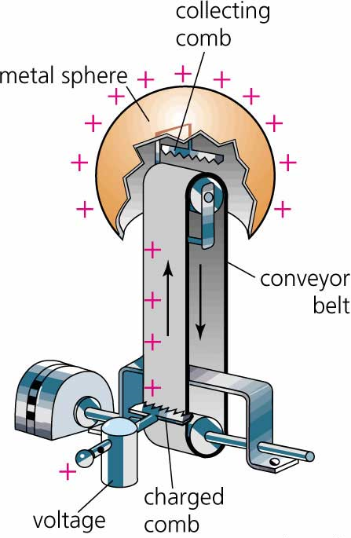

The electrostatic machine known as the Van de Graaff generator was invented by Robert J. Van de Graaff at Princeton University (New Jersey, USA), starting in 1929, to generate high voltages for experiments in nuclear physics.

The Van de Graaff generator produces a charge on the metal sphere by the following steps:
- The motor turns the conveyor belt
- As the belt rubs against the charged comb it gains a positive or negative charge (much like rubbing a balloon)
- The charge is transferred from the belt to the collecting comb
- The charge is then transferred to the sphere.

Van de Graff Generator Activity Questions

1) To determine if your Van de Graaff generator develops a positive or negative charge, the easiest thing to do is to rub a balloon on your hair or shirt to develop a net negative charge on the balloon and throw it at the generator while it is charged.
a) What happened when the balloon came near the generator?

b) Based on your observation, what is the charge of the generator?

2) a) Sketch what the generator does when it is on and paper strips are taped to it.

b) Explain why the paper strips act in this manner.

3) a) Describe (or sketch) what happened to your classmate’s hair when he/she has his/her hands on the generator.

b) How does this occur?

c) Why does he/she have to stand on a chair in order for this phenomenon to occur?

4) Why does a person receive an electric shock when they are near the generator?

5) What happens when the discharge electrode is held near the dome of the generator? Why does this occur?

7) a) What happens to the bubbles as we blow them in the direction of the generator?

b) Why does this happen?

8) a) What happened when the fluorescent light was near the generator?

b) What causes this occur?

9) What happens when we create a human chain? Why?

10) What happened with the pie pans when they were stacked on the Van de Graaff generator? Is this what you expected? Why or why not?

