AWM Math 11 – Unit 7 – Practice Test

Surface Area and Volume

Section A – Multiple Choice
Choose the best response for each of the following questions. Circle that response.
1) Area is measured in which type of units?
a) zero units
b) square units
c) linear units
d) cubic units

2) Surface area is measured in which type of units?
a) zero units
b) square units
c) linear units
d) cubic units

3) Volume is measured in which type of units?
a) zero units
b) square units
c) linear units
d) cubic units

4) At his stationary store, Ray buys supplies in large boxes shaped like cubes. If the volume of one of these boxes is 15 625 cm³, what is its side length?

a) 25 cm
b) 125 cm
c) 1953.1 cm
d) 5208.3 cm

5) A crate with no lid is shaped like a cube with sides that are 0.8 m long. What is the surface area of the crate?

a) | 2.6 m² | c) | 2.9 m²
b) | 3.5 m² | d) | 3.2 m²

Section B – Short Answer
Answer the following questions, showing ALL steps and work.
1) Calculate the area of the following figures. Remember to put the units in your final answer!

a)
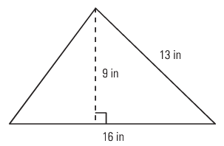

b)
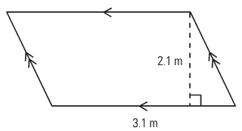

c)

66 cm

2) Calculate the area of the following composite figures. Remember to put the units in your final answer!

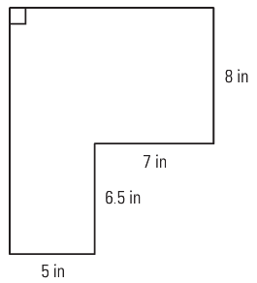
a)

b)
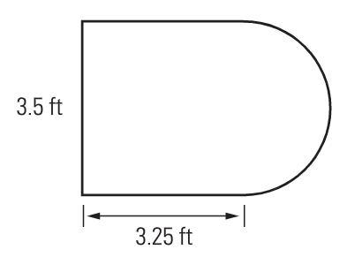

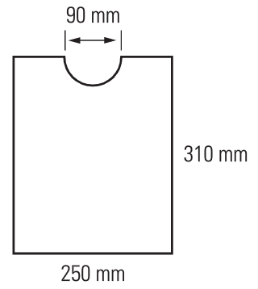
c)

3) A crate is 5 feet long, 3 feet wide, and 2.5 feet high. Draw and label a diagram of the crate, and calculate its surface area.

4) Calculate the surface area of each of the following:
- a cone with a slanted side of 20 cm and a radius of 12 cm
- a sphere with a diameter of 23 cm
- a cylinder with a height 43 cm of and a radius of 23 cm
Which shape has the smallest surface area?

5) Two boxes are stacked one on top of the other. The top box has measurements of 5 inches by 4 inches by 7 inches, and the bottom box has measurements of 12 inches by 14 inches by 11 inches as shown. What is the exposed surface area of the stack? Include the bottom face of the stack.
5 in
4 in.

7 in.

12 in.
11 in
14 in.

6) The roof of a building is shaped like a square pyramid. Its base is 18 m by 18 m and the slant height is 12.8 m. What is the volume of the roof?

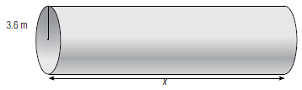
7) A large pipe has a volume of 879.44 m³. If the radius of the pipe is 3.6 metres, how long is the pipe, x?

8) Gravel is poured from a truck and forms a pile in the shape of a cone. If the diameter is 6.8 m and the height is 2.8 m, what is the volume of gravel in the pile?

9) A small water tower is shaped like a sphere. If the radius of the sphere is 25 cm, calculate the volume to the closest whole cm³, and capacity that the water tower holds to the closest whole litre. Remember 1000 cm³ = 1000 mL = 1L

10) Three boxes are stacked one on top of the other. The top box has measurements of 5 inches by 4 inches by 7 inches, the middle box has measurements of 12 inches by 14 inches by 11 inches and the bottom box has measurements of 24 inches by 18 inches by 24 inches. What is the volume of the stack?

11) Donna is a candle maker. She has a rectangular block of wax as shown. She melts the wax and shapes it into a spherical candle. What is the approximate radius (to the closest whole cm) of the largest candle that Donna can make?

6.8 cm

4.2 cm
7.9 cm

Formula Sheets

l s

A = l × w w A = s² s

b a

h A = b × h A = (a + b) × h
h 2

b

A= (b × h) A = πr²
2
h r

b

