Unit 7 –surface area and volume
Review: Calculating Area of 2D Shapes
This unit teaches about surface area and volume. In order to be able to calculate the surface area of a 3-dimensional object, you need to first know how to calculate the area of a 2-dimensional shape. The shapes you are required to know how to calculate the area for include: rectangle, square, parallelogram, trapezoid, triangle, and circle. These calculations are explained on the following pages.

AREA
In geometry, area refers to the measure of a region. It is ALWAYS in square units – cm², in², m², etc. The area of a geometric figure is the number of square units needed to cover the interior of that figure. The following formulas are used to find area. These formulas are also provided for you on a single sheet as a handout.

In equations, the symbol for area is a capital a A.

Rectangle: A rectangle has 4 right angles, with opposite sides equal in length. Area for a rectangle is the length (or base) times the width (or height). Both terms are used depending on author.

A = l × w or A= b × h

Example:
A = l × w
6 m

15 m

Square: In a square, all the sides have the same length. The 4 angles are all right angles. The area is the side times side, or side squared.

A = s × s or A= s²

Example:
A= s²
7 cm

7 cm

Parallelogram: A parallelogram is a 4 sided figure that has opposite sides equal in length. The 4 angles are NOT right angles. It looks like a rectangle that has been pushed over. The area is base times the height. The height is always perpendicular (at right angles or 90⁰) to the base.

A= b × h

Example:
A = b × h 9 mm

14 mm

Trapezoid: A trapezoid is a 4 sided figure that has one pair of opposite sides parallel and the other pair of opposite sides not parallel. The area is the average of the parallel sides (often the top and base, usually called a and b), times the height.

A= (a + b) × h which means (a + b) ÷ 2 × h
2
Example: 5 cm
A= (a + b) × h
2 8 cm

9 cm

Triangle: A triangle is any 3 sided figure. It can have any other combination of angles. The area is base times the height divided by 2. The height is always perpendicular (at right angles or 90⁰) to the base.
A= (b × h) which means A= b × h ÷ 2
Example:
A= b × h ÷ 2
9 cm

6 cm
These are other shapes of triangles that still follow this formula.

5 cm 5 in

4 cm 9 in
Circle: In a circle, there are no “sides”. So the area is calculated using the length of the radius in the following formula. Remember, the radius goes from the centre of the circle to touch the circle at any place. Use the π button on your calculator.

A = πr² which means A = π × r × r

Example:
A = πr²

r = 6 cm

If given the diameter, divide that number by 2 before calculating the area because the radius is half the length of the diameter.

r = d ÷ 2

d = 18 in

A = πr²

This page summarizes the formulas for the 2-D shapes discussed previously.

l s

A = l × w w A = s² s

Rectangle Square

b a

h A = b × h A = (a + b) × h
h 2

b
Parallelogram Trapezoid

A= (b × h) A = πr²
2
h r

b
Circle
Triangle

ASSIGNMENT 1 – Calculating Area of 2D Shapes
For each of the following, name the shape and calculate its area. Write the formula for your calculations as part of your answer. DON’T FORGET THE UNITS!

1)

6.2 cm

5.7 cm

2)

67 m

3) 25 mm

15 mm

35 mm

4) 17 in

11 in

5)

7.9 m

9.6 m

6) 5.3 ft

7)

8.1 cm

4.9 cm

8)

3.5 mm

7.7 mm

Calculating THE Area of 2D COMPOSITE FIGURES
A composite figure is an irregular shape that can be broken into two or more smaller, regular shapes. In order to find the area of a composite 2-D shape, you need to find the areas of regularly shaped parts that make it up, and then add those areas together. There are often different ways to break up an irregular shape. These solutions present just one way to solve the problems.

Example: Calculate the area of the figure below.

2.5 mm

2.2 mm

9.9 mm

4.9 mm
3.7 mm
Solution: The figure above can be broken into a triangle and two rectangles. The individual areas of these shapes are calculated and added together.

ASSIGNMENT 2 – CALCULATING AREA OF COMPOSITE 2D FIGURES
1) In the irregular figures below, draw lines to show one way to separate the figures into smaller regular shapes. You do not need to calculate the area of these figures.

2) Show four possible ways to divide the irregular figure below into regular shapes to be able to calculate its area. Then choose one method, show all your measurements, and calculate the total area.

4.7 m
4.5 m

2.9 m 2.3 m
5.9 m
5.3 m

10.5 m

3) Calculate the area of the following figures.

a)

8 ft

7 ft

6.5 ft
5 ft

b) 6.8 cm

3.4 cm

8.6 cm

c)

25 cm

16 cm

Assignment: Area worksheet
what is a Prism?
A prism is a three-dimensional object with ends that are called bases, and sides that are called lateral faces. On every prism, the ends are parallel and congruent (the same size) while the sides are parallelograms.

If a prism is a right prism, the sides are perpendicular to the bases and the lateral faces will be rectangles (remember a rectangle is a special parallelogram). A Kleenex box is a right prism – a right rectangular prism that meets these conditions. If the lateral faces are not perpendicular to the bases, the prism is called an oblique prism and the sides will be parallelograms.

A prism is named by two factors: whether it is a right prism or an oblique prism and the shape of its base.

Example: Name the following prisms.

- b)

Solution:

ASSIGNMENT 3 - PRISMS
Complete the following table to help you name the following prisms.

1) 2)

3) 4)

5) 6)

Prism | Shape of base | Right or oblique | Shape of lateral faces | Name
1
2
3
4
5
6

Nets of Prisms
A net (in the geometry sense) is a two-dimensional pattern that can be folded to form a three-dimensional shape. If you think of a pizza box or a box for photocopy paper, they are one piece of cardboard that has been folded into the shape of a right, rectangular prism.

Nets of prisms are useful when calculating the surface area of that prism. If you opened the prism out and laid it flat, it would produce the net. Then it is easier to calculate the area of all the faces to get the total surface area of that prism.

In this section, we will look at what the nets of different prisms look like and deal with learning about calculating the surface area in the next section.

Example: Given the following prism, what would a net look like if it was made from one piece of cardboard?

10 mm

10 mm
40 mm
10 mm

Solution: The prism can be cut along the edges where the base meets the sides, with the exception of the bottom. This will produce a net like this:
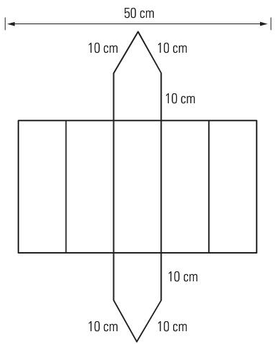

There are often many nets that can be produced that can be re-assembled to make a prism. This is only one of the possibilities. Be careful however, that a net you produce can be put back to make the prism desired. Not always can this be done!

ASSIGNMENT 4 – NETS OF PRISMS
1) Draw nets for each of the following prisms. Label the side lengths. Drawings do NOT need to be to scale.

a)

8 in

8 in
20 in

b)
25 cm

5 cm

2) The net for a right octagonal prism was drawn by two students as shown below. Which is the correct net? Explain your answer.

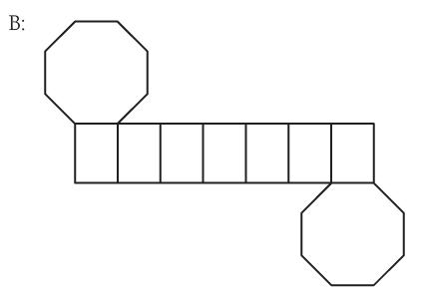
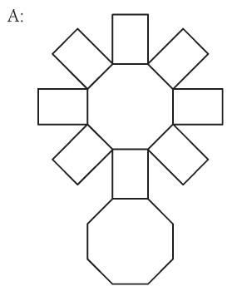

Quiz next class
Assignment: What did the Taxi Driver say About His Daughter?
Day3/4: SURFACE AREA
The surface area of a three-dimensional object is the area of the entire outer surface. Just as area is expressed in square units, surface area is also ALWAYS expressed in square units; – cm², in², m², etc. For all prisms, drawing a net, finding the area of each part of the net, and adding these values together will always find the surface area. Some prisms have specific formulas that can be used to calculate the surface area.

Example 1: Draw a net for the right rectangular prism below and calculate the surface area.

4.5 m
3.8 m
5.7 m

Solution: Draw the net, label all the dimensions, and find the area of each part. Add the areas together to get the surface area.

Alternate Solution: A formula exists for surface area of a right rectangular prism. Draw the net and then use the formula to calculate the surface area.

SA = 2lw + 2lh + 2wh

ASSIGNMENT 5 – SURFACE AREA OF PRISMS USING NETS
For the following prisms, draw a net and use it to calculate the surface area.

1)

27 cm

11 cm
16 cm

2) 10 in.

18 in.

8 in.
6 in.

Surface Area of Irregular FIGURES
Sometimes figures are not a nice regular prism, but a combination of several prisms put together or one prism with parts missing. In order to calculate the surface area of these irregular figures, the shape often needs to be divided into parts and the area of the individual faces needs to be calculated and added together.

Example: Calculate the surface area of this figure. Include the bottom and the back.

4.4 m

5 m 1.8 m

3.5 m
9.5 m

Solution: Divide the figure into parts, label all the dimensions, calculate the individual area of each face, and add these areas together.

The figure is divided into 2 main rectangular prisms. The dimensions have been labelled and capital letters have been assigned to different faces.

NOTE: This is not the only way to divide the figure into parts. Other ways exist.

ASSIGNMENT 6 – Surface Area of Irregular FIGURES
Calculate the surface area of the following figures. Show ALL calculations and work.

1)

7 cm 5 cm

4 cm 4 cm
6 cm
15 cm

2)

3 m 3 m

10 m
15 m

12 m
28 m

Assignment: What Happened to Zelda After She Swallowed Two Nickels, Three Dimes, and a Quarter?
SURFACE AREA OF CYLINDERS AND SPHERES
A cylinder is like a prism but its bases are circles. To find the surface area of a cylinder, you need to find the area of the two circles and the area of the side between them – the lateral face. It is easy to see how to do this by drawing a net of a cylinder.

C
top
circumference, C
radius, r

h
height, h

base r

From this net, you can see that the cylinder is made up of 2 circles and the lateral face which is a rectangle. The length of the rectangle is the circumference of the circle, and the width of the rectangle is the height of the cylinder. To calculate the surface area of a cylinder, calculate these parts and add them together.

Example 1: Calculate the surface area of a cylinder that has a radius of 9 cm and a height of 25 cm, as shown below.

9 cm

25 cm

Solution:

NOTE: The formula for surface area of a cylinder is:

SA = 2πrh + 2πr²
A sphere is like a ball. All points on a sphere are the same distance from the centre. It is not possible to draw the net of a sphere, and thus we simply use a formula to calculate its surface area. The surface area depends on the radius of the sphere.

The formula for surface area of a sphere is:

SA = 4πr² r

Example 2: Calculate the surface area of the following sphere.

5.2 cm

Example 3: If a ball has a surface area of 3500 mm², what is the radius of this ball?

ASSIGNMENT 7 – SURFACE AREA OF CYLINDERS AND SPHERES
1) Draw a net and use it to find the surface area of a pipe that has a radius of 15 cm and is 75 cm long.

2) Find the surface area of a cylindrical pop can that is 37 cm tall and has a diameter of 8 cm.

3) A sphere has a radius of 7.6 m. What is its surface area?

4) Find the radius of a sphere with a surface area of 6700 m².

5) A hemisphere is half a sphere. What is the surface area of a hemisphere with a radius of 28.4 mm?

SURFACE AREA OF PYRAMIDS AND CONES
A pyramid is a three-dimensional object with a base that is a regular polygon and lateral sides that are triangles. The triangles join the base along one side, and meet at a point called an apex. In a right pyramid, the apex is directly above the centre of the base.

The net of a pyramid is made up of the base and as many triangles as there are sides on the base.

Example 1: Find the surface area of the square-based pyramid shown below.

15 cm

20 cm
20 cm

Solution

Example 2: Find the surface area of the square based pyramid shown below.
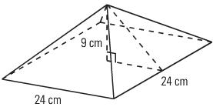

Solution: In this pyramid, the slant height of triangles is not given. Instead the height of the overall pyramid is given. In order to calculate the surface area, the slant height must first be calculated. To do this, use the right angle triangle inside the pyramid and Pythagorean Theorem in order to calculate the slant height.

Continued on the next page.

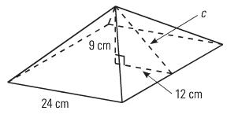

9 cm c

12 cm

Pythagorean Theorem states: c² = a² + b²

A cone is like a pyramid except that it has a circular base. The net of a cone is a circle for the base (or top depending on the orientation) and a sector of a different large circle.

s h

r

The surface area of the side or lateral region of a cone is calculated using a formula. The components of the formula are the radius of the base of the cone, and the slant height of the cone as shown above.
The area of the base of the cone is calculated using the formula for a circle.

Thus the entire formula for calculating the surface area of a cone is:

SA = πrs + πr²

Example 3: Calculate the surface area of the cone shown below.

18 cm

5 cm

Solution:

Example 4: Calculate the surface area of the cone shown below.

14.6 m
r
15.8 m

Solution: The slant height is not given so it must be determined using Pythagorean Theorem. Also, the diameter is given as 15.8 m so the radius is half that size: 15.8 ÷ 2 = 7.9 m.

ASSIGNMENT 8 – SURFACE AREA OF PYRAMIDS AND CONES
1) Find the total surface area of the square-based pyramid shown below.
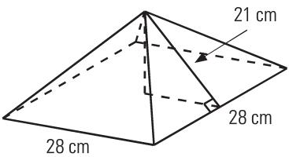

2) Calculate the slant height, and then the surface area of the pyramid below.

height, h = 12 cm
12 cm

18 cm
18 cm

3) The surface area of this square-based pyramid is 680 m². The side lengths are 16 m. What is the height, h, of the pyramid? Hint: subtract the area of the base and work from there.

h

16 m
16 m

Calculate the surface area of the cone shown below.

4)
25 cm

67cm

5)

78 mm

88 mm

6) 22.5 m

18 m

Assignment: Worksheet D-66 and D-55
This page summarizes the formulas for the surface area used in this unit.

Right Rectangular Prism Cube
SA = 2lw + 2lh + 2wh SA= 6s²

r

r
h

Cylinder Sphere
SA = 2πrh + 2πr² SA = 4πr²

s s h
h
r
b
b
Square Based Pyramid Cone
SA = 2bs + b² SA = πrs + πr²

SURFACE AREA OF COMPOSITE FIGURES
Just as finding the area of composite figures can be done, the surface area of composite figures can be calculated. With composite figures that sit on top of one another however, the lateral areas are added but an allowance must be made for the missing surface area between the figures.

Example: Calculate the exposed surface area of the composite figure shown below.

3 cm 2 cm

3 cm 5 cm

Solution:

ASSIGNMENT 9 – SURFACE AREA OF COMPOSITE FIGURES
Calculate the exposed surface area of the following composite figures.

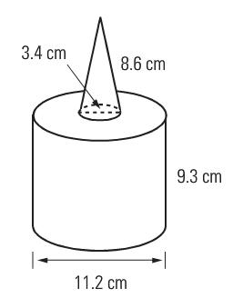
1)

2)

18 cm (diameter)

15 cm

3)
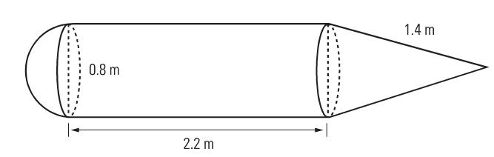

Assignment: Composite Worksheet
Quiz next class
VOLUME AND CAPACITY
The volume of a three-dimensional object is the amount of space it occupies. There are specific formulas used to find the volume of different geometric solids. Just as area is expressed in square units, volume is ALWAYS expressed in cubic units; – cm³, in³, m³, etc.

Capacity is the maximum amount that a container can hold. It is related to volume in that the capacity of a container can be the volume of the container. But capacity is most often used with liquid measurements. Therefore, capacity is measured in liquid units like litres and gallons.

Volume and capacity are closely related. In the metric system, a volume of 1000 cm³ is equal to a capacity of 1 L. Also, 1 cm³ = 1 mL and 1 ft³ = 7.48 US gallons. These are useful conversions to remember.

In equations, the symbol for volume is a capital v V.

VOLUME AND CAPACITY OF PRISMS
The volume of a prism is found by multiplying the area of the base by the height of the object. This formula is the same for prisms and cylinders, even if the prism is oblique. In that case, the height just has to be perpendicular to the base.

Example 1: Calculate the volume and capacity of the rectangular prism below.

12 cm

6 cm
15 cm

V = A_{base} × h
V = l × w × h

Example 2: Calculate the volume and capacity of the following triangular prism.

3 ft. 4 ft.

2 ft.

.

V = A_{base} × h
V = (b × h ÷ 2) × h

Note that in the formula (b × h ÷ 2), the b and h refer to the base and height of the triangular face NOT the prism itself. To avoid this confusion, often these two lengths are referred to as “a” and “b”.

Capacity =

Example 3: A rectangular prism has a square base with sides that are 12 cm long. If the volume of the prism is 2304 cm³, what is the height of the prism?

Solution: Use the formula for volume of a rectangular prism and solve for h.

V = A_{base} × h
V = l × w × h

ASSIGNMENT 11 – VOLUME AND CAPACITY OF PRISMS
1) Calculate the volume and capacity of the following prisms.
a) A rectangular prism with a base of 17.5 cm by 13.2 cm and the height is 18.8 cm.

b) A rectangular prism with a square base with sides of 2.75 ft, and a height of 5.8 ft.

2) A rectangular prism has a base of 6.9 cm by 8.8 cm. If the volume is 212.5 cm³, what is the height of the prism? Answer to one decimal place.

3) One rectangular prism has dimensions of 8 mm by 12 mm by 20 mm. A second prism has a base of 32 mm by 6 mm. What must the height of the second prism be so their volumes are the same?

4) A hole 18 m by 8 m by 5 m is being dug in a backyard to make a swimming pool. A dump truck can only carry 12 m³ of dirt. How many trips will the truck have to make to remove the dirt for the pool?

VOLUME AND CAPACITY OF CYLINDERS AND CONES
The volume of a cylinder is calculated using the general formula for the volume of a prism: V = A_{base} × h. In a cylinder, the area of the base is the area of a circle: πr². So the formula for volume of a cylinder combines these two formulas to make:

V = πr²h

Example 1: A cylinder has a radius of 5.3 cm and a height of 14.8 cm. Calculate its volume and capacity.

Solution: Use the formula for volume to calculate the volume. Then use the conversion to calculate the capacity.

V = πr²h

Capacity =

The volume of a cone is equal to $\frac{1}{3}$ of the volume of a cylinder with the same base and height. The volume is calculated using the following formula: V = $\frac{1}{3}$ × A_{base} × h
For a cone, the formula is: V = $\frac{1}{3}$ πr²h or V = 1 ÷ 3 × π × r² × h

Example 2: A paper cup is shaped like a cone. It has a radius of 5 cm and a height of 8 cm. Calculate its volume and capacity.

Capacity:

ASSIGNMENT 12 – VOLUME AND CAPACITY OF CYLINDERS AND CONES

1) Calculate the volume and capacity of a cylinder with a radius of 27 cm and a height of 45 cm.

2) A large cylinder has a capacity of 4.25 L. If the cylinder has a diameter of 13 cm, what is the height of the cylinder?

3) Find the volume of a cone with a radius of 5 inches and a height of 14.5 inches.

4) A cone has a radius of 15 mm and a volume of 5890.5 mm³. What is the height of this cone?

5) Which has a greater volume – a cylinder with a radius of 2.5 cm and a height of 16.7 cm or a cone with a diameter of 4 in. and a height of 6 in.? Hint: 1 inch = 2.54 cm.

Assignment: Fascinating Facts Sheet

VOLUME AND CAPACITY OF PYRAMIDS AND SPHERES
The volume of a pyramid is directly related to the volume of a prism with the same base and height. The pyramid relates to this prism in that it is only one third the size of the prism. The formula used to calculate the volume of a pyramid is:
V = $\frac{1}{3}$ A_{base} × h
For a rectangular pyramid, the formula is: V = $\frac{1}{3}$ lwh or V = 1 ÷ 3 × l × w × h

Example 1: Calculate the volume and capacity of the pyramid shown below.
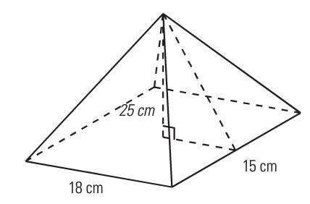

Solution: Use the formula to calculate the volume of the pyramid.

V = 1 ÷ 3 × l × w × h

Since 1 L = 1000 cm³, divide the volume by 1000 to get the capacity in litres.

Capacity =
If given the slant height instead of the height of the pyramid, the height can be calculated using Pythagorean Theorem as in previous assignments.
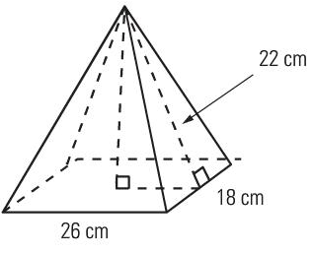

b 22 cm

13 cm

This is the height of the pyramid that can now be used to calculate the volume.
The volume of a sphere is calculated using a formula as well. It is:

V = $\frac{4}{3}$ πr³

Another way of writing this formula that is a little easier to cork with when calculating the volume is:
V = 4 ÷ 3 × π × r³
When using these formulas, do all the calculating at one time without rounding between steps.

Example 2: A tennis ball has a radius of 4 cm. What is the volume and capacity of the tennis ball?

Solution: Use the formula for volume to calculate the volume. Then use the conversion to calculate the capacity.

V = 4 ÷ 3 × π × r³

1000 cm³ = 1 L or 1000 mL
Capacity:

ASSIGNMENT 13 – VOLUME AND CAPACITY OF PYRAMIDS AND SPHERES

1) Calculate the volume of the following pyramids.
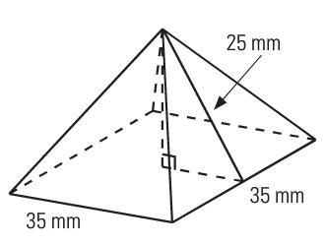
a)

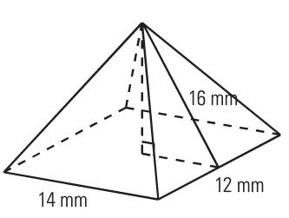
b)

2) Calculate the volume of the pyramid and the prism below. What is the difference in their volumes?
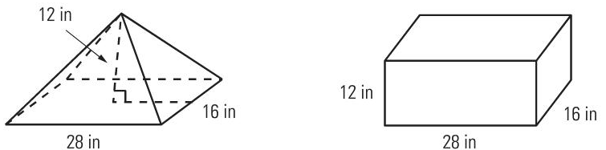

3) Find the volume and capacity of the Omnimax Theatre at Science World which is almost a sphere with a radius of 25 m. (Hint: 1m³ = 1000 L)

4) What is the capacity, in gal (US), of a water tower shaped like a sphere with a diameter of 28.4 feet? Remember, 1 ft³ = 7.48 gal (US).

5) Tennis balls are usually sold in containers shaped like cylinders. One such containers holds 3 tennis balls each with a radius of 3.5 cm. What is the volume of one tennis ball, and what is the volume of the container?

Assignment: Problem Solving with Volume.
This page summarizes the formulas for the volume used in this unit.

Rectangular Prism Triangular Prism
V = A_{base} × h V = A_{base} × h
V = l × w × h V = (b × h ÷ 2) × h

r

r
h

Cylinder Sphere
V = A_{base} × h V = A_{base} × h
V = πr²h V = $\frac{4}{3}$ πr³

s s h
h
r
b
b
Square Based Pyramid Cone
V = $\frac{1}{3}$ A_{base} × h V = $\frac{1}{3}$ A_{base} × h
V = $\frac{1}{3}$ lwh V = $\frac{1}{3}$ πr²h

VOLUME OF COMPOSITE FIGURES
As we did with area and surface area, the volume of composite can be calculated. Unlike surface area though, there is no need to make an allowance for surfaces that sit on top of each other. Simply calculate the volume of each part of the figure and add all these parts together.

Example: What is the volume of the figure shown below?

1.0 m

2.0 m

3.0 m
2.5 m

Solution:

ASSIGNMENT 14 – VOLUME OF COMPOSITE FIGURES
Calculate the volume of the following figures. Show all work. Remember to include units for the final answer. Volume is always in cubic units (cm³, m³, in³, etc.)
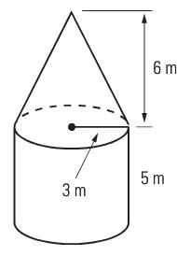
1)

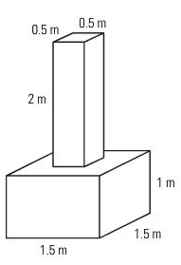
2)

3)
18 cm (diameter)

15 cm

4) A jeweler is making a string of pearls. Each pearl is 0.8 cm in diameter. A hole with a 0.9 mm radius is drilled through each pearl. What is the volume of one pearl on the necklace, to the nearest cubic millimetre (mm³)?

5) A plumber’s plastic pipe is 4 m long, has an inside diameter of 4.0 cm and an outside diameter of 5.0 cm. What is the volume of the plastic in the pipe?

6) A storage container has the shape of a cylinder. At the base of the cylinder is a cone that allows the contents to flow out as show below. What is the volume that the storage container can hold, including the cone? Answer to the closest mm³.

18 mm

15.7 mm

19.3 mm

Assignment: Compound Solids Sheet
Quiz next class
Test:______________________________

