AWM 11 – UNIT 6 – SCALE REPRESENTATIONS
REVIEW – PROPORTIONS
In a previous unit, you learned about ratios and proportions. In this unit you will use proportional reasoning to calculate the size in different situations. So it is important to review these concepts.

A ratio is a comparison between two numbers in the same units – that last part is extremely important in this unit. An example of a ratio is the number of hours I worked this week compared to the number of hours you worked this week. It could be written 18:15.
A rate is a comparison between two numbers with different units. And example is comparing the distance I rode on my bike compared to the time it took me to ride it, and could be written as 15 km / h (15 kilometres per hour).

An equation showing equivalent ratios or rates is called a proportion. To solve proportions, use the process Cross Multiply and Divide. Refer to that handout if you need to review the concept.

ASSIGNMENT 1 – SOLVING PROPORTIONS
Find the missing term by using cross multiply and divide. If necessary, round answers to one decimal place. SHOW YOUR WORK.

1. $\frac{x}{13}$ = $\frac{7}{91}$
2. $\frac{90}{198}$ = $\frac{5}{x}$
3. $\frac{12}{49}$ = $\frac{x}{73}$
4. $\frac{12}{x}$ = $\frac{5}{6}$
5. $\frac{x}{85}$ = $\frac{76}{39}$
6. $\frac{34}{289}$ = $\frac{2}{x}$
7) The ratio of Peter’s age to Dorothy’s age is 2:7. If Peter is 10 years old, how old is Dorothy? Show your work.

SCALE DRAWINGS AND MODELS
A scale drawing represents objects that are either too large or too small to be drawn to their actual size. In a scale drawing, all parts are in the same proportion of their true size. Examples of scale drawings are blueprints, maps, drawings from microscope views, and floor plans.

A scale statement is a ratio of the length of the drawing or model to the length of the actual object. The scale statement can be represented in these three ways, just like the ratios above:
in words like “Three centimetres represents fifty centimetres.”
as a fraction $\frac{3}{50}$ using notation 3:50
A model airplane kit is marked on the box with a scale statement of 1:350, this compares the size of the model to the size of the actual or original object. If the scale statement is written as a fraction where one of the numbers is 1 like this, $\frac{1}{350}$, this is the scale factor. The scale factor is the number used to calculate the dimensions of the actual figure when the dimensions of the model are known, and vice versa.

To write scale statements, set up a fraction ratio including the symbols “m” and “a” for the English words “model” and “actual”, and fill the spaces in appropriately.

Example 1: Write a scale statement for the objects below. Calculate the scale factors.

Solution: Set up the ratio using words and known information.

a)
model actual scale statement = model:actual

scale statement = __________
This is an enlargement: the actual is
larger than the model.
5 cm

15 cm
known
words information
() =

The words set up the ratio – they tell us where to put the numbers. Now reduce the fraction to lowest terms.

scale factor = $\frac{model}{actual}$ scale factor = _______The scale factor is ____or just___ .
b) model actual

scale statement = model:actual
scale statement = ________
This is a reduction: the actual is
smaller than the model.
5 cm
10 cm
known
words information
= or =

The words set up the ratio – they tell us where to put the numbers.

scale factor = $\frac{model}{actual}$ scale factor =
Remember that the scale factor is always 1:x or $\frac{1}{x}$ , to reduce this scale factor, use a proportion and solve for x
scale factor = Scale factor is ______ or _____ (no decimals).

c) A dining room table 1.25 m long but on my blueprint it is 5 cm long.

The dimensions MUST be in the same units in order to compare in a ratio.

scale statement = model:actual
scale statement =
This is an enlargement.

known
words information
or

The words set up the ratio – they tell us where to put the numbers.

scale factor = $\frac{model}{actual}$ scale factor = The scale factor is

Scale statements and scale factors cannot have decimal numbers or fractions as part of the numerator or denominator in the final answer. If this occurs, you must multiply or divide to eliminate them.
Example 2: An architect drew a plan for a house where ¼ inch represents 1 foot.
a) Write this as a scale statement
b) Write this as a scale factor in the form $\frac{1}{x}$
c) If a room has a length of 5 ¼ inches on the plan, how big is it actually?

Solution: a) To write the scale statement, both parts need to be in the same units, and cannot include fractions. Convert 1 foot to inches; then eliminate the fraction.

1 foot = 12 inches
scale statement = model:actual = plan : actual house
scale statement =

To eliminate the fraction, multiply both sides by the denominator, in this case that is 4. Then reduce the left side of the ratio.

scale statement =

scale statement =
b) Written as a scale factor in the form $\frac{1}{x}$ the scale factor is .

c) Change the length of the room to a decimal number. Now use a proportion including the scale factor and the known information to solve for the length of the room. Cross multiply and divide to get the answer.

scale known
words factor information
Length of room or

ASSIGNMENT 2 – WORKING WITH SCALE DIAGRAMS
1) Write a scale statement and calculate the scale factor for the figure below.

20 cm 80 cm

model
actual

2) A volleyball court measures 8.5 m long. A drawing of the court shows that the length is 4.25 cm. Write a scale statement and calculate a scale factor for the court.

3) The distance between Calgary and Vancouver is approximately 675 km in a straight line. The distance on a map is 2.25 cm. Write a scale statement for this situation. What is the scale factor used to make this map?

4) You take a picture of a boy is standing beside a giant redwood tree. In the picture, the boy measures 2.3 cm and the tree measures 12.6 cm. If you know that the boy is really 1.15 m tall, how tall actually is the tree?

5) A baby killer whale that is 4.1 m long is shown on the internet with this picture.
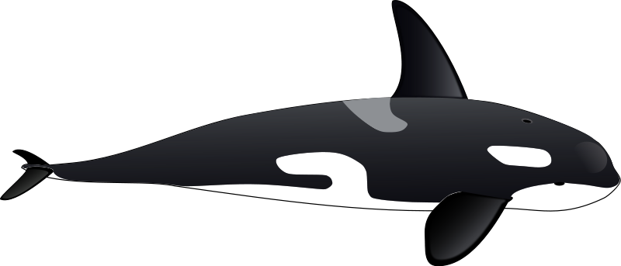

a) Measure the length of the killer whale (the line, in mm) and write a scale statement for the picture. Hint: 1 m = 1000 mm.

b) What is the scale factor of this diagram? Express your answer as a fraction.

c) If a boat is drawn at the same scale, and the drawing is 17.8 cm long, what is the actual length of the boat? Express your answer in m, rounded to the nearest metre.

d) How long would a dolphin be in the picture if it is actually 2.5 m long? Express your answer in cm, rounded to 1 decimal place.

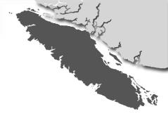
6) The coastline of Vancouver Island is approximately 3440 km long. If a map of Vancouver Island is drawn with a scale of 3 cm : 120 km, how long would the coastline be on the map?

7) For 34 years, the CN Tower in Toronto was the tallest free-standing structure in the world. It measures approximately 455 metres tall with an antenna that extends another 95 meters. A souvenir model of the tower without the antenna is 9.1 cm tall.

a) What is the scale factor used to make the model?

b) How long would the antenna be on this model at this scale factor? Express your answer in cm, rounded to 1 decimal place.

8) A flag pole is 22.5 m tall. If the scale factor is 1:500, what is the height is the flag pole in a diagram? Express your answer in cm, rounded to 1 decimal place.

9) A micro-photograph of a human hair shows the hair magnified 150 times. If the hair is 2 cm wide in the photograph, what is the actual width of the hair? Express your answer in mm, rounded to 2 decimal places.

10) The new Surrey Centre has several tall buildings. On a model of the area, one building was 16.6 cm tall and another was 15.0 cm tall. How tall are these two buildings if the scale factor used was 1 cm:10 m? Express your answer in m, rounded to the nearest metre.

DIFFERENT VIEWS OF OBJECTS
When you are looking at a floor plan of a house of room, you are looking at a plan view, or bird’s eye view. You can also create views that show the front or side or back of a building or other object. A view is a two-dimensional, or flat, representation showing one face of an object. Views are also known as elevations. Drawings of different views can help imagine what the real object looks like.

Consider the following pictures. The top view is the side of a car, while the bottom two views show the front on the left and the rear on the right. Finally, the last diagram is the top or bird’s eye view of the car.

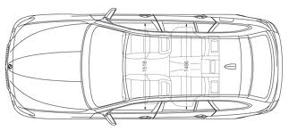

Notice that there are things that can be seen in one view that are not visible in another view. For example, you cannot see the tires in the top view, but you can see the whole roof. All these views are necessary to understand what the whole object really looks like.

In this section, you will be drawing the different views of simple objects, but nothing as complicated as a car!

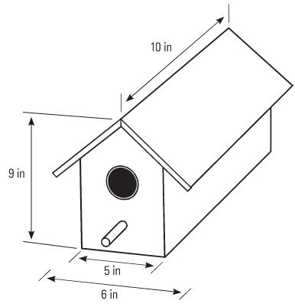
Example: Given the birdhouse below, draw the view of each face and label the dimensions.

Solution: It is not necessary to draw the sides to scale, nor must they be exactly the right length. This is a view that is a representation of the real object.

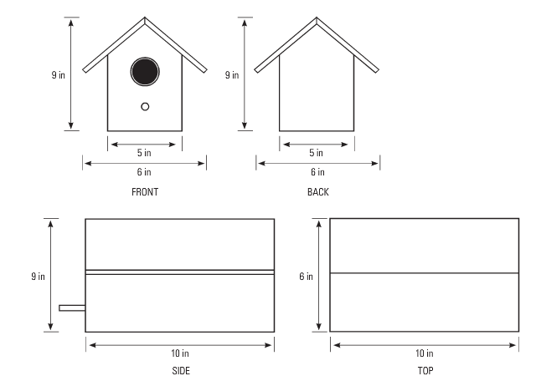

Example 2) On the grid paper, draw the front and side views of the sets of blocks. If you have difficulty, ask your teacher for some blocks to build a model to see in 3-D.

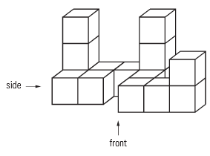
a)

Front Side

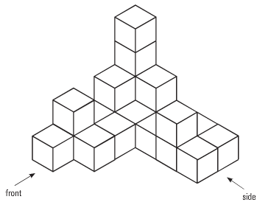
b)

Front Side

Example 3) Sketch the front and side views of this object. Label the dimensions.

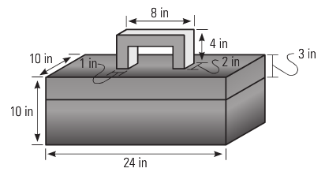

Assignment Pg. 246 #1-4 & Pg. 241 #1-6

COMPONENT PARTS DIAGRAMS
While different views show what the sides of an object look like, a component parts diagram shows all the parts needed to assemble an object. Furniture from IKEA comes with a sheet of assembly instructions with a composite parts diagram. This is a scale diagram showing each part of the object.

Example: A toy box is in the shape of a rectangular prism. The box is 150 cm long, 90 cm deep, and 90 cm high as shown below. There is no lid.

90 cm

90 cm

150 cm

Draw the component parts using a scale of 1:30.

Solution:

1) Draw the component parts of the bookcase. Label the dimensions. Drawing does not need to be to scale.

25 cm

120 cm

55 cm

2) Draw the component parts of this table. Label the dimensions. Drawing does not need to be to scale.

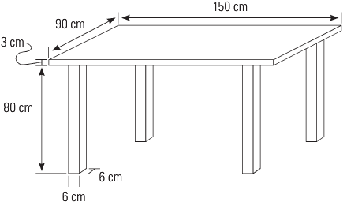

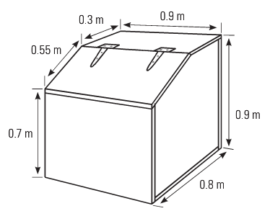
3) Draw the component parts of this feed bin for horses. There are 6 different parts. Label the parts with the dimensions given. Ignore the thickness of the wood.

4) Draw the component parts of this cat scratching platform. There are 5 different parts. Label the parts with the dimensions given. Ignore the thickness of the wood.

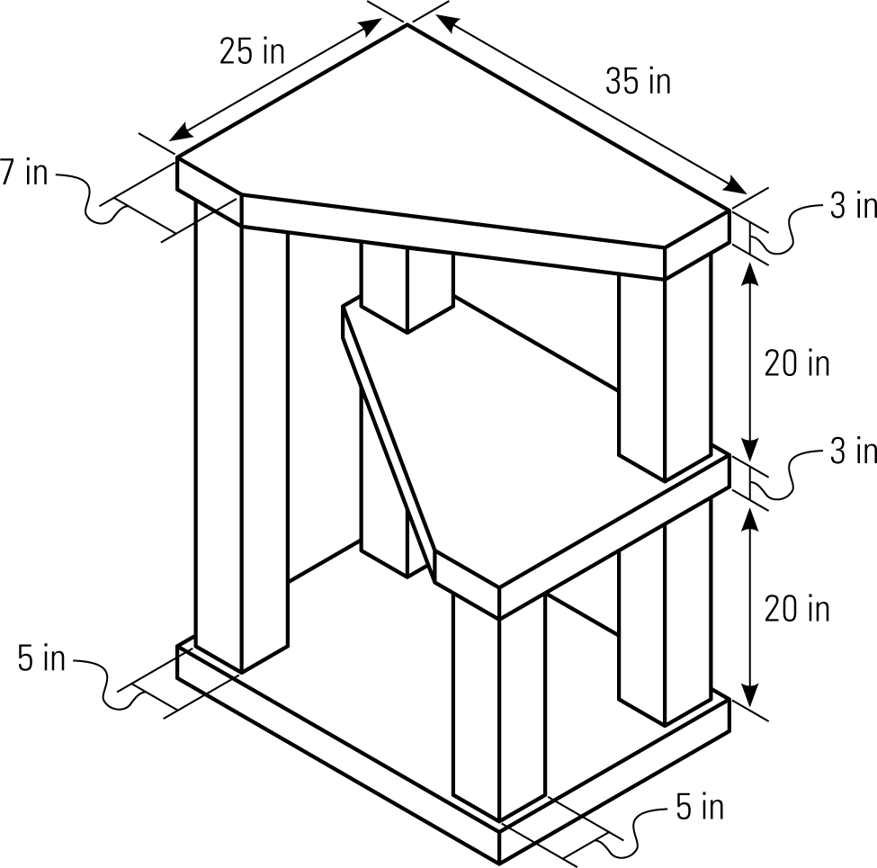

Assignment: Pg. 252 #1-5, 7; Quiz next class
EXPLODED DIAGRAMS
An exploded diagram shows the relationship between the component parts of an object. It is a 3-D representation of how the components connect or fit together. The components are show separated but in their relative positions, and often dotted lines show where the pieces fit together. You might see such a diagram in the instructions for the furniture that you assemble from IKEA or other stores. Or you might see this kind of diagram with a model or toy that needs assembling. Even automotive parts and food can have exploded diagrams associated with them.
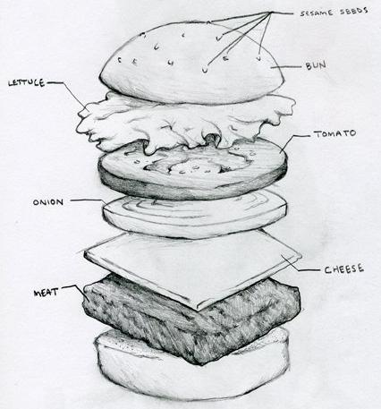

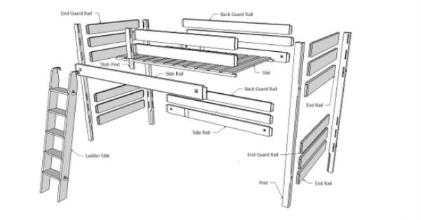

Bunk Bed Cheeseburger

Example: Sketch an exploded diagram of the bookcase below.

Solution: The parts are the back, top, bottom, sides, and shelf. Start by drawing the back and then the parts separately so that they fit together. Draw the dashed lines to show how the parts connect.

ASSIGNMENT 5 – DRAWING EXPLODED DIAGRAMS
1) Sketch an exploded view of this box.

2) Sketch an exploded view of this planter.

3) From this exploded view, sketch what the bookcase would look like.

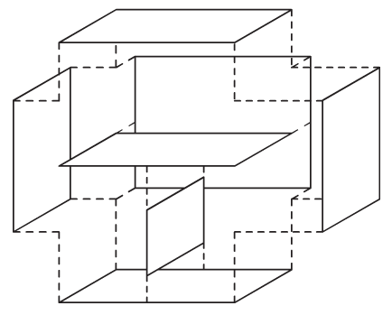

ISOMETRIC DRAWINGS
An isometric drawing is a way of representing a three-dimensional object on a two-dimensional plane. Isometric drawings are done on special dot paper where lines that are drawn to represent width and height are shown at an angle of 30⁰ from the horizontal. Vertical lines are always vertical lines. Isometric drawings are also drawn to scale and lines that are parallel in real life are parallel in the drawing.

This is a section of isometric dot paper. When drawing objects
on this kind of paper, it helpful to orient drawings as shown.
front right
side
Example: Use isometric dot paper to draw a cube with sides that are each 3 units long.

Solution: To draw the cube shown above, draw the front face so that the height is vertical and the width is diagonal. Follow these steps.

- Start with the bottom right corner in the middle of the dot paper.
- Draw the vertical line segment going up 3 squares that represents the edge on the right.
- Draw lines up to the left and up to the right from the bottom point.
- Draw vertical lines up from these two endpoints.
- Join the tops of the three vertical lines to form parallel lines to the base lines.
- From the top of the left vertical line, go up
to the right for 3 squares.
- From the top right vertical line, go up to the
left for 3 squares to meet the other line.
- Your cube should now be complete.

Notice that the vertical lines on the original cube are still vertical when the cube is drawn on isometric dot paper, and that parallel sides are still parallel. These two attributes should help you draw objects on isometric dot paper.

Also remember that the scale of drawing always remains constant.
ASSIGNMENT 6 – CREATING ISOMETRIC DRAWINGS
1) Use isometric dot paper to draw a cube with sides that are each 4 units long.

2) Use the isometric dot paper to draw the blocks shown below.

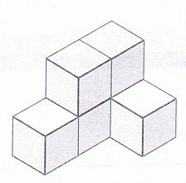

3) Use the isometric dot paper to draw the bookcase shown below. Use the corner indicated by the arrow as your starting point.

4) The following isometric drawing is a room, without the ceiling. The front wall is 18 feet long. Find the lengths of the walls labelled x, y, and z, and the height of the room, h. Remember, isometric drawings are always drawn to scale. Show your calculations.

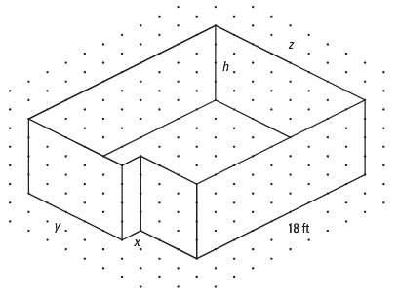

5) Draw an isometric representation of the object below, showing its shape as the front face. Extend the drawing to the length as indicated. Use the scale shown in the top left corner.

1 cm

5 cm

3 cm

6) Draw the shape below as an isometric drawing, at a scale of 1:10. Use the edge indicated by the arrow as your starting point. Remember vertical lines stay vertical!

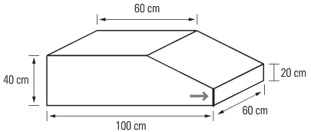

PERSPECTIVE DRAWINGS
While isometric drawings show drawings of 3-D objects in a two-dimensional plane at 30⁰ angles, perspective drawings are drawings that try to represent objects as we actually see them. Perspective drawings use the idea that parallel lines appear to intersect at a point on the horizon line – a horizontal line that is not always visible and is at eye level of the viewer. The point on the horizon line where the parallel lines appear to converge is called the vanishing point. In perspective drawings, the further objects are away from the viewer, the smaller they appear.

To draw a perspective drawing, follow the following example.

Example: Use a perspective drawing to draw a rectangular prism.

Solution:
Step 1: Draw a horizon line and a vanishing point H on the line. Draw a rectangle below and on one side of the vanishing point.

H

Step 2: Draw lines from the corners of the rectangle to the vanishing point.

H

Continued on the next page.
Step 3: Mark a point, called X, anywhere on the line joining the top left corner to the vanishing point and draw a line parallel to the top of the rectangle. Label the end on the line joining the top right corner to the vanishing point Y.

H

X Y

Step 4: Draw a vertical line from point Y to the line joining the bottom right corner to the vanishing point. Label it Z.

H

X Y

Z

Step 5: Now that the rectangular prism is completed, erase the horizon line and the lines joining the prism to the vanishing point.

Example 2) Draw two perspective drawings of the rectangular prism below, using the two vanishing points given. What differences do you notice?

A B

Example3) Draw a perspective drawing of the object shown below.

H

Assignment: Pg. 269#1-5
Quiz next class
Test:__________________

