Math 11 AWP Unit 6 – Scale Representations
Assignment 2 – Component Parts Diagrams
- Draw the component parts of this bookcase. Label the dimensions.
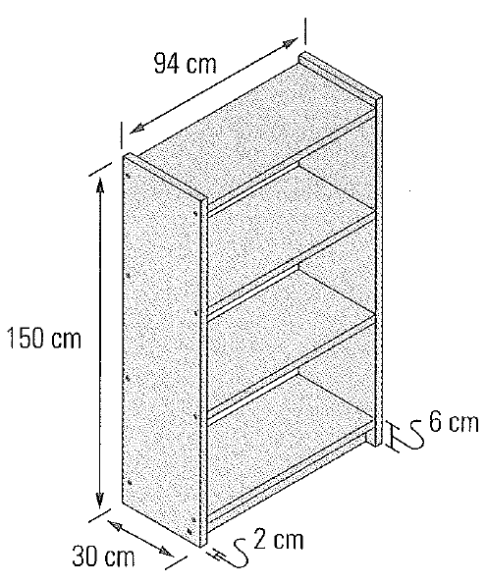

- Richard is making a model village to go with his model train set. He wants to build a set of three row houses like those shown in this scale drawing.
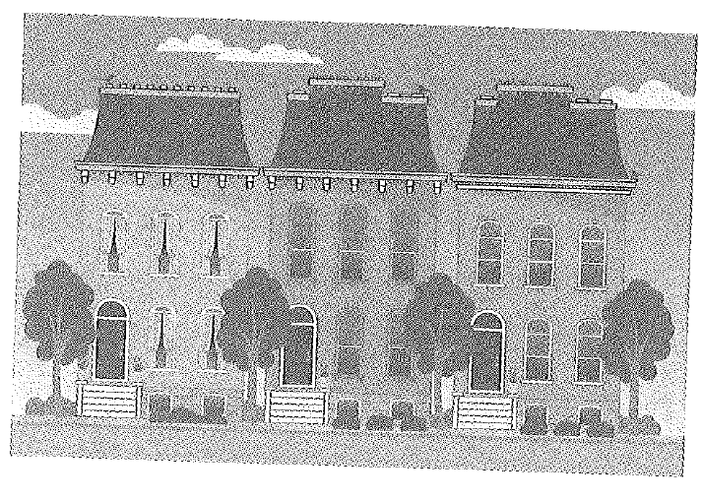
- Measure the width and height of the hosues with a ruler. If each house is actually 14 metres tall and 7 metres wide, what scale was used to draw the diagram?

- The scale of Richard’s train set is 1:100. What will the front dimensions of his model houses be?

- Can you draw top and side views of the houses? Why or why not?

- Jamila built a bird feeder as shown below. She wants to prepare instructions and diagrams so that others can build the same bird feeder.
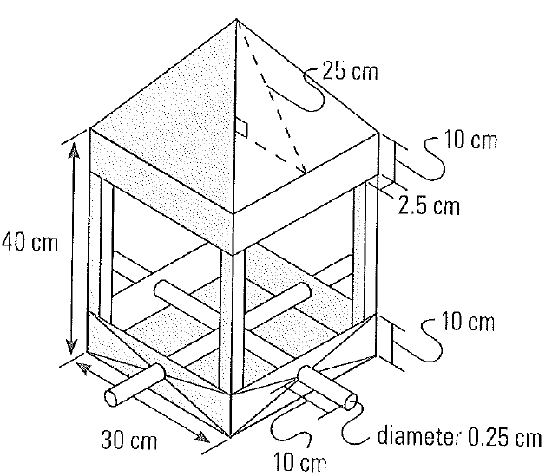
- What views and measurements will she need to provide?

- Draw to scale the view(s) needed to build the bird feeder. Write a scale statement for your diagrams.

- Draw the component parts of this boot rack, and label them with their dimensions. Note that the dowels sink 1 cm into the bottom rail.
