Math 11 AWP Unit 6 – Scale Representations
Assignment 1 – Different Views of Objects
- Sketch the top, front, and side views of this set of blocks.
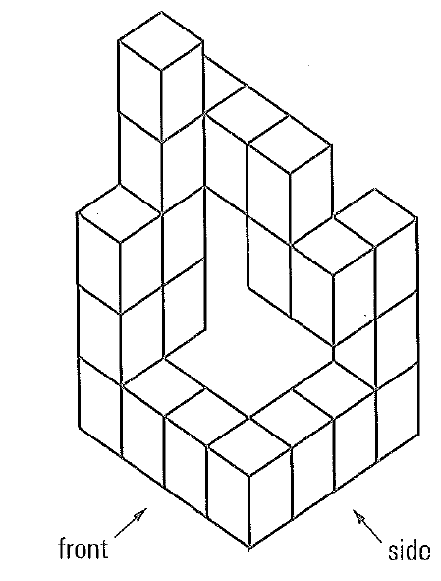

- For the diagram below, do you have enough information to draw the top view? Why or why not?
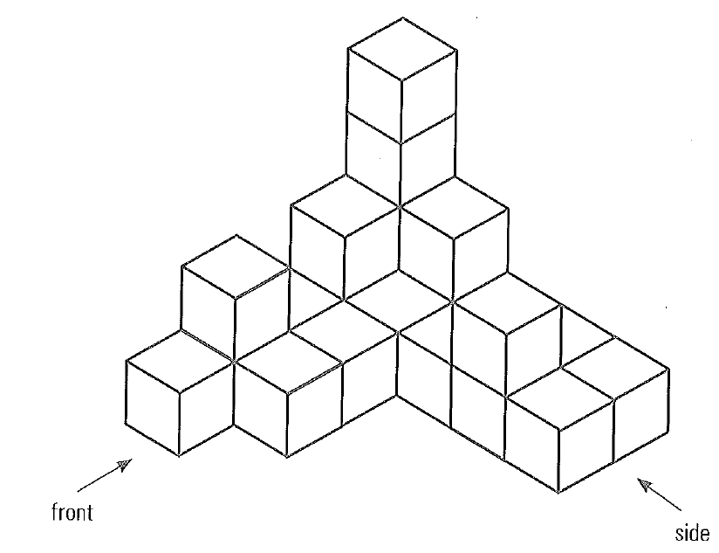

- Sketch the front and side views of this doghouse. Label the dimensions.
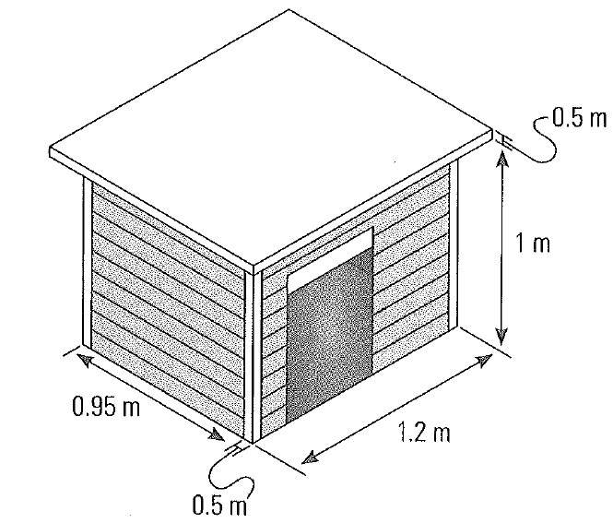

- The following diagram shows the design of a desk organiser. Draw the front and top views of the organizer using the measurements given and a scale of 1:6.
