**AWM 11 – UNIT 5 – SLOPE AND RATES OF CHANGE**

**RATIOS AND PROPORTIONS**

A **ratio** is a comparison between two numbers measured in the same units.

A ratio can be expressed in three ways as shown below:

as a fraction 

in words by using the word “**to**” **9 to 16**

a notation using colon **: 9 : 16**

Ratios, like fractions, can be simplified. For example, the ratio **150 : 15** can also be expressed



which can be simplified 150 ÷ 15 = 10

15 ÷ 15 = 1

Notice that the numerator of the fraction is larger than the denominator. This can be common with ratios.

If two ratios are equivalent (equal), the first (top) term of each ratio compares to the second (bottom) term in an identical manner. You can represent this equivalence in the two ratios here:

 = 

An equation showing equivalent ratios is called a **proportion**.

**RATIOS AND PROPORTIONS**

1) Write the following ratios in two other ways.

a)  b) 5 to 12 c) 18 : 11

2) Are the following proportions?

a)  =  b)  =  c)  = 

**Cross Multiply and Divide**

When two fractions are equal to each other, any unknown numerator or denominator can be found. The following example shows the process.

Find the missing term by using cross multiply and divide. If necessary, round answers to one decimal place. SHOW YOUR WORK.

1.  = 

2.  = 

3.  = 

4.  = 

**WORKING WITH RATIO**

Ratios can be used in word problems to express the relationship between parts.

1) A conveyor belt has 2 pulleys. One pulley has a diameter of 45 cm and the other has a diameter of 20 cm. What is the ratio of the smaller diameter to the larger diameter?

2) On a bicycle with more than one gear, the ratio between the number of teeth on the front gear and the number of teeth on the back gear determines how easy it is to pedal. If the front gear has 30 teeth and the back gear has 10 teeth, what is the ratio of front teeth to back teeth?

3) What is the ratio of 250 mL of grape juice concentrate to 1 L of water?

(Hint: 1000 mL = 1L)

**WORKING WITH PROPORTION**

When given a ratio and one of the parts, write a **proportion** to solve using cross multiply and divide. Remember, a proportion is an equation showing equivalent ratios. Use a letter or word to represent the parts to put the numbers in the correct location.

1) If a secretary types 55 words in one minute, how long will it take the secretary to type a 2000 word report?

2) The ratio between Siu’s height and Tai’s height is 5:6. If Tai is 145 cm tall, how tall is Siu, to the nearest whole centimetre?

3) A mechanic can rotate the 4 tires on a truck in 15 minutes. How many minutes would it take the mechanic to rotate the tires on 5 trucks? Hint: what are you comparing??

Assignment: pg. 11 #1-3; pg. 12 #4-6

Quiz tomorrow.

**SLOPE**

The **slope** of a line is the *steepness* of that line. It is the numerical value – a number – of how steeply something is slanted. The something could be a roof, a wheelchair ramp, a ski hill, or a road. Other words you may have heard associated with slope are pitch and grade. We will explore those later in the unit.

In mathematical terms, the slope is a ratio that compares the change in a vertical distance (↕) to the change in a horizontal distance ( ↔ ). Slope is the ratio between these two numbers and can be written like this:

slope = $\frac{change in vertical distance}{change in horizontal distance}$

The symbol for change is Greek letter delta which looks like this: Δ . We use it to replace the words “change in” so the formula looks like this:

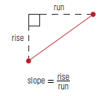 slope = $\frac{ Δ vertical distance}{ Δ horizontal distance}$

The change in the vertical distance is also called the “rise” while the change in horizontal distance is called the run. The variable used for slope is “**m**” (note the lower case). So the formula commonly used in math to describe slope is:

m = $\frac{ rise}{ run}$

When calculating the slope, the answer will have no units because it is a ratio not a measurement.

1) Complete the table below with slope as a fraction and as a decimal (2 decimal places).

|  |  |  |  |
| --- | --- | --- | --- |
| ***Rise*** | ***Run*** | ***Slope*** | |
| *Fraction ( m = $\frac{ rise}{ run}$)* | *Decimal* |
| 15 in | 67 in |  |  |
| 2 cm | 25 cm |  |  |
| 18.5 mm | 5.2 mm |  |  |

2) Calculate the slope of the following. Show your work!

a) A ramp has a rise of 5 feet and a run of 25 feet.

b) A children’s slide has a rise of 2.5 m and a run of 4.2 m.

c) A hill rises 12 metres over a horizontal distance of 8 metres.

d) An eavestrough has a rise of 1 inch and a run of 60 inches.

e) The roof on my house covers 24 feet horizontally and is 6 feet high.

**FINDING RISE OR RUN**

If you are given the slope, and another value for either the rise or the run, you can calculate the missing value using a proportion and the process of Cross Multiply and Divide.

1) The slope of a street is $\frac{ 27}{ 50}$. If the run is 28 metres, what is the rise?

2) If the rise of a hill covers a vertical distance of 45 metres, and the slope of the hill is $\frac{ 4}{ 25}$, what is the run?

3) The slope of a staircase is 0.65. If the horizontal distance covered by the staircase is 200 m, what is its rise?

4) A waterslide has a vertical height of 9 metres. If the slope of the slide is 0.93, what horizontal distance does it cover?

5) A ladder needs a slope of 1 foot of run for every 4 feet of rise. If the ladder needs to reach 36 feet above the ground (vertical distance), what should the run for that ladder be?

6) The slope of a ditch needs to be 2 cm deep for every 1250 cm across. How much will the rise be if the run is 25 000 cm (25 m)?

Assignment: pg. 17 #1-9

**SPECIAL SLOPES**

There are several words associated with slope that have special meanings. These include *grade* and *pitch*. While they all are examples of slopes, they apply in different situations.

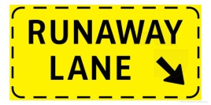**Grade** refers to the slope of a hill. When driving in British Columbia we have all seen signs that refer to the grade of a road on a hill. Grade is simply slope expressed as a percent. This is important information for truck drivers who are approaching a steep hill. Often, there are roadside pull outs before steep hills for truck drivers to check their brakes so they can safely negotiate the hill. As well there might be runaway lanes on steep grades that help trucks stop in case their brakes fail.

To calculate the grade of a hill on a road, find the slope and then multiply it by 100. This is referred to as the percent grade.

percent grade = $\frac{ rise}{ run}$ × 100

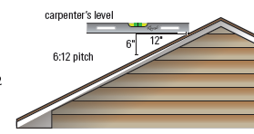The slope of a roof is often referred to as the **pitch** of the roof. The pitch of a roof can be expressed as the number of inches of rise compared to the number of inches of run. So a pitch might be written as 6:12, like the roof in the picture.

This is not the only ratio used to express pitch. Remember that the pitch is just another way to describe the slope of the roof. It is always defined as rise over run.

It is worthwhile noting that while Canada is a metric country, and has been since the 1980s, there are many things, especially in the construction industry, that are still measured and thought of in the imperial units of inches and feet. Pitch is usually measured in this way.

Pitch can also be used to refer to other climbing things such as a staircase, whether it is the whole flight of stairs or an individual step.

1) Nathan is building a ramp for his dirt bike. If the rise is 8m and the run is 22 m, what is the percent grade of his ramp to the closet whole number?

2) In 1885, the CPR built a railway line from Field, BC through the Kicking Horse Pass. At the time, it was one of the steepest railway tracks in the world. The line dropped 300 m over 6 km. What was the percent grade of the hill?

3) Samuel uses a helicopter to harvest the logs from slopes that have a grade of more than 10%. If the hill he is looking at has a rise of 19 m and a run of 157 m, will he have to use a helicopter?

4) If the slope of a ramp is 15.5% and the run is 18 m, what is the rise?

5) The pitch of a garden shed is 3:5. If the shed is 8 m

wide as illustrated, how tall is the roof (rise)?

8 m

6) The roof of one house has a pitch of 6.7:18 while the second house has a pitch of 4.5:12. Which roof is steeper?

Assignment: pg. 28# 6-8 + pg. 31 #9-11

**ANGLE OF ELEVATION, TANGENT AND SLOPE**

There is a relationship between the angle of elevation, tangent ratio and slope. Before we discuss this relationship, a review of these concepts is necessary.

Remember that **Pythagorean Theorem** states that in any right triangle, the sum of the squares of the lengths of the legs is equal to the square of the length of the hypotenuse. So in ΔABC with the right angle at C, the following relationship is true:

c2 = a2 + b2

where a and b are the other 2 legs of the triangle.

c

b

a

When we look at trigonometry, we consider the sides in their relationship to the angle of interest, θ. The sides are referred to as hypotenuse, opposite and adjacent.

h = hypotenuse

h o o = opposite

a = adjacent

θ

a

The **tangent of angle θ** means the ratio of the opposite side to the adjacent side. It is abbreviated as **tan θ** but read as tangent θ. It is written like this:

tan θ =  or tan θ = $\frac{o}{a}$

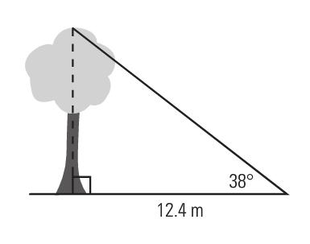Finally, the **angle of elevation** is the angle between the horizontal and your line of sight. In the diagram to the right, the angle of elevation is the angle marked as 380 – between the ground (horizontal) and the top of the tree (line of site).

So how does this all fit together? First let’s look at how the Pythagorean Theorem and the tangent ratio work together.

In the triangle below, the Pythagorean Theorem states that c2 = a2 + b2

c

b

θ

a

But if we look at trigonometric ratios for the same triangle,

c = h b = o a = a

So tan θ = $\frac{o}{a}$ and using the side letter names, tan θ = $\frac{b}{a}$

From this relationship, the length of hypotenuse and the size of ∠θ can be found.

1) Complete the table below. Round angles to the closest whole number, and rise and run to the nearest whole number.

|  |  |  |  |  |
| --- | --- | --- | --- | --- |
| **Rise** | **Run** | **Slope as Fraction** | **Slope as Decimal** | **Angle of elevation** |
| 28 | 48.5 | $$\frac{28}{48.5}$$ | 0.5773 | tan-1 (0.5773) = 300 |
|  | 13 |  | 2.36 | tan-1 (2.36) = _______ |
| 5 | 8 |  |  |  |
| 49 |  |  |  | tan-1 (0.488) = _______ |

2) A skateboard ramp has a rise of 3 feet and a run of 4 feet.

a) Calculate the **length** of the ramp. ramp

b) What is the angle of elevation of the ramp?

3) Find the slope of the hypotenuse in fraction form, and use it to find the angle of elevation.

50 ft

30 ft

4) Calculate the slope of the hypotenuse and the angle of elevation for the triangle below.

25 m

35 m

5) Andrew is installing a pipe to drain water for a landscaper. The pipe must have a drop (rise)

of 2.5 cm for a run of 3.5 m (350 cm). (The picture is not drawn to scale.)

350 cm

a) What is the slope of the pipe? θ

2.5 cm

pipe

b) How much drop will Andrew need if the run is 12 m (or 1200 cm)?

c) What is the angle of depression, θ, of the pipe?

Assignment: pg 32 #1-8 Quiz 2 next class.

**THE CARTESIAN COORDINATE SYSTEM**

Slope can also be calculated from the values of points on a line using a formula. How is this done? First, you must know the coordinates of 2 points on that line, and the use the formula. Before investigating the formula, review of the Cartesian coordinate system is necessary.

The **Cartesian coordinate system** is a grid that identifies the location of a point by a pair of numbers which are a specific distance from a fixed point called the **origin** (For our purposes, we are only using 2-dimensions but 3-dimensions can be used!).

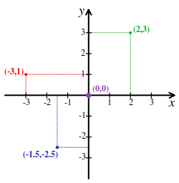The grid is shown, with several points marked. Notice that the points are located by 2 lines, one horizontal and the other vertical. When marking a point on a grid system, the first number indicates how far right or left of the origin (0,0) the point is (x-coordinate), and the second number indicates how far up or down the point is (y-coordinate). With these two values, any point can be plotted.

Each reference line is called an axis, and they cross at the origin. For each axis, one half is positive (right and up) and the other half is negative (left or down). This is like two number lines – one horizontal and one vertical. You can see this reflected in the points plotted to the right.

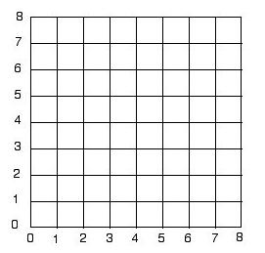

For the purposes of this course, we will only deal with the **FIRST** quadrant of the grid, where both numbers have a positive value.

Identifying the locations of points on this grid is called naming the points. As mentioned before, we put the coordinates in parentheses, with the x-coordinate first and the y-coordinate second.

Using the grid below, answer the following questions.



1) Name the letter of the point located at each of the following coordinate pairs.

_____ ( 10, 0 ) _____ ( 5, 8 )

_____ ( 8, 7 ) _____ ( 2, 12 )

_____ ( 7, 7 ) _____ ( 0, 10 )

2) Write the ordered pair for each given point.

N _________ R _________

O _________ G _________

J _________ F _________

3) Plot the following points on the coordinate grid.

S ( 3, 6 ) T ( 8, 2 ) U ( 10, 8 )

W ( 5, 5 ) X ( 4, 2 ) Y ( 2, 7 )

**REVIEW – SIMPLIFYING FRACTIONS**

To simplify a fraction, divide the numerator and denominator by a common factor. Easy common factors to start with are 2 for even numbers, 3, or 5. If the resulting fraction cannot be divided by any other common factor, then it is in **lowest terms**. If it can be divided again by another common factor, keep repeating the process until it is in lowest terms.

1) Simplify these fractions to their lowest terms.

a) $\frac{4}{16}$ b) $\frac{3}{12}$ c) $\frac{25}{75}$

d) $\frac{15}{21}$ e) $\frac{8}{18}$ f) $\frac{45}{100}$

**CALCULATION OF SLOPE OF A LINE**

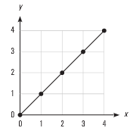When calculating slope, you will always be working with a straight line. These lines will have identifiable points plotted along them.

To calculate the slope of such a line, two points are needed. You can see from this example that there are 5 usable points. Any 2 can be used – it doesn’t matter which ones. And it doesn’t matter which point you start with. Usually it is a good idea to choose the point with the bigger values.

When you choose the two points, they must be in the form ( x , y ) – that means that you read the x-coordinate first followed by the y-coordinate.

Slopes can be positive or negative. If the line goes up to the right, the slope is positive (graph on the left). If it goes down to the right, the slope is negative (graph on the right). Slope of a line has no units, it is just a numerical value; just a number.

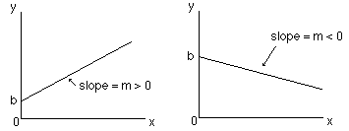

The slope is calculated as the change in the vertical distance divided by the change in the horizontal distance. The letter “*m*” is used to represent slope. The formula used to calculate slope is:

*m* =

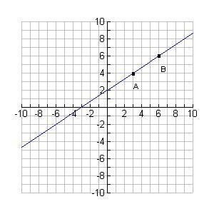

1) Calculate the slope for each of the following pairs of points. State whether the line would slope up or down to the right.

a) A (2, 2) B (6, 3) b) C (5, 1) D (3, 2)

c) E (12, 8) F (2, 10) d) G (1, 4) H (3, 1)

2) For each of the following graphs, state whether the slope is positive or negative. Then calculate the slope using

a) b)



c) d)

3) Plot a line on the graph that goes through (4, 2) and has a slope of 3. Write the coordinates of 2 other points that are on that line.

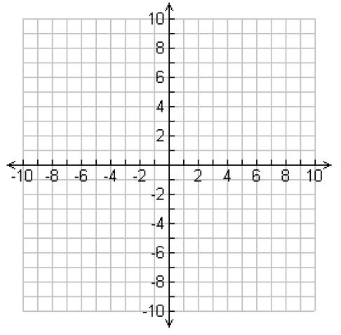

Assignment: Slope worksheet

**SPECIAL SLOPES**

There are two special lines that give unique slopes. That means that lines like these always have the same slopes. These lines are horizontal and vertical lines.

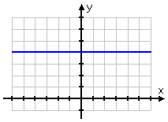

A horizontal line is always parallel to the x-axis. It runs across the page. Regardless of which points you choose on a horizontal line, they will always have the same y-coordinate because the line is the same distance up from the x-axis.

In the example here, every point on this line has a y-coordinate of 4. So some examples of points on the line would be (1, 4), (0, 4), (10, 4), (3, 4), (5, 4), (2, 4), (4, 4) and so on. The list is limitless.

When calculating the slope of this line then, the top of the formula (called the numerator) will always be 4 – 4 = 0. So the slope will be zero. This proves the rule that says the slope of any horizontal line is zero. This makes sense if we remember what slope is: the steepness of the line. A flat line has no steepness!

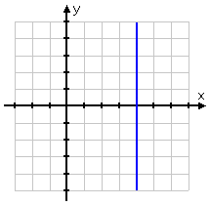

A vertical line on the other hand, is always parallel to the y-axis. It runs up and down. Regardless of which points you choose on a vertical line, they will always have the same x-coordinate because the line is the same distance up from the y-axis.

In the example here, every point on this line has an x-coordinate of 4. So some examples of points on the line would be (4, 1), (4, 0), (4, 10), (4, 3), (4, 5), (4, 2), (4, 4) and so on. The list is limitless.

When calculating the slope of this line then, the bottom of the formula (called the denominator) will always be 4 – 4 = 0. So the slope will be a formula trying to divide by zero. If you try this on your calculator, it will give you a message that says “Error.” In Math, when we have a fraction number has a denominator of zero, we say the fraction is **undefined**. So the slope is undefined. This makes sense if we remember what slope is: the steepness of the line. A vertical line is completely steep – it can’t be made steeper.

1) Which line looks like it has a slope of zero and which looks as if it has an undefined slope?

 Slope: ____________ Slope: ____________

2) Use the slope formula to verify the slope of each line above. Show your work.

3) Is the line joining each pair of points below vertical, horizontal, or neither? Prove your answer by using the slope formula to calculate each slope.

a) (40, 100) and (40, 200) b) (4, 8) and (9, 5)

c) (2.3, 0.1) and (8.3, 0.2) d) (25.4, 6.7) and (28.5, 6.7)

Assignment: worksheet

**Slope: Practice Problems**

Foe each problem, draw two points, draw the line connecting the two points, draw the slope triangle, and fine the rise, the run, and the slope.

1. (-3, 5) and (2,7) 2. (-5, 6) and (-2, 8)





Rise: Rise:

Run: Run:

Slope: Slope:

1. (4, -3) and (2,-1) 4. (-7, 10) and (8, -4)





Rise: Rise:

Run: Run:

Slope: Slope:

1. (-3, 5) and (2,7) 6. (-5, 6) and (-2, 8)



Rise: Rise:

Run: Run:

Slope: Slope:

**Slope and RATE of CHANGE**

Up until this point, we have looked at a graph as having an x-axis and a y-axis, which of course they do. But when looking at a straight line or linear graph as the ones we examining are, we can analyze the graph a little differently.

When you compare the *change* in the y variable to the *change* in the x variable as we have been doing to calculate the slope of the line, it is referred to as a **rate of change**. The rate of change therefore, is the rate at which one variable changes compared to another variable.

One variable is always referred to as the **dependent variable** because its value depends on another variable called the independent variable. The **independent variable** is a variable whose vales may be chosen. It is important to understand that the dependent variable must always be calculated based on the independent variable. It is necessary to be able to determine the relationship between two variables, and to determine which is the dependent and which is the independent variable.

1) Identify the independent and dependent variables in each pair below.

a) number of paperclips in my hand / the mass of those paperclips

b) the distance travelled on my bike / the time I rode my bike

c) the number of boxes of chocolates sold / the profit made

d) the total cost for stamps at the post office / the number of stamps I bought

e) the commission income earned / the amount of sales

As stated earlier, the rate of change is the slope of the line on a graph. When a relationship remains constant, it produces a straight line graph like the ones we have been calculating the slope of. Remember, it doesn’t matter which points you choose on the line to calculate the slope – it remains the same. So any two points will produce the same rise over run.

When asked to write an equation (or formula) of the line, it follows the format:

**dependent variable = slope × independent variable**

1) Use the graph below to answer the following.

a) Identify the independent and dependent variables.

b) Calculate the slope of the line. Remember it’s sloping down to the right so it will be a negative slope.

c) Write an equation to describe the relationship shown.

2) Maurice is a salesman and earns a commission of 15% on all his sales.

a) Identify the independent and dependent variables in this relationship.

b) Complete the Table of Values below to calculate how much commission Maurice makes on the sales given.

|  |  |  |  |  |  |
| --- | --- | --- | --- | --- | --- |
| Sales | $1000 | $2000 | $5000 | $8000 | $9000 |
| Commission earned |  |  |  |  |  |

c) Create a graph to represent this relationship on the grid paper below.



d) Calculate the slope of the line of this relationship.

e) Write an equation to represent this relationship using ***c***for commission and ***s*** for sales.

3) The graph below shows a plane’s altitude as it descended to land. At what rate does the plane descend? (Find the slope of the line!)

4) Daniel and Henrick have weekend jobs. Daniel earns $73.20 in 6 hours while Henrick earns $55.50 in 5 hours.

a) Calculate their earnings for the two times given and for 2 other different lengths of time. Record these values in the Table of Values below.

|  |  |  |  |  |  |
| --- | --- | --- | --- | --- | --- |
| Hours | 1 | 6 | 5 |  |  |
| Daniel’s earnings |  |  |  |  |  |
| Henrick’s earnings |  |  |  |  |  |

c) Who makes more money after an 8-hour shift?

d) What are Daniel and Henrick’s rate of earnings?

5) Which of the following graphs has the steeper slope? Show your calculations.

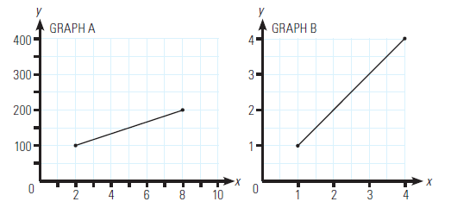

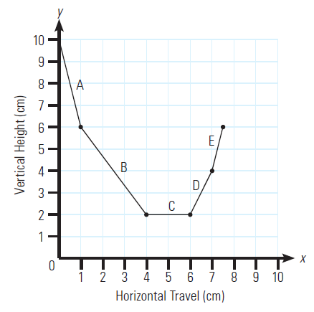

6) Calculate the slope of each segment of the line on the graph to the right.

7) Harry drives a highway truck for a living. On his recent trip, he travelled 350 km in 5 hours.

a) Plot this on the graph paper below.



b) What is Harry’s rate of speed? Hint: find the slope!

c) How far had Harry travelled after 2 hours? Use the graph to **interpolate** this answer. Show your work on the graph.

d) If Harry continues at this speed, how many hours will it take him to drive 630 km? Use the graph to **extrapolate** this answer.

Assignment: Pg. 50 #1-7

Quiz next class

Test:_____________________________