Math 11 AWP Unit 5 – Slope and Rates of Change
Assignment 4 – Angle of elevation, tangent and slope
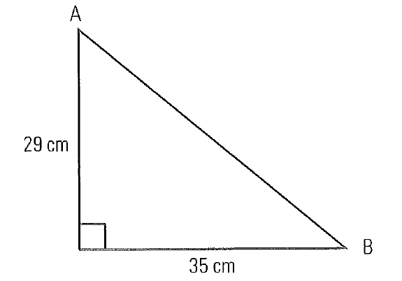
- Calculate the missing angles and the slope of the hypotenuse.
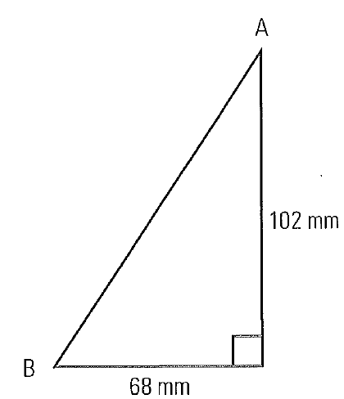
- b.

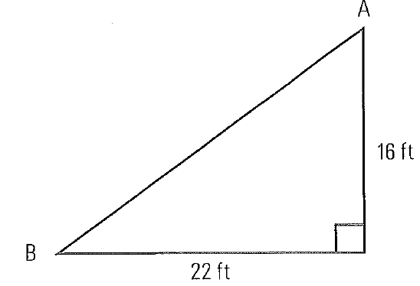
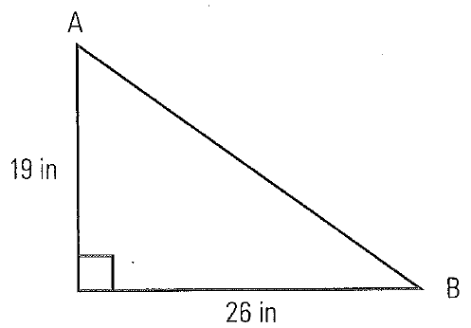
- d.

- Jon is building a wheelchair ramp at his grandmother’s house. The ramp will rise 1.2 m over a run of 7.2 m. Jon will purchase roll roofing to lay on the ramp to create a non-slip surface.
- What length of roll roofing will Jon have to purchase to cover the wheelchair ramp?

- What is the angle of elevation of the ramp?

- Akiko works as a ski instructor. He has read that human-triggered avalanches occur most often on slopes with an angle of elevation between 35° and 45°.
- What are the slopes of these two angles of elevation?

- What are the percent grades?

- Aurena is installing a pipe for drainage.

