**AWM 10 – UNIT 5 – ANGLES AND PARALLEL LINES**

**Vocabulary: Unit 5**

angle

angle bisector

angle referent

acute angle

alternate exterior angles

alternate interior angles

complementary angles

corresponding angles

obtuse angle

parallel lines

perpendicular lines

reflex angle

right angle

straight angle

supplementary angles

transversal

vertically opposite angles

**CLASSIFYING ANGLES**

An **angle** is formed when two rays meet at a point called a **vertex**. For the purposes of this course, angles will always be measured in degrees, and can be measured with a protractor. There are 3600 in a circle, and the angle measure you will be dealing with range from 00 to 3600. Once the angle is formed, it is possible to classify it by how many degrees it is as follows:

**Acute** angle – measure is between 00 and 900

**Right** angle – measure is exactly 900; the two rays are perpendicular to each other

**Obtuse** angle – measure is between 900 and 1800

**Straight** angle – measure is exactly 1800

**Reflex** angle – measure is between 1800 and 3600

***You will need to remember these terms and what they represent***.

Example 1:

Identify the following angles.



Solution:

**ASSIGNMENT 1 – CLASSIFYING ANGLES**

1) Identify the type of angle indicated below.

a) b)

c) d)

e) f)

2) Identify the type of angle indicated.

a) 680 b) 2150 c) 910

d) 320 e) 1800 f) 890

g) 1950 h) 2650 i) 900

**REFERENT ANGLES**

In many jobs, people have to draw angles or estimate their measures. To estimate the size of an angle, you can use referent angles. Referent angles are angles that are easy to visualize. You can use these referents to determine the approximate size of a given angle.

These are the referent angles commonly used:

When looking at the referents, these are the things to keep in mind. A right angle of 900 has the rays perpendicular to each other. It is helpful to make a 900 (or 1800) angle on any angle you are trying to estimate. A 450 angle is about half of a right angle. The 300 angle and the 600 angle are each smaller than and bigger than the 450 angle.

These referents can be combined with each other, or with a straight angle (1800) to estimate larger angles.

Example: Use the referent angles above to estimate the size of these angles. After estimating their size, use a protractor to accurately measure each angle.







Solution:

The symbol used to say “angle” is ∠ . So ∠ P reads as angle P.

**ASSIGNMENT 2 – REFERENT ANGLES**

Use the referent angles to estimate the following angles. DO NOT MEASURE THE ANGLES!



1)

2)

3) What is the approximate angle between the railing of the stairs and the ground as shown below?



**DESCRIBING ANGLES**

Angles are often described in pairs. There are three terms you will need to be familiar with in order to do this; adjacent angles, complementary angles, and supplementary angles. **Adjacent angles** are *angles that share a common vertex and a common ray* as illustrated below.

**Complementary angles** are *two angles that when added together total 900* as shown below.

**Supplementary angles** are *two angles that when added together total 1800* as shown below.

Finding the complement and supplement of an angle can be done by subtraction. However, not all angles will have a complement or supplement depending on their size. If an angle is greater than 900, it will not have a complement, and if an angle is greater than 1800, it will not have a complement or a supplement

Example: Find the complement and supplement for each angle, if they exist.

a) 750 b) 1030 c) 3000 d) 870

Solution: To find the complement, subtract the angle from 900. To find the supplement, subtract the angle from 1800.

**ASSIGNMENT 3 – DESCRIBING ANGLES**

1) Complete the following chart. If an angle does not exist, write “N/A”.

|  |  |  |
| --- | --- | --- |
| *Angle* | *Complement to angle* | *Supplement to angle* |
| 530 |  |  |
|  |  | 1210 |
|  | 280 |  |
|  |  | 670 |
| 2340 |  |  |

2) Determine the size of the *x* in each diagram below. Write the answer in the angle.

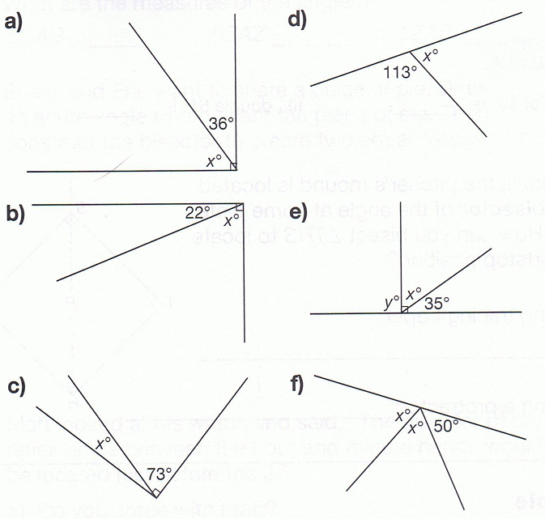

Quiz next class

**TRUE BEARING**

In navigation and map-making, people often measure angles from the vertical, or north. This angle, referred to as **true bearing**, is measured in a clockwise direction from a line pointing at north. Straight north has a bearing of 00.

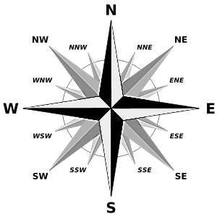

The compass rose is illustrated to the right. It shows many of the common bearings you might have heard of. The main 4 directions with the longest points, north (N), south (S), east (E) and west (W) are called **cardinal directions**. The four directions in between the four cardinal directions are called **ordinal directions**. They are: northeast (NE), southeast (SE), southwest (SW), and northwest (NW). In between each of the cardinal and ordinal directions, are 8 more minor directions. These are: north northeast (NNE), east northeast (ENE), east southeast (ESE), south southeast (SSE), south southwest (SSW), west southeast (WSW), west northwest (WNW), and north northwest (NNW).

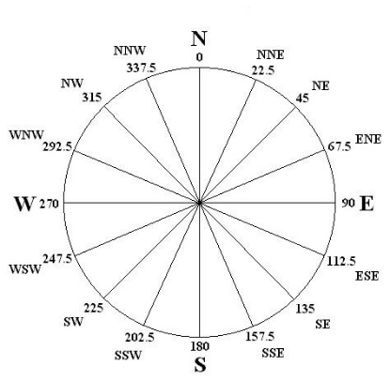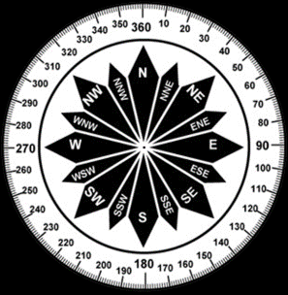

On these compass roses, you can see the degrees associated with each direction. East has a bearing of 900, south has a bearing of 1800, and west has a bearing of 2700. Each of the ordinal directions is halfway between their cardinal directions. So northeast (NE) has a bearing of 450 (half of 900) and SE has a bearing of 900 + 450 = 1350, and so on.

Each of the minor divisions is separated from its closest neighbour by half of the 450 it splits, which is a measure of 22.50. West northwest, for example, is 22.50 past due west. The bearing of west northwest then is 2700 + 22.50 = 292.50. Through addition and subtraction, all other bearings can be found.

Example: What is the true bearing of a boat heading southwest?

Solution:



**ASSIGNMENT 4 – TRUE BEARING**

1) A car is travelling 250 south of straight east. What is its true bearing? Show any calculations.

2) What is the true bearing of a boat travelling north-northwest? Show any calculations.

3) A boat is travelling WSW. Show 2 ways to calculate its true bearing.

**Drawing a RIGHT Angle Using a Ruler and Compass**

You have used a protractor to measure angles. You can also use the protractor to draw a 900 angle. Another way to draw a 900 angle is with a ruler and compass. This creates a perpendicular line to the original line given.

To create a right angle, follow these steps.

1) Draw a line segment and put a mark on it where you want the 900 angle to go. (The mark does not need to be exactly in the middle!)

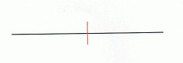

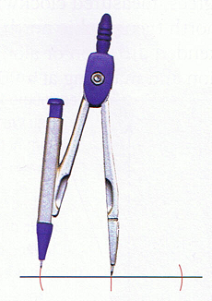

2) Put the compass tip on the mark you made. Open the compass slightly and make two small marks (called arcs) on each side of the first mark along your line. Make sure you do not adjust the compass so the marks are the same distance on either side if the first mark.

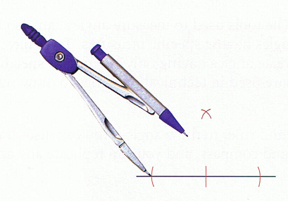

3) Open up the compass a bit more and then place the tip on one of the new marks you just made. Make a small mark and then do the same thing after placing the compass tip on the other new mark. Make sure these two new arcs cross each other.

4) Draw a line segment that goes through the point where the arcs crossed and the first mark you made. The new line and the first line you drew are perpendicular to each other, and therefore form a 900 or right angle.

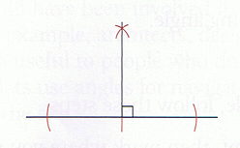

**ASSIGNMENT 5 – Drawing a RIGHT Angle Using a Ruler and Compass**

1) Draw a perpendicular line to the line on the page, using only a compass and a ruler. Ask your teacher for a compass if you don’t have one. Do not erase any of your construction marks from the compass.

**COPYING aN Angle Using a Compass AND Ruler**

You can also copy any angle with a compass and ruler. This is also referred to as replicating the angle, and is useful when you want to copy an angle from one figure to another without measuring.

To copy an angle, follow these steps.

1) Start with the angle you want to copy on your page. Using your compass, put the tip of the compass on the vertex of the angle and draw an arc across both of the legs of the original angle.

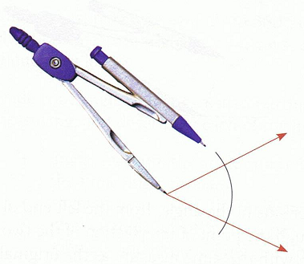

2) Using a ruler, draw one leg of your new angle somewhere else on the page. Without adjusting the compass, put the tip of the compass on one end of your new line and draw an arc of the same length as the one you drew on the original angle.

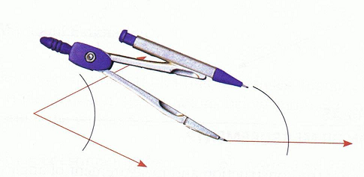

3) Take the compass back to the original angle, and set it so that its tip and pencil end touch points where the original arc intersects the sides of the angle. This measures the size of the angle using the compass.

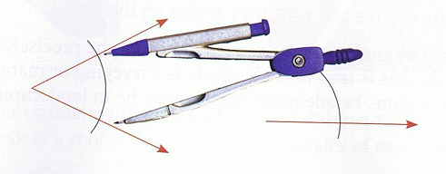

4) On the new angle, place the compass tip on the point where the side and the new arc meet. Draw a short arc through the big arc you drew before.

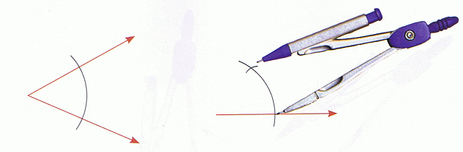

5) Use the ruler to draw the other side of the angle, from the vertex through the point where the two arcs intersect. The result is a new angle with the same measurement as the original angle.

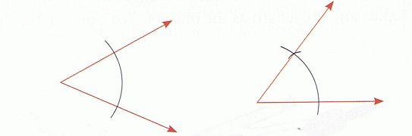

**ASSIGNMENT 6 – COPYING aN Angle Using a Compass AND Ruler**

1) Copy the angle to another location on this page using only a compass and ruler. Ask your teacher for a compass if you don’t have one. Do not erase any of your construction marks from the compass.

**BISECTING AN ANGLE**

To bisect something means to cut it into two equal parts. An angle can be bisected by another ray, splitting the angle into two smaller but equal angles.

There are 2 ways to bisect angles and straight lines:

1) Using a protractor, measure the angle. Divide that measure in two and measure the resulting angle within the original angle.



2) To bisect an angle without a protractor, use a compass and a ruler. Complete the following steps:

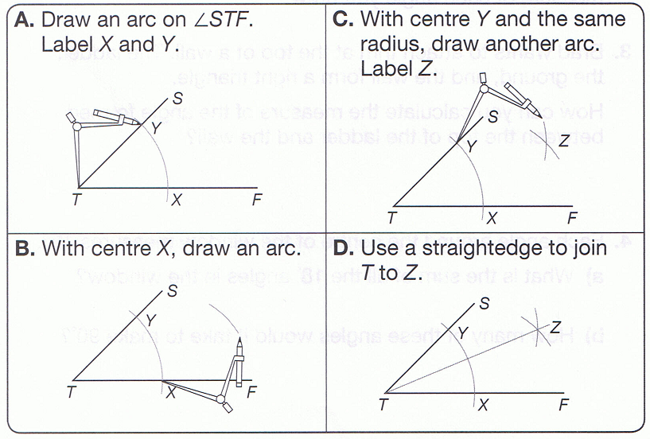

**ASSIGNMENT 7 – BISECTING AN ANGLE**

1) Bisect the angle below using only a compass, ruler, and pencil. Ask your teacher for a compass if you don’t have one. Do not erase any of your construction marks from the compass.

2) If a right angle is bisected, what is the size of each angle?

3) An angle is bisected and the resulting angles are 780 each. How big was the original angle?

**PARALLEL AND PERPENDICULAR LINES**

**Parallel lines** are *lines that are always the same distance apart*. Parallel lines will *never* cross. A short form way of indication that lines are parallel is to use the symbol \parallel . So if you read the following: AB \parallel CD, it would mean that line AB is parallel to line CD.

Little arrows on the lines are also used to show that the lines are parallel.

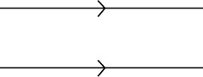

We have already discussed perpendicular line. **Perpendicular lines** are *two lines that meet at a right angle – 900*. The symbol to show that two lines are perpendicular when writing about them is ⊥ . So to say that line EF is perpendicular to line GH you might see the following:

EF ⊥ GH

The little box in the corner of a right angle also illustrates this.

G

E H F

**ASSIGNMENT 8 – PARALLEL AND PERPENDICULAR LINES**

1) Using a protractor, determine whether these lines are perpendicular.



Quiz 2 next class

**LINES AND TRANSVERSALS**

Many angles can be formed by two lines and a transversal. By definition, a **transversal** is just *a line that intersects (or crosses) two or more other lines*. Whether or not the two lines the transversal crosses are parallel, there are specific relationships formed when lines intersect. The illustration below shows these relationships.

t

2 1

l1 3 4

l2 6 5

7 8

In this diagram, the two lines, l1 and l2 are clearly not parallel. The relationships described below hold true for parallel lines too.

There are 6 angle relationships that you **MUST LEARN**! Use the names of the angles to help you remember where they are located.

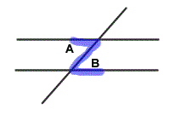

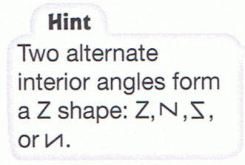**interior alternate angles**: angles in opposite positions between two lines intersected by a transversal and also on alternate sides of the same transversal. These angles can be thought of as a “Z” pattern – see the illustration to the right. Note that the “Z” can be stretched out or backwards too.

Examples:

**exterior alternate angles**: angles in opposite positions outside two lines intersected by a transversal and also on alternate sides of the same transversal. These angles can be thought of as an outside “Z” pattern – see the illustration to the right. Note that the “Z” can be stretched out or backwards too.

Examples:

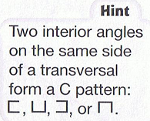**interior angles on the same side of the transversal**: angles inside the two lines that are intersected by the transversal and also on the same side of the transversal. This forms a “C” pattern.

Examples:

**exterior angles on the same side of the transversal**: angles outside the two lines that are intersected by the transversal and also on the same side of the transversal.

Examples:

**vertically opposite angles**: angles that are created by intersecting lines, these angles are opposite each other

Examples:

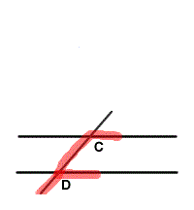**corresponding angles**: two angles that occupy the same relative position at two different intersections. These angles can be thought of as an “F” pattern – see the illustration

to the right. Note that the “F” can be upside down or

backwards too.

Examples:

**ASSIGNMENT 9 – LINES AND TRANSVERSALS**

1) Using the diagram below, identify the relationship between each pair of angles named.

2 1

5 8

7 3

4 6

a) ∠ 7 and ∠ 8 _________________________________________________

b) ∠ 2 and ∠ 7 _________________________________________________

c) ∠ 1 and ∠ 6 _________________________________________________

d) ∠ 5 and ∠ 7 _________________________________________________

e) ∠ 6 and ∠ 7 _________________________________________________

2) Using the diagram below, identify the following angles.

2 1

3

7 4

5 6

a) an exterior alternate angle to ∠ 2

b) an interior angle on the same side of the transversal as ∠ 7

c) an interior alternate angle to ∠ 4

d) a corresponding angle to ∠ 5

e) a vertically opposite angle to ∠ 3

3) Using the diagram below, calculate the size of each unknown angle indicated in the figure. Hint: Remember what the angle measure of a straight angle is. Show your calculations below the diagram.

1 1200

2 3

700 4

6 5

a) ∠ 1 = _________________________________________________

b) ∠ 2 = _________________________________________________

c) ∠ 3 = _________________________________________________

d) ∠ 4 = _________________________________________________

e) ∠ 5 = _________________________________________________

f) ∠ 6 = _________________________________________________

**PARALLEL LINES AND TRANSVERSALS**

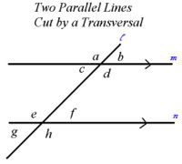So far, the transversals we have used have not crossed parallel lines. If the lines are parallel however, there is more information about the measures of the angles that can be determined.

If the lines crossed by the transversal are parallel, the following are true:

* the interior alternate angles are **equal**
* the exterior alternate angles are **equal**
* the corresponding angles are **equal**
* interior angles on the same side of the transversal are **supplementary**
* exterior angles on the same side of the transversal are **supplementary**

Conversely, if you know that two lines are crossed by a transversal and any of the above relationships are true, then the angles must be parallel.

Example: In the diagram below, the two lines, l1 and l2 are parallel. What are the measures of the three angles indicated? Explain your answers.



Solution:

NOTE: This is not the only way to determine the angle measures. There are other possible solutions to find the same answers.

**NOTE: THE ANGLES IN A TRIANGLE ALWAYS ADD UP TO 1800 - ALWAYS!**

**ASSIGNMENT 10 – PARALLEL LINES AND TRANSVERSALS**

1) If ∠ A is 160°, what is the measure of ∠ B? Explain your reasoning.

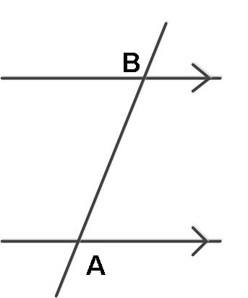

2) In the diagram below, the two lines crossing the transversal are parallel. State the relationship between the pairs of angles and the relationship of their angle measurements.

2 1

3 4

6 5

7 8

∠ 1 & ∠ 3 _________________________________________________

∠ 2 & ∠ 6 _________________________________________________

∠ 3 & ∠ 5 _________________________________________________

3) The diagram below shows two pipes that are vertical but not yet parallel to each other. How much must the second pipe be moved (what angle should be added or subtracted) to make them parallel? Show your calculations.



4) In the diagram below, the side of the house and the side of the attached shed are parallel. What are the measures of ∠ 1 and ∠ 2?



5) A plumber must install pipe 2 parallel to pipe 1. He knows that ∠ 1 is 530. What is the size of angle ∠ 2?

6) In the diagram below, the two lines, l1 and l2 are parallel. What are the measures of the four angles indicated? **Explain your answers**.



∠ 1 ____________________________ ∠ 3 ________________________________

∠ 2 ____________________________ ∠ 4 ________________________________

7) In the diagrams shown, are the lines ED and HG parallel? Explain how you know using correct terminology.

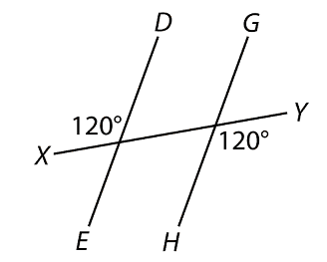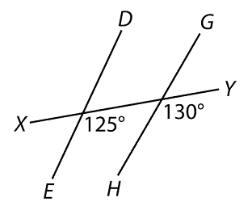a) b)

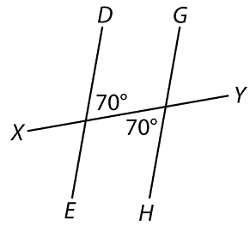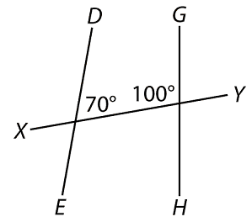c) d)

8) Determine the size of angles x, y and z in each figure below. Show your work!

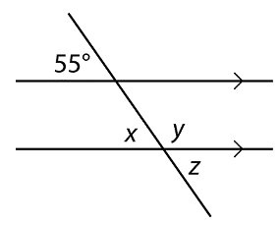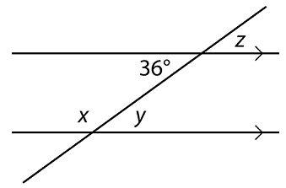a) b)

9) What is the measure (how big in degrees) is angle x?

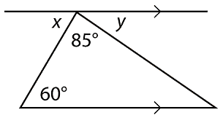

10) What is the measure (how big in degrees) is angle y?



11) What are the measures of angles x, y, and z?

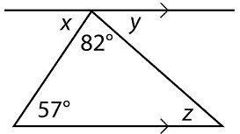

12) What are the measures of angles x, y, and z?

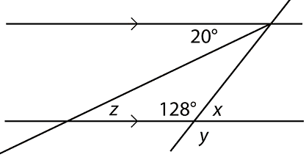

Practice Test Next Class.