**Unit 4**

**Polynomials**

Objectives:

* to demonstrate an understanding of polynomials using mathematical language
* to model, record, and explain addition and subtraction of polynomials
* to apply the distributive property and simplify polynomials
* to evaluate polynomials
* to multiply polynomials
* to multiply and divide polynomials using models and symbols
* to simplify polynomial expressions by combining like terms

**Lesson 1 – The Language of Mathematics (5.1)**

Mathematics is a developing science made up of several branches, including arithmetic, geometry, and algebra. It is a science that studies quantity, shape and arrangements. As with any science, mathematics comes with its own unique language. The language of mathematics is universal; it can be understood anywhere around the world.

A **term** is _______________________________________________________________

Examples of terms: $3x^{2}$, $-6mn$, 4, $y$

Note: If a term is made up of a number only with no variables, it is called a

________________ ____________.

A **polynomial** is __________________________________________________________

_______________________________________________________________________.



Polynomials

**Polynomial**

* No special name for polynomials with more than 3 terms.
* Ex: 3*m2* − 7*n* – 18*n*2 + 1

**Monomial**

* Polynomial with 1 term
* Ex: *x*,   
  *ab*,   
  −4*y*,   
  5

**Trinomial**

* Polynomial with 3 terms
* Ex: *m2* + 7*n* – 18,   
  −2*x2 + xy – 7y2*

**Binomial**

* Polynomial with 2 terms
* Ex: 4*x* + 3,   
  −2*x2 + xy*,   
  *c* – 7*c*2

Example: For the expression 5*x*3 + 2*y* + 3, determine

|  |  |
| --- | --- |
| * the number of terms: | * constant term: |
| * name of the polynomial: | * variables: |
| * coefficient(s): |  |

Note:  or  are **NOT polynomials** because the variable cannot have a negative exponent or be in the denominator.

**1)** Classify the following as a monomial, binomial, trinomial or polynomial.

|  |  |  |
| --- | --- | --- |
| **Expression** | **Number of terms** | **Name** |
|  | 1 | monomial |
|  |  |  |
|  |  |  |
|  |  |  |
| 1. 10 |  |  |

The **degree of a term** (monomial) is __________________________________________

__________________________________________________________________.

**2)** Determine the degree of each monomial.

|  |  |  |  |  |  |
| --- | --- | --- | --- | --- | --- |
| **Monomial** |  |  | 12 |  |  |
| **Degree** | 3 |  |  |  |  |

The **degree of a polynomial** is ______________________________________________

__________________________________________________________.

Example: 

|  |  |  |  |  |
| --- | --- | --- | --- | --- |
| * Break the polynomial down to each monomial |  |  |  |  |
| * Determine the degree of each monomial |  |  |  |  |

The highest monomial degree is the degree of the polynomial:

**3)** Determine the degree of each polynomial

|  |  |  |  |  |
| --- | --- | --- | --- | --- |
| **Polynomial** |  |  |  |  |
| **Degree** | 2 |  |  |  |

**Descending order of power**

We arrange the terms of a polynomial so that the powers of one variable are in ascending (smallest to biggest) or descending (biggest to smallest) order. The usual order is **alphabetically and descending unless stated otherwise**. That is, we arrange the variables alphabetically and do descending powers of the first variable (note: constant term go last).

4) Arrange the terms of each polynomial alphabetically and descending order of exponent.

1. 
2. 
3. 

**Modeling**

If your polynomial involves only one variable, you can use algebra tiles or diagrams to model your polynomial.

|  |  |
| --- | --- |
| Represents −1  Represents −1 *x*  Represents −1 *x*2  Represents +1  Represents +1 *x*2  Represents +1 *x* | Example: Draw a model for |

Homework:

**Lesson 2 – Equivalent Expressions (5.2)**

Recall: Definition

* A **variable** is a letter or symbol used to represent an unknown number.
* A **coefficient** is a number that multiplies with a variable. It is usually written before the variable.

**Exponents: 2, 3**

Example: −7*x*2*y*3

**Coefficient: −7**

**Variables: *x, y***

**1)** For each term, determine the coefficient, variable(s) and the exponent(s)

|  |  |  |  |
| --- | --- | --- | --- |
| Expression | Coefficient | Variable(s) | Exponent of  Variable(s) |
| a) | 4 | *x* | 1 |
| b) |  |  |  |
| c) |  |  |  |
| d) |  |  |  |

**Like Terms** are __________________________________________________________

**Unlike Terms** are ________________________________________________________

**2)** Identify if the following are like terms.

1. 
2. 
3. 
4. 
5. 

You can **combine like terms** together to simplify the algebraic expression by adding or subtracting their coefficients.

**3)** Collect like terms/Simplify:

|  |  |
| --- | --- |
|  |  |
|  |  |
|  |  |
|  |  |
|  |  |

**Translating Expression:**

1. Twenty-five decreased by a number
2. Eighteen less than a number
3. The product of three and a number
4. The sum of twice a number and 10
5. Five more than the number
6. One more than three times the number

Homework:

**Lesson 3 – Adding and Subtracting Polynomials (5.3)**

To add polynomials, remove the brackets and collect like terms.

1) Add:

1. (2*a* – 1) + (6 – 4*a*)
2. (−2*x*2 + 6*x* – 7) + (3*x*2 – *x* – 2)
3. (3*t*2 – 5*t*) + (*t*2 + 2*t* + 1)

2) Use algebra tiles to model (−2*x*2 + 6*x* – 7) + (3*x*2 – *x* – 2) to determine if your solution is correct.

To subtract polynomials, add the ***opposite*** of the polynomial that is being subtracted.

What is the opposite for each of the following?

(a) -2 (b) 3*x* (c) 4*x* – 1 (d) *a*2 – 3*a* + 2

3) Subtract the following polynomials:

1. (2*x* + 3) – ( 3*x* – 4)
2. (5*x*2 – *x* + 4) – (2*x*2 – 3*x* – 1)
3. (3*y*2 – 3*y* + 2) – (–2*y*2 + *y* + 2)
4. (*y*2 – 3*y*) – (7 – 6*y*)

**Evaluating Polynomials:**

Simplify each expression and determine its value when x = 2 and y = -1.

1. 4*x* + 2*x* – 2
2. (5*x* – 3*y*) + (−8*x* + y)
3. (*y2* + 2) – (3*y* – 7)

Problem Solving:

1. A triangle has the dimensions shown

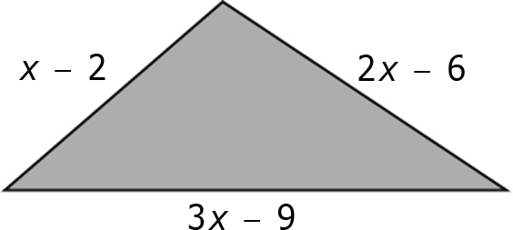

1. What does (*x* – 2) + (3*x* – 9) + (2*x* – 6) mean?
2. Simplify the expression in (a).
3. If *x* has a value of 6, what is the perimeter of the triangle?
4. The perimeter of the triangle shown is 12*x*2 + 6*x*, in metres. Find a polynomial representing the missing side length.

5*x*2 – 3*x*

3*x*2 + 7*x*

**?**

Homework:

**Lesson 4 – Multiplying and Dividing Monomials (7.1)**

|  |  |
| --- | --- |
| = positive *x*-tile | = negative *x*-tile |
| BLM7-5-5a   = positive *x*2-tile | BLM7-5-5b   = negative *x*2-tile |
| = positive *y*-tile | BLM7-5-4   = positive *xy*-tile |

**1)** Write a monomial multiplication statement for each set of algebra tiles.

**a)** **b)**

**2)** Represent each of the following monomial multiplication statements with a model. Determine each product.

a) (–3*x*)(–2*x*) b) (*x*)(4*x*)

3) Determine the product of each pair of monomials.

a) (–4*x*)(2*x*) b) (3*y*)(7*y*) c) (5*x*)(–3*y*)

d) (6*m*)(–0.2*m*) e) 

**4)** Write a monomial division statement for each set of algebra tiles.

**a)** **b)**

**5)** Represent each of the following monomial division statements with   
a model. Determine each quotient.

a)  b) 

**6)** Determine the quotient of each pair of monomials.

a)  b)  c) 

d)  e) 

**7)** A triangle has a base of 12*x* cm and a height of 3.4*x* cm. What is the area of the triangle?

**8)**  The area of a parallelogram is 25.6*x*2 m2. Determine the height if the base is 8*x* m.

Homework:

**Lesson 5 - Distributive Property and Multiplying Polynomials by Monomials (7.2)**

What are two ways to simplify 2(3 + 5)?

How to simplify 2(*x* + 5)?

**1)** Use the distributive law to simplify the following:

1. 9(3*c* + 4*d* – 6)
2. −3( 4*y* + 1)

**2) Adding and Subtracting Polynomials using the distributive law:**

|  |  |
| --- | --- |
| 1. 2(*x* – 2) + 3*x* + 1 | 1. −(*x* + 2) – 3*x* + 7 |
| 1. 4*m* – 1 – 3(2 – *x*) | 1. 3(*k* – 2) – (*k* – 3) |
| 1. −5(*t*2 + 2*t* – 1) + 8(*t*2 – 3*t*) | 1. −5(*t*2 + 2*t* – 1) + 8(*t*2 – 3*t*) |

|  |  |
| --- | --- |
| = positive 1 | = negative 1 |
| **BLM7-7-3** = positive *x* | = negative *x* |
| BLM7-7-5  = positive *x*2 | BLM7-9-8= negative *x*2 |

**1)** What polynomial multiplication statement is represented by each area model?

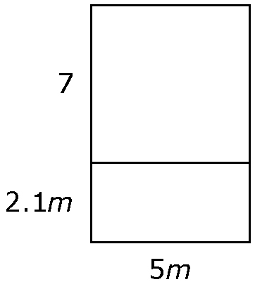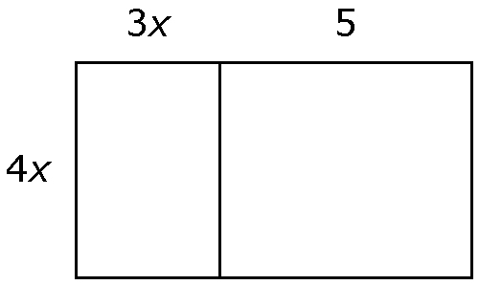**a)**  **b)**

**2)** Use an area model to expand each expression.

**a)** (3*x*)(2*x* – 1) **b)** (4*d* + 3)(3*d*)

**3)** Determine the polynomial multiplication statement shown by the diagrams.

**a)**  **b)**

**4)** Use models to expand each expression.

**a)** (4*x* + 1)(2*x*) **b)** (–*x*)(*x* + 4) **c)** (2*x*)(3*x* – 1)

**5)** Use the distributive property to expand each expression.

|  |  |
| --- | --- |
| 1. (5*m*)(2*m* + 3) | 1. (–*n*)(*n* + 1) |
| 1. (–*m* + 2)(3*m*) | 1. (4.1*k* – 5.3)(–3*k*) |

**6)** Multiply.

|  |  |
| --- | --- |
|  |  |
|  |  |

**7)** The length of a cement pad on a playground is 3 metres longer than the width. The width is 5*x* metres.

**a)** Write an expression for the area of the cement pad.

**b)** If *x* = 2 metres, what is the area of the cement pad?

Homework:**Lesson 6 – Dividing Polynomials by Monomials (7.3)**

|  |  |
| --- | --- |
| = positive 1-tile | = negative 1-tile |
| **BLM7-5-1** = positive *x*-tile | **BLM7-9-4** = negative *x*-tile |
| BLM7-9-7= positive *x*2-tile | BLM7-9-8= negative *x*2-tile |
| = positive *y*-tile | BLM7-5-4   = positive *xy*-tile |

**1)** What polynomial division statement is represented by the algebra tiles? Determine the quotient.

**a)**  **b)**

**2)** Use a model to divide each expression. Determine the quotient.

**a)**  **b)** 

**3)** Determine the polynomial division statement shown by the algebra tiles. Determine the quotient.

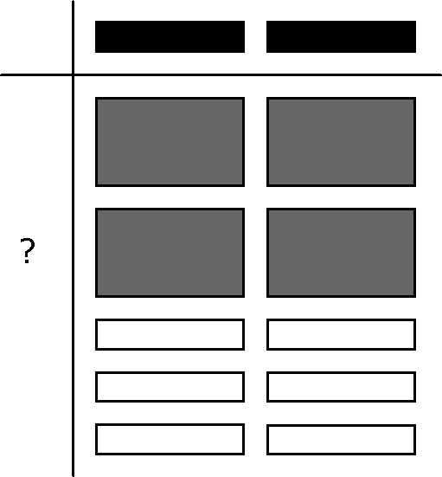**a)**  **b)**

**4)** Divide.

**a)**  **b)** 

**5)** Divide.

**a)**  **b)** 

**c)**  **d)** 

**6)** You are decorating the bulletin board in your classroom with pictures of your class-mates. Each picture covers an area of 4*x* cm2. The area of the board is 4*x*2 + 16*x* cm2. Write an expression to represent how many pictures are required to cover the board.

**7)** A rectangular lawn has a width of 3*x* metres. The area is 15*x*2 + 45*x* metres squared. You wish to put a fence around the lawn.

**a)** What is an expression to represent the perimeter of the lawn?

**b)** You are placing a post every 2 metres. Find an expression to represent how many posts will be required.

Homework:

**Lesson 7 – Multiplying Two Binomials (FOIL)**

Recall that a binomial is a polynomial with two terms, e.g. *x* + 2

We can multiply two binomials. This process is called FOIL.

Follow the example:

**Expand (3*x* + 2)(*x* + 4)**

Step 1: (3*x* + 2)(*x* + 4)

Multiply F (first, of each bracket)

____________ = ______

Step 2: (3*x* + 2)(*x* + 4)

Multiply O (outside, of each bracket)

____________ = ______

Step 3: (3*x* + 2)(*x* + 4)

Multiply I (inside, of each bracket)

____________ = ______

Step 4: (3*x* + 2)(*x* + 4)

Multiply L (last, of each bracket)

____________ = ______

Put it all together and you get: __________________ = ________________

Similar to algebra tiles, you can use area maps to expand multiplying 2 binomials.

Example: Expand (2*x* − 1)(*x* + 8)

Step 1: write each bracket along the left and top (like algebra tiles)

Step 2: multiply

Step 3: collect like terms

|  |  |  |
| --- | --- | --- |
|  |  |  |
|  |  |  |
|  |  |  |

**1)** Expand the following:

1. (*x* + 3)(*x* – 2)
2. (2*x* + 1)(7*x* – 3)
3. (*x* – 6)2
4. (*x* – 3)(*x* + 3)
5. (5*x* – 2*y*)(3*x* + 4*y*)

Homework:

**Lesson 8 – Factoring Trinomial *x*2 + *bx* + *c***

Recall: Expand (*x* + 2)(*x* + 4).

Is there a way to work backwards? Do you see any patterns?

How about ? Can your pattern be applied?

To factor trinomials of the form ***x*2 + *bx* + *c*** where *b* and *c* are coefficients, you need to think of two numbers that multiply to equal c and adds to equal *b*.

Example: Factor *x*2 − 3*x* − 28.

**1)**  Factor the following trinomials

1. 
2. 
3. 
4. 
5. 
6. 
7.  *Hint:* 

Homework: