**UNIT 4-TRIGONOMETRY**

**TRIANGLE REVIEW**

In this unit, you will be looking at triangles, specifically right angle triangles, also called right triangles. You will review the basic trigonometric ratios and the Pythagorean Theorem, and then learn to apply these situations that have 2 or 3 triangles. But first it is necessary to review some facts about triangles.

Fact 1: Every triangle contains 3 sides and 3 angles or vertices (plural of vertex).

Fact 2: The measurements of these angles always total 1800.

Fact 3: To identify the side or vertex in a triangle, it is important to label the triangle following a standard routine. Each vertex of a triangle is labeled with a capital case letter – like “A” - and each side is labeled with the lower case letter that matches the opposite vertex. An example is below.

A

c b

B a C

Fact 4: A triangle that contains a 900 angle (a right angle) is called a right triangle (or right-angle triangle). ALL triangles in this unit will be right triangles.

Fact 5: The side of the triangle that is opposite the 900 angle is always called the **hypotenuse**. It is labelled in the triangle below. The other two sides of the triangle are called legs.

hypotenuse

Fact 6: The hypotenuse is **always** the longest side in the triangle. It is always opposite the largest angle which is the 900 or right angle.

Fact 7: Pythagorean Theorem states that in any right triangle, the sum of the squares of the lengths of the legs is equal to the square of the length of the hypotenuse. So in ΔABC with the right angle at C, the following relationship is true:

c2 = a2 + b2

where a and b are the other 2 legs of the triangle.

c

b

a

We can also rearrange the equation to find the length one of the legs;

c2 = a2 + b2

a2 = c2 – b2

b2 = c2 – a2

When we use Pythagorean Theorem to find a length of the hypotenuse or a leg, you need to have a calculator that has the square root function on it. The computer symbol looks like this: √ or

Example 1: Use Pythagorean Theorem to find the length of the missing side to one decimal place.

P

Solution:

3.8 cm q

Q 5.2 cm R

Example 2: Use Pythagorean Theorem to find the length of the missing side to one decimal place.

A

Solution:

b 12.8 in

C 10.78 in B

**ASSIGNMENT 1 – Pythagorean Theorem Practice**

1) Find the missing value in each of the following to 2 decimal places.

a) p2 = 62 + 92 b) m2 = 42 + 72

c) y2 = 82 – 52 d) z2 = 102 – 52

2) Use the Pythagorean Theorem to calculate the unknown side length to one decimal place.

a) b)

22.0 m

14.0 m 25.0 in

9.0 in

3) A ramp into a house rises up 3.5 meters over a horizontal distance of 10.5 meters. How long is the ramp? Use the diagram below and show your work.

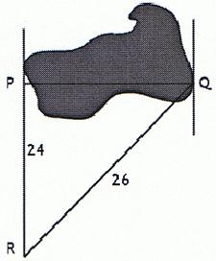

4) You need to find the width of a lake, PQ, as shown. The measurements of the other sides are given on the diagram. You know that ∠P = 900. What is the width of the lake?

5) A 40 foot ladder reaches 38 feet up the side of a house. How far from the side of the house is the base of the ladder? Draw a diagram and show your work.

6) A flagpole is 12 metres tall. It makes a shadow on the ground that is 15 metres long. How long is a line that joins the top of the flagpole with the end of the shadow? Draw a diagram and show your work.

**TRIGONOMETRY REVIEW**

Trigonometry is one of the most important topics in mathematics. Trigonometry is used in many fields including engineering, architecture, surveying, aviation, navigation, carpentry, forestry, and computer graphics. Also, until satellites, the most accurate maps were constructed using trigonometry.

The word ***trigonometry*** means triangle measurements. It is necessary to finish our triangle facts here.

Fact 8: In trigonometry, the other two sides (or legs) of the triangle are referred to as the **opposite** and **adjacent** sides, depending on their relationship to the angle of interest in the triangle.

In this example, if we pick angle DEF – the angle labelled with the Greek letter θ called ***theta*** – then we are able to distinguish the sides as illustrated in the diagram below.

D

opposite hypotenuse

θ

F adjacent E

The side that is opposite the angle of interest, in this case θ, is called the **opposite** side. The side that is nearest to angle θ and makes up part of the angle is called the **adjacent** side. To help you, remember that adjacent means beside. Although the hypotenuse occupies one of the two adjacent positions, it is **never** called the adjacent side. It simply remains the hypotenuse. This is why it is identified first. It is recommended to label the side in the order hypotenuse, opposite, and finally adjacent. You may use initials for these side, h, o, and a, but always use lower case letters to avoid mixing up the labelling with a vertex.

Example 1: Using the triangle below, answer the questions.

15

9

θ

12

1. What is the hypotenuse? __________
2. What is the opposite side to θ? __________
3. What is the adjacent side to θ? __________

This example uses the same triangle as in Example 1; however, this time, the *other* acute angle is labelled as θ. This is done to show that the opposite and adjacent sides switch when the other angle is the angle of interest. The hypotenuse **always** stays the same.

Example 2: Using the triangle below, answer the questions.

θ

15

9

12

1. What is the hypotenuse? __________
2. What is the opposite side to θ? __________
3. What is the adjacent side to θ? __________

**ASSIGNMENT 2 – TRIGONOMETRY**

For each of the right triangles below, mark the hypotenuse, and the sides that are opposite and adjacent sides to θ as shown in the example.

Example:

h = hypotenuse

h o o = opposite

a = adjacent

θ

a

1) 2)

θ

θ

3) 4)

θ

θ

Quiz 1 next class.

**Trigonometric Ratios**

In the previous unit about similar figures, you learned that the ratios of corresponding sides of similar triangles are equal. When the angles of different triangles are the same, the ratio of the sides within the triangle will always be the same. They depend only on the measure of the angle of interest, not the size of the triangle. These ratios are the trigonometric ratios.

There are three trigonometric ratios we are concerned with: sine, cosine, and tangent.

**The Sine Ratio**

The *sine* *of angle* *θ* means the ratio of the length of opposite side to the length of the hypotenuse. It is abbreviated as **sin θ** but read as sine θ. It is written like this:

sin θ =  or sin θ = 

Example 1: Find the sine of θ in this triangle. Round to 4 decimal places.

13

5

θ

12

Note: Rounding to 4 decimal places is standard when calculating trigonometric ratios.

Example 2: Use your calculator to determine the following sine ratios. Round to 4 decimal places.

a) sin 150 b) sin 670 c) sin 420

**\*\*\*\*\* REMEMBER TO SET YOUR CALCULATOR ON DEGREES (DEG) \*\*\*\***

Solution: Type “sin” followed by the angle, and then “=” to solve

**THE COSINE RATIO**

The *cosine* *of angle* *θ* means the ratio of the adjacent side to the hypotenuse. It is abbreviated as **cos θ** but read as cosine θ. It is written like this:

cos θ =  or cos θ = 

Example 1: Find the cosine of θ in this triangle.

13

5

θ

12

Solution:

Note: Rounding to 4 decimal places is standard when calculating trigonometric ratios.

Example 2: Use your calculator to determine the following cosine ratios. Round to 4 decimal places.

a) cos 150 b) cos 670 c) cos 420

**\*\*\*\*\* REMEMBER TO SET YOUR CALCULATOR ON DEGREES (DEG) \*\*\*\***

Solution: Type “cos” followed by the angle, and then “=” to solve

**The Tangent RATIO**

The *tangent* *of angle* *θ* means the ratio of the opposite side to the adjacent side. It is abbreviated as **tan θ** but read as tangent θ. It is written like this:

tan θ =  or tan θ = 

Example 1: Find the tangent of θ in this triangle.

13

5

θ

12

Solution:

The opposite side is 5 and the adjacent side is 12. So

tan θ =  =  = 0.4167

Note: Rounding to 4 decimal places is standard when calculating trigonometric ratios.

Example 2: Use your calculator to determine the following tangent ratios. Round to 4 decimal places.

a) tan 150 b) tan 670 c) tan 420

**\*\*\*\*\* REMEMBER TO SET YOUR CALCULATOR ON DEGREES (DEG) \*\*\*\***

Solution: Type “tan” followed by the angle, and then “=” to solve

**ASSIGNMENT 3 – THE TRIGONOMETRIC RATIOS**

1) Calculate the value of **sin θ** to four decimal places.

θ 5.2 in 8.1 in

θ

6.9 m 9.6 in

4.3 m

2) Use your calculator to determine the value of each of the following sine ratios to four decimal places.

a) sin 100 = ______________ b) sin 480 = ______________

c) sin 770 = ______________ d) sin 850 = ______________

3) Calculate the value of **cos θ** to four decimal places.

θ 5.2 in 8.1 in

θ

12.4 cm 7.9 cm 9.6 in

4) Use your calculator to determine the value of each of the following cosine ratios to four decimal places.

e) cos 100 = ______________ f) cos 480 = ______________

g) cos 770 = ______________ h) cos 850 = ______________

5) Calculate the value of **tan θ** to four decimal places.

θ

5.2 in 8.1 in

6.5 m

θ

9.6 in

5.1 m

6) Use your calculator to determine the value of each of the following tangent ratios to four decimal places.

i) tan 100 = ______________ j) tan 480 = ______________

k) tan 770 = ______________ l) tan 850 = ______________

7) There are two special sine ratios. Calculate the following.

a) sin 00 = ______________ b) sin 900 = ______________

8) There are two special cosine ratios. Calculate the following.

a) cos 00 = ______________ b) cos 900 = ______________

9) There are some special tangent ratios. Calculate the following.

a) tan 00 = ______________ b) tan 450 = ______________

c) tan 890 = ______________ d) tan 900 = ______________

Note what the answer key says that the tan 900 equals. Just because your calculator says one thing, doesn’t mean the calculator knows what is going on!

**Using THE Sine RATIO**

Whenever one side and one angle of a right triangle are already known, the remaining sides can be found using the trigonometric ratios. The sine ratio can be used to find missing parts of a right triangle.

Example 1: Use the sine ratio to find the ***x*** in the triangle below.

***x***

9

θ = 350

Solution:

Example 2: A ladder 8.5 m long makes an angle of 720 with the ground. How far up the side of a building will the ladder reach?

Solution:

**Using THE Cosine RATIO**

Whenever one side and one angle of a right triangle are already known, the remaining sides can be found using the trigonometric ratios. The cosine ratio can be used to find missing parts of a right triangle.

Example 1: Use the correct trig ratio to find the ***x*** in the triangle below.

5 cm

θ = 300

***x***

Solution:

**Using THE TANGENT RATIO**

Whenever one side and one angle of a right triangle are already known, the remaining sides can be found using the trigonometric ratios. The tangent ratio can be used to find missing parts of a right triangle.

Example 1: Use the correct trig ratio to find the ***x*** in the triangle below.

2 mm

θ = 150

***x***

Solution:

**ASSIGNMENT 4 – FINDING SIDES IN Right Triangles + wHAT DO THEY CALL THE BIG gRASS FIELD ON AN ORBITING SATELLITE?**

1) Calculate the length of the side indicated in the following diagrams. Round to **one** decimal place. SHOW ALL STEPS AND WORK!!! Check that your calculator is on degrees “DEG”.

a)

580

9.7 cm ***x***

b)

5.2 m

230

***x***

c) ***x***

680

19.3 cm

d)

***x***

110

12.3 m

e)

480

***x*** 6.5 cm

f)

***x***

370

9.2 m

Quiz 2 next class

**ANGLE OF ELEVATION AND DEPRESSION**

When you look up at an airplane flying overhead for example, the angle between the horizontal and your line of sight is called the **angle of elevation**.



When you look down from a cliff to a boat passing by, the angle between the horizontal and your line of sight is called the **angle of depression**.

When you are given the angle of depression, it is important to carefully use this angle in your triangle.

Example 1: You are standing at the top of a cliff. You spot a boat 200 m away at an angle of depression of 550 to the horizon. How far is the boat from the coast? Draw a diagram to illustrate this situation.

**ASSIGNMENT 5 – ANGLE OF ELEVATION AND DEPRESSION**

Check that your calculator is on degrees “DEG”.

1) in the triangle below, what is the measure of the angle of elevation?

650

Measure _______________

250

2) Write the angle of elevation in each diagram. Then find the length of the unknown side, to one decimal place.

a) Angle of elevation = 430 b) Angle of elevation = 210

w5.6 m

18.5 ft

x

3) In the diagram below, name the angle of depression. What is the measure of this angle?

A D

Name _________________

630

Measure _______________

B C

4) Find the length of the unknown side, to one decimal place.

610 180

8.2 in.

*y* 6.4 cm *z*

**ASSIGNMENT 6 – word problems**

1) A child’s slide rises to a platform at the top. If the angle of elevation of the slide is 200 ,and the horizontal distance that the slide covers is 25 m long, how long is the slide?

200

25m

2) A surveyor must determine the distance AB across a river. If he knows the information in the diagram below, how wide is the river?

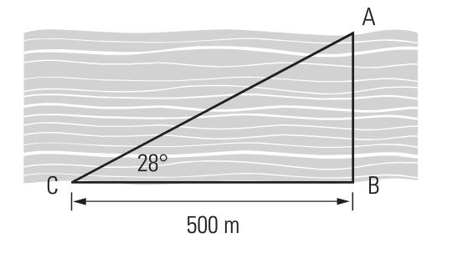

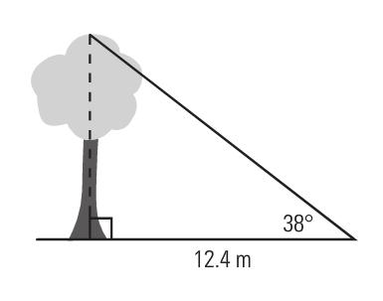3) A tree is measured to be 12.4 m tall. If a man views the top of the tree at an angle of elevation of 380, how far away from the tree is he standing?

4) A ladder is placed against the side of the house. If the base is 41 feet away from the house, and the angle of elevation between the ladder and the ground is 700, how long is the ladder?

5) A weather balloon, which is blowing in the wind, is tied to the ground with a 15 m string. How high is the balloon (***x***) if the angle of elevation is 380?

balloon

15 m

*x* string

380

6) A flagpole is anchored to the ground by a guy wire that is 12 m long. The guy wire makes an angle of 630 *with the ground*. How far from the base of the flagpole must the guy wire be anchored into the ground?

7) From the top of a 45 metre tall pole, the angle of depression to the ground is 120. Draw a sketch to illustrate this situation, and then find the distance from the top of the pole to the ground along the sight line.

8) The angle of elevation of Sandra’s kite string is 70°. If she has let out 55 feet of string, how high is the kite?

9) A cable is secured at the top of a cliff to make a zip line. If the cliff is 15 m high and the angle of depression to the zip line is 22.60, how long does the zip line cable need to be to reach the ground?

**FINDING ANGLES in right triangles**

So far in this unit, you have used the trigonometric ratios to find the length of a side. But if you know the trigonometric ratio, you can calculate the size of the angle. This requires an “inverse” operation. You can use your calculator to find the opposite of the usual ratio provided you can calculate the ratio. To do this you need 2 sides in the triangle.

You can think of the inverse in terms of something simpler: addition is the opposite or inverse of subtraction. In the same way, trig functions have an inverse.

To calculate the inverse, you usually use a 2nd function and the sin/cos/tan buttons on your calculator in sequence. If you look at your calculator just above the sin/cos/tan buttons, you should see the following: sin-1, cos-1, tan-1. These are the inverse functions. If you use these buttons, you will be able to turn a ratio into an angle.

Example 1: Calculate each angle to the nearest whole degree.

a) sin X = 0.2546

b) cos Y = 0.1598

c) tan Z = 3.2785

Example 2: Determine the angle θ in the following triangle.

5 m

θ

3 m

**ASSIGNMENT 7 – FINDING ANGLES in right triangles_+**

**DAFFINITION DECODER SHEET**

1) Calculate the following angles to the nearest whole degree.

a) sin D = 0.5491 b) cos F = 0.8964

c) tan G = 2.3548 d) sin P = 0.9998

e) cos Q = 0.3097 f) tan R = 0.4663

2) After an hour of flying, a jet has travelled 300 miles, but gone off course 48 miles west of its planned flight path. What angle, θ, is the jet off course?

48 mi

300 mi

θ

3) At what angle to the ground is an 8 m long conveyor belt if it is fastened 5 m from the base of the loading ramp?



4) If a boat is 150 m from the base of a 90 m cliff, what is the angle of elevation from the boat to the top of the cliff?

5) A statue of Smokey the Bear is found in Revelstoke, BC. At a distance of 6.3 m from the base, the angle of elevation to the top is 550. How tall is the statue?

6) What is the angle of depression, θ, from the top of a 65 m cliff to an object 48 m from its base?

θ

7) A cable is secured at the top of a cliff to create a zip line. What angle, ***x0***, does the zip line make with the ground, to the nearest whole degree?

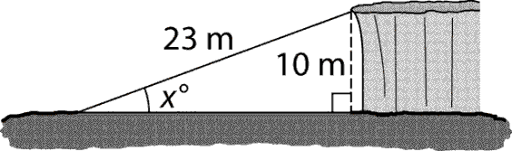

8) Justin works for an oil company. He needs to drill a well to make an oil deposit below the surface of the lake. The drill site is located on land as shown. What is the angle of depression, ***x0***, for drilling the well? Round to the whole degree.

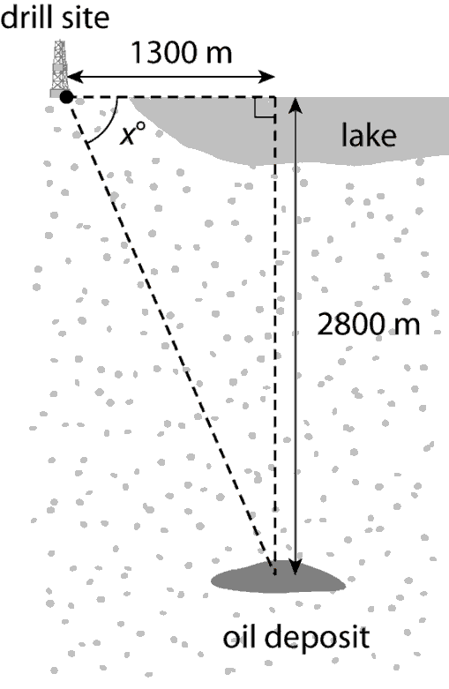

9) What angle, ***x0***, does the slide meet the ladder? Round to the nearest whole degree.

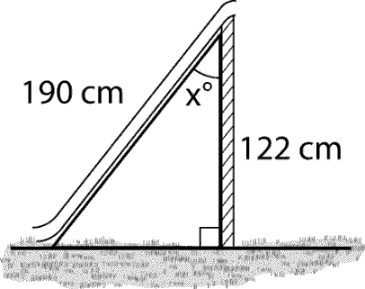

**Solving Complex Problems**

In some circumstances, you will have two or more triangles together in one diagram, and you will need to complete several steps in order to find the answer for the angle or the side you are specifically asked for. These multi-step problems are no harder than a single triangle problem as long as you follow through with the method you have been taught.

Example: In the following diagram, find the length of AB.

A

B

500

260

C 38 m D

NOTE: The way the two (or three) triangles are arranged will not always be the same as shown in this example. It is helpful to draw the individual triangles and work with them separately.

Solution:

**ASSIGNMENT 8 – WORKING WITH TWO TRIANGLES + SHEET**

1) What is the length of *x* in the diagram below?

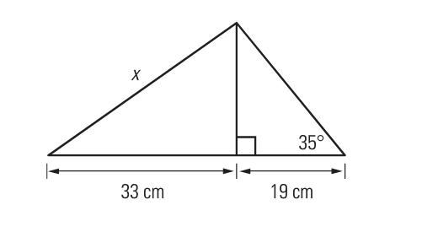

2) Find the lengths of *x* and *z* below.

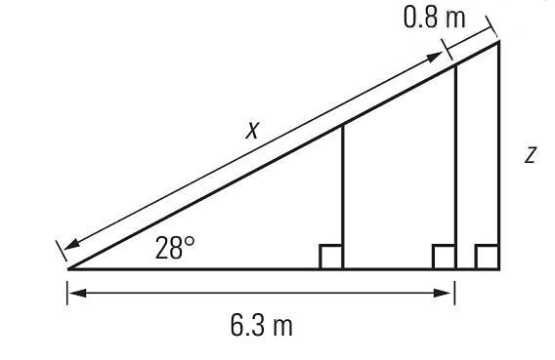

3) Find the lengths of *x* and *y* below. Hint: use Pythagorean Theorem to find *x* first.

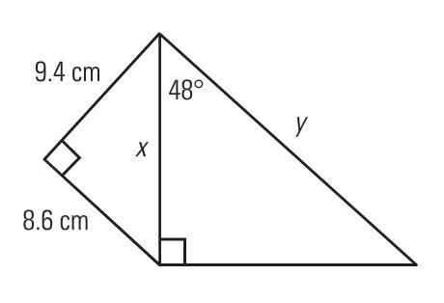

4) From the top of 200 m tall office building (B1), the angle of elevation to the top of another building (B2) is 400. The angle of depression to the bottom of that building is 250. How tall is that second building (B2)?

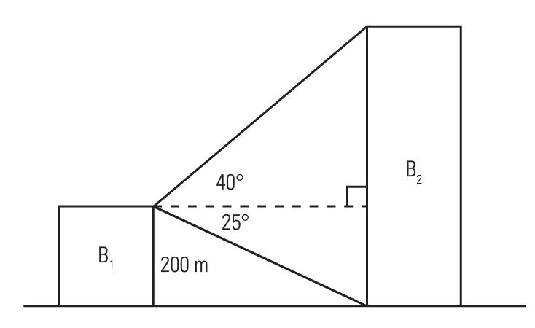

5) A flagpole is supported by two guy wires, each attached to the same peg in the ground that is 4 m from the base of the flagpole. The guy wires have angles of elevation of 350 and 450 as shown below. How long is each guy wire, *a* and *b* on the diagram?

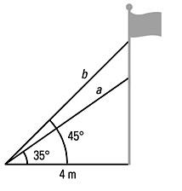

Quiz 3 next class.

**Solving Complex 3D Problems in the Real World**

In some situations, you will need to work with triangles that are at an angle to each other. Also, some situations will involve triangles that share a common edge but in each triangle this edge will represent a different dimension. It is sometimes hard to visualize these diagrams as they are trying to represent three dimensional images on a two dimensional paper. If you are having difficulties, draw the triangles separately and work that way. Remember, we are **always** using right triangles in these problems.

Example: Calculate the height of a cliff, AB below, given the information on the diagram.

A

510 B

C

780

105 m

D

**ASSIGNMENT 9 – WORKING WITH TRIANGLES IN 3-D**

1) Susan and Marc spot a bird’s nest at the top of a tree. Marc is 89 m from the tree. The angle between Susan’s line of sight and Marc’s line of sight is 730. If the angle of elevation from Susan to the top of the tree is 350, what is the height of the nest in the tree – how tall is the tree?

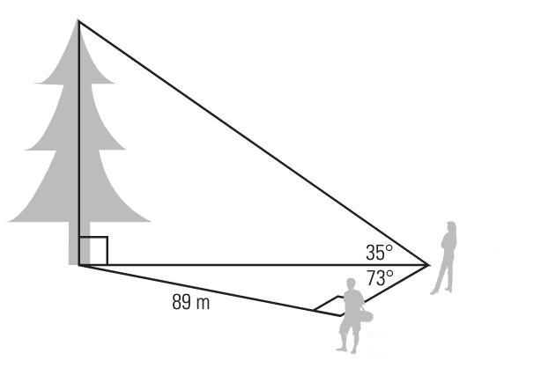

Susan

Marc

2) You need to calculate the height of a cliff that drops vertically into a river. Use the information in the diagram to calculate the height of the cliff.

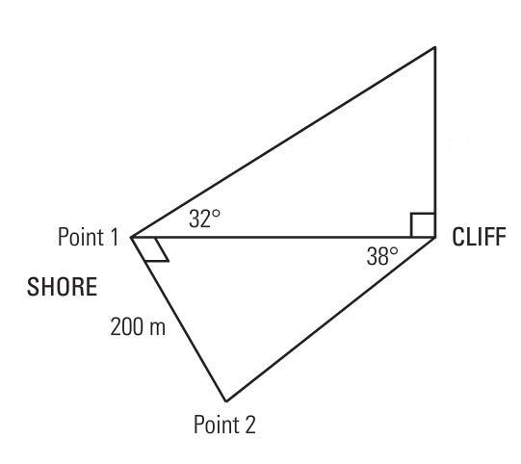

3) An airplane is flying 100 km north and 185 km west of an airport. It is flying at a height of 7 km.

a) Draw a diagram to show this problem. There should be 2 right triangles in your diagram. Label the vertices of each triangle with letters.

b) Using your diagram to help, calculate the straight-line distance from the plane to the airport. Round each answer to one decimal place.

c) What is the angle of elevation of the plane from the airport?

4) A box (shown below) is 10 cm by 12 cm by 15 cm. Length *d* is the diagonal along the bottom of the box.

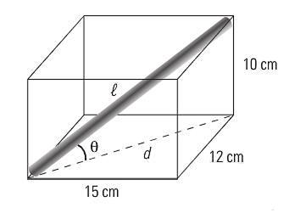

a) What is the length of the longest rod that can be carried in this box?

b) What angle, θ, does it make with the bottom of the box?

Test: _______________________