**Unit 3**

**Exponents** and exponent laws with whole-number exponents

Objectives:

* to use powers to represent repeated multiplication
* to solve problems involving powers

**Lesson 1 – Using Exponents to Describe Numbers (3.1)**

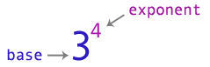

This reads as, “3 to the power of 4” or “3 to the fourth power.”

Exponents are used as a short-cut method to show how many times a number is multiplied by itself.

34= 3×3×3×3 (note: that the • symbol can be substituted for the × symbol)

34= 81

The base can also be a negative number:

(-3)4

(-3)4= -3 • -3 • -3• -3 (even number of negative signs means answer is positive)

(-3)4= 81

NOTE:

Whenever you have a negative base and the exponent is even, your answer will always be ________________.

Whenever you have a negative base and the exponent is odd your answer will always be ________________.

Example: (a) (-2)4 (b) (-2)3

Note: The parenthesis must stay around the (-2) to indicate that (-2) is raised to the fourth power. Without the parenthesis you would get a different answer.

Example: -24

Since -2 is not in parenthesis, this problem really means: -1• 24

-24 = (-1) • 2 • 2 • 2 • 2

-24= -16 2 • 2 • 2 • 2 = 16

16(-1) = -16

Tip! When you have a 0 as an exponent, your answer will always be ______. The only exception is 00 = ____.

Let’s look at why that is:

|  |  |
| --- | --- |
| Power | Value |
| 34 |  |
| 33 |  |
| 32 |  |
| 31 |  |
| 30 |  |

Practice using a calculator to evaluate powers:

1. 26 = 4.    7.55 = 7. (-3.2)3 =

2. 1012 = 5.    (-3)8 = 8. -54 =

3. 69 = 6. (-9)3 = 9. -43 =

**Homework:**

**Lesson 2 – Exponent Laws (Part 1) (3.2)**

We use exponent laws to simplify expressions and make evaluating powers easier to calculate.

[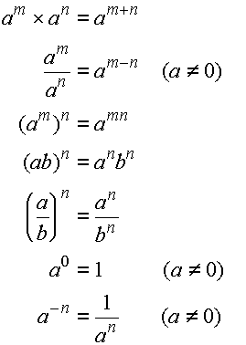](http://gradeninemath.blogspot.com/2010/06/number-sense.html)

Product of Powers:

Quotient of Powers:

Power of a Power:

Power of a Product:

Power of a Quotient:

Zero exponent:

***Negative exponent:

Examples:

* *Multiplying Powers with the* ***Same Base***

Rule: add the exponents

Method 1: Use Repeated Multiplication

23 × 22 =

Method 2: Apply the Exponent Laws

23 × 22 =

Examples:

85 × 84 = a6 × a = 72 × 7□ =76

* *Divide Powers with the* ***Same Base***

Rule: subtract the exponents

Method 1: Use Repeated Multiplication

(-5)9 ÷(-5)4 =

Method 2: Apply the Exponent Laws

(-5)9 ÷(-5)4 =

Examples:

916 ÷97 = a10 ÷a4 = x6 ÷x□ =x3

*Practice of multiplying and dividing exponents: Simplify and evaluate where possible.*

a) y7 × y12 = b) 53 + 52= c) 517 ÷510 = d) a20 ÷a4 =

e) (-6)10 ÷(-6)5 = f) = g) =

* *Raise Powers*

Rule: multiply the powers

Method 1: Use Repeated Multiplication

(23)2 =

Method 2: Apply the Exponent Laws

(23)2 =

Examples:

(a10)4 = (32)2 = ((-1)6)3 =

*Practice*: (42)5 = (x3)3 = (m4)3 = (-23)5 =

**Homework:**

**Lesson 3 – Exponent Laws (Part 2) (3.2)**

***Continuing Exponent Laws:***

* *Products and Quotients to an Exponent*

Rule: Raise power to each of the numbers

Method 1: Use Repeated Multiplication

1. [2 × (-3)]4 (b) (¾)3

Method 2: Apply the Exponent Laws

1. [2 × (-3)]4 (b) (¾)3

Examples: (32×30)2= (3ab)3= (a2b5)3= (-2mn)(-4m3n2)=

***Note:*** (5 + 4)3 ≠ 53 + 43

* *Exponent of Zero*

Examples: (a) (b) 2-3 × 23

*Practice:*

(a) [7 × (-2)]3 (b) (c) (2xy)3 (d) 2ab(-3ab) (e) $\frac{a^{3}×a^{2}}{a^{5}}$

* *Negative Exponent*

Using your calculator determine the power 2-2________________.

Now change your answer to a fraction.

How would you be able to determine the power of 2-2 without a calculator?

The negative exponent becomes **positive** once the base is reciprocated.

Examples:

a) ${\left(-5\right)}^{3}$ b) ${\left(\frac{2}{3}\right)}^{-2}$ c) $\frac{5^{-2}}{3^{-4}}$ d) $\frac{1}{2^{3}}=2^{}$

**Homework:**

**Lesson 4 – Order of Operations (3.3)**

|  |  |  |
| --- | --- | --- |
| Problem: | Evaluate the following arithmetic expression:   3 + 4 x 2 | [IMAGE] |
|  | |
| Solution: | |  |  |  |  |  |  |  |  |  |  |  |  | | --- | --- | --- | --- | --- | --- | --- | --- | --- | --- | --- | --- | | |  |  |  |  |  | | --- | --- | --- | --- | --- | | **Student 1** |  |  |  | **Student 2** | | 3 + 4 x 2 | 3 + 4 x 2 | | = 7 x 2 | = 3 + 8 | | = 14 | = 11 | | |

|  |
| --- |
| It seems that each student interpreted the problem differently, resulting in two different answers. Student 1 performed the operation of addition first, then multiplication; whereas student 2 performed multiplication first, then addition. When performing [arithmetic operations](javascript:x2826022670('arithmetic_operation')) there can be only one correct answer. We need a set of rules in order to avoid this kind of confusion. Mathematicians have devised a standard order of operations for calculations involving more than one arithmetic operation. |

|  |  |
| --- | --- |
| **Rule 1:** | First perform any calculations inside parentheses. |
| **Rule 2:**  **Rule 3:** | Next evaluate any exponents  Then perform all multiplications and divisions, working from left to right. |
| **Rule 4:** | Lastly, perform all additions and subtractions, working from left to right. |

Therefore, Student ____ was correct because the rules were followed in the correct order.

In order to solve a question with multiple operations (add/subtract, multiply/divide) there is an order to follow often referred to as “**BEDMAS**”

***BEDMAS*** is an acronym that stands for:

**B** – Brackets   
**E** – Exponents  
**DM** – Multiply or divide (left to right)  
**AS** – Add subtract (left to right)

This acronym is designed to help you remember what order to do the work in.

Examples:

1. 3(2)4 (b) -3(-5)2 (c) 42 + (-42)

(d) 42 – 8 ÷ 2 + (-32) (e) (3 + 6) – 8 × 3 ÷ 24 + 5

(f) 8(5 + 2)2 – 12 ÷ 22 (g) -2(-15 – 42) + 4(2 + 3)3

**Homework:**

**Lesson 5 – Using Exponents to Solve Problems (3.4)**

Examples:

1. What is the surface area of a cube with an edge length of 5 cm?

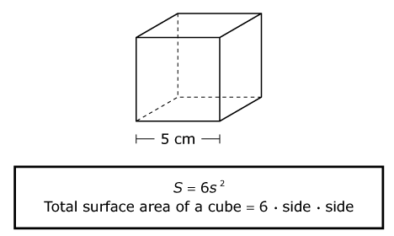

1. What is the volume of a cube with side length of 5 cm?
2. Find the area of the square attached to the hypotenuse in the diagram, where a = 5 cm and b = 12 cm.

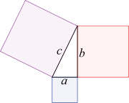

1. A circle is inscribed in a square with length of 20 cm. What is the area of the shaded region?

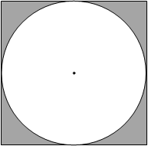

1. The formula for the volume of a cylinder is V = πr2h.Find the volume, V, of a cylinder with radius of 6 cm and a height of 5.4 cm. Express your answer to the nearest tenth of a cubic centimeter.
2. A pebble falls over a cliff. The formula that approximates the distance an object falls through air in relation to time is d = 4.9t2, where *d* is distance, in metres, and *t* is time in seconds. What distance would the pebble fall during 4 s of free fall?
3. A type of bacterium is known to triple every hour. There are 50 bacteria to start with. How many will there be after 5 hours?

**Homework:**

**Lesson 6 – Scientific Notation (Optional)**

Scientists need to express small measurements, such as the mass of the proton at the centre of a hydrogen atom (0.000 000 000 000 000 000 000 000 001 673 kg), and large measurements, such as the temperature at the centre of the Sun (15 000 000 K). To do this conveniently, they express the numerical values of small and large measurements in scientific notation, which has two parts.

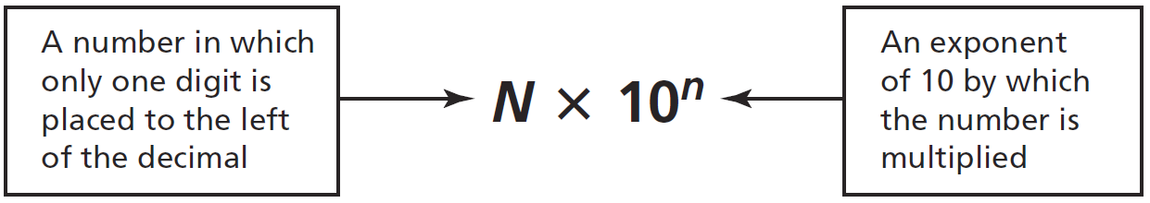

Thus, the mass of the proton is written as $1.673×{10}^{27}$ kg and the temperature of the Sun, 15 million Kelvin, is written as $1.5×{10}^{7}$ K in scientific notation.

**Positive Exponents:** Express 1234.56 in scientific notation

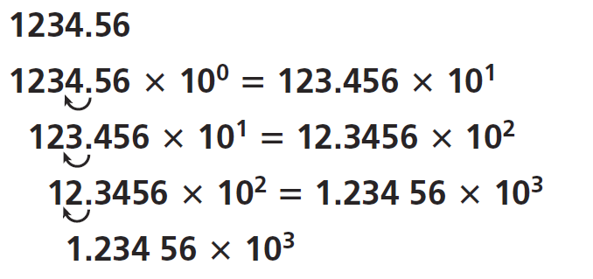Each time the decimal place is moved one place to the ____________, the exponent is _____________ by one.

**Negative Exponents:** Express 0.006 57 in scientific notation

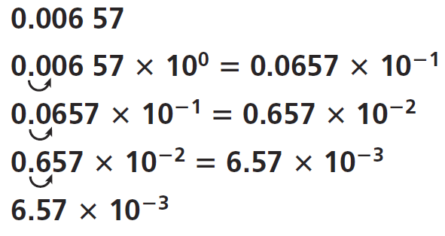Each time the decimal place is moved one place to the ____________, the exponent is _____________ by one.

Example 1: Express the following numbers in scientific notation

1. 230 =____________________
2. 5601=____________________
3. 14 100 000

=____________________

1. 56 million

=

$\frac{2}{10}$____________________

1. =____________________
2. 0.450 13

=____________________

1. 0.089=____________________
2. 0.000 26

=____________________

1. 0.000 000 698

=____________________

1. 12 thousandth

=____________________

=____________________

Example 2: Express each of the following in scientific notation

1. Speed of light in a vacuum, 299 793 458 m/s

=____________________________________________

1. Number of seconds in a day, 86 400 s

=____________________

1. Mean radius of the Earth, 6378 km

=____________________

1. Density of oxygen gas at 0°C and pressure 101 kPa, 0.001 42 g/mL

=____________________

1. Radius of an argon atom, 0.000 000 000 098 m

=____________________

Homework: