**WORKPLACE 10 - UNIT 2 – CONVERSION**

**Vocabulary: Unit 2**

base unit

foot (ft or ’)

imperial system

inch (in or ”)

mile (mi)

referent

Système international d’unités (SI)

yard (yd)

**THE METRIC SYSTEM**

The **Metric System** is a system of measurement based on multiples of 10, where the base unit for length is the metre. Since the 1960s, the International System of Units (SI) ("***S****ystème* ***I****nternational d'Unités*" in French, hence "SI") has been the internationally recognized standard metric system. Metric units are widely used around the world. To convert from one unit to another in the metric system, we multiply or divide by powers of 10 and attach a different prefix to the base unit (metre, for length). The standard set of prefixes used in the metric system and their meanings is found below.

|  |  |  |  |  |  |
| --- | --- | --- | --- | --- | --- |
| **PREFIX** | **SYMBOL** | **QUANTITY** | | | |
| tera | T | trillion | 1 000 000 000 000 | 1 000 000 000 000 | 1012 |
| giga | G | billion | 1 000 000 000 | 1 000 000 000 | 109 |
| mega | M | million | 1 000 000 | 1 000 000 | 106 |
| kilo | k | thousand | 1000 | 1 000 | 103 |
| hecto | h | hundred | 100 | 100 | 102 |
| deca | da | ten | 10 | 10 | 101 |
| basic unit |  | one | 1 | 1 | 1 |
| deci | d | one-tenth | 0.1 | 1/10 | 10-1 |
| centi | c | one-hundredth | 0.01 | 1/100 | 10-2 |
| milli | m | one-thousandth | 0.001 | 1/1000 | 10-3 |
| micro | µ | one-millionth | 0.000 001 | 1/ 1 000 000 | 10-6 |
| nano | n | one-billionth | 0.000 000 001 | 1/ 1 000 000 000 | 10-9 |
| pico | p | one-trillionth | 0.000 000 000 001 | 1/1 000 000 000 000 | 10-12 |

There are a lot of prefixes in the table above that we do not use on a daily basis, but no doubt you will have heard of many of these. My computer’s hard drive is measured in GB – gigabytes, while newer ones are measured in TB - terabytes. And a common measurement in science is a nanometere – it is very small!

There are some prefixes that you need to know, and the relationship between them. These are the prefixes from kilometre to millimetre – km to mm. They are km, hm, dam, m, dm, cm, mm. There is a little rhyme that might help you remember the order of these units: **King Henry died, Mary didn’t cry much**. Each first letter in this phrase, **khdmdcm**, represents the first letter in the corresponding unit, in order from km down to mm. The only area left for confusion is between decametres and decimeters. I remember these two because “a” comes before “i” in the alphabet and so decametres comes first in the little rhyme. **LEARN THIS RHYME!**

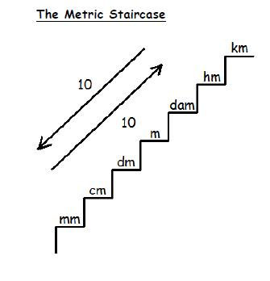When you know the prefixes in order, it is easy to use them. Make a set of stairs and label the top step “km” and the bottom step “mm” and then fill in the rest using the rhyme like is shown here.

Notice that I have also put two arrows beside the staircase. These are used for converting between the units on the staircase.

If you are going **DOWN** the stairs, you will multiply by 10 for *each* step – now you put a “×” sign on the left of the “10” going down.

If you are going **UP** the stairs, you will divide by 10 for *each* step – now you put a “÷” sign to the left of the “10” going up.

**YOU NEED TO LEARN THIS STAIRCASE** so you can use it as the order of the prefixes will NOT be given to you on the test or exam.

Another way to convert between the metric units is to either multiply or divide by 10 ***for each*** arrow as shown below.

km  hm  dam m  dm cm  mm  means × 10

km  hm  dam  m dm  cm  mm  means ÷ 10

As with every system of measurement, different base units are used for different types of measurement. The following chart shows the different base units in the metric system.

|  |  |  |
| --- | --- | --- |
| **MEASUREMENT** | **UNIT** | **SYMBOL** |
| length | metre | m |
| mass | gram | g |
| capacity | litre | L |
| temperature | degrees Celsius | 0C |

These other measurements can also use “The Staircase” by simply replacing the m for metres with an L for litres or a g for grams. Just think of replacing Mary with Larry or Gary in the rhyme!!

**Referents** – objects that represent approximately one unit of measurement - for these units include: mm – the thickness of a paperclip, cm – the width of an adult baby finger, metre – the length of a pace (2 steps) or the height of a standard doorknob, for a metre.

**Measuring** with a metric ruler is usually done in centimeters or millimeters. Metric rulers are fairly easy to read. They show centimeters and millimeters. Answers and measurements are recorded in decimal numbers rather than fractions.

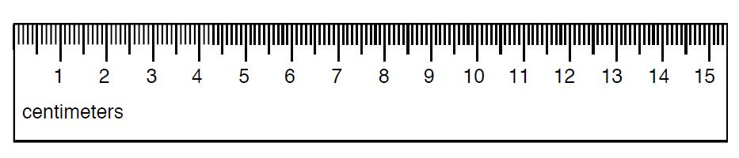Look at the ruler below:

The larger lines with the numbers show the centimeters and the smaller lines in between them represent millimeters. Remembering that there are 10 mm in 1 cm, if you measure 8 lines after the 2 cm line – the arrow below - the measurement is 2.8 cm long.



The measurement 2.8 cm can also be expressed as 28 mm.

**ASSIGNMENT 1 – THE METRIC SYSTEM**

**Part A** Choose the most sensible measure. Circle your answer.

1. Length of a small paper clip.

31 mm 31 cm 31 m 31 km

2. Length of a tennis racket.

68 mm 68 cm 68 m 68 km

3. Distance around a racetrack.

2 mm 2 cm 2 m 2 km

4. Length of a canoe

4 mm 4 cm 4 m 4 km

5. Length of a key.

54 mm 54 cm 54 m 54 km

6. Height of a woman.

160 mm 160 cm 160 m 160 km

7. Width of a room.

8 mm 8 cm 8 m 8 km

8. Distance from Vancouver to Hope.

125 mm 125 cm 125 m 125 km

9. Length of a bowling alley.

18 mm 18 cm 18 m 18 km

10. Height of a giant redwood tree.

67 mm 67 cm 67 m 67 km

11. Length of a safety pin.

26 mm 26 cm 26 m 26 km

12. Width of a desk.

75 mm 75 cm 75 m 75 km

13. Long-distance run.

10 000 cm 10 000 m 10 000 km

**Part B** Convert the following measurements as indicated, using the Data Pages to help. SHOW YOUR WORK!

1. 38 km × 1000 = 38 000 m
2. 0.4 km ____________ = _______ cm
3. 758 mm ___________ = ________ m
4. 0.52 km __________ = _______ mm
5. 8.5 m ___________ = ________ mm
6. 2460 mm _________ = ________ cm
7. 155 cm __________ = _________ m
8. 1.6 m ___________ = _________ km
9. 1245 m __________ = ________ km
10. 247 cm _________ = ________ mm
11. 16.5 m _________ = _________ cm
12. 2500 mm ________ = ________ km

Note: These units above are the common units used. Students are also responsible for knowing the less common units as illustrated in the following conversions.

1. 30 dam ________ = _________ m
2. 67 dm _________ = ________ cm
3. 456 m __________ = _______ dam
4. 920 mm _________ = ________ dm
5. 7800 hm _________ = ________ km
6. 11 km __________ = _________ dm

**Part C** Solve the following questions. Show all your work.

1) The diameter of a loonie is about 26.5 mm. What is this measurement in centimetres?

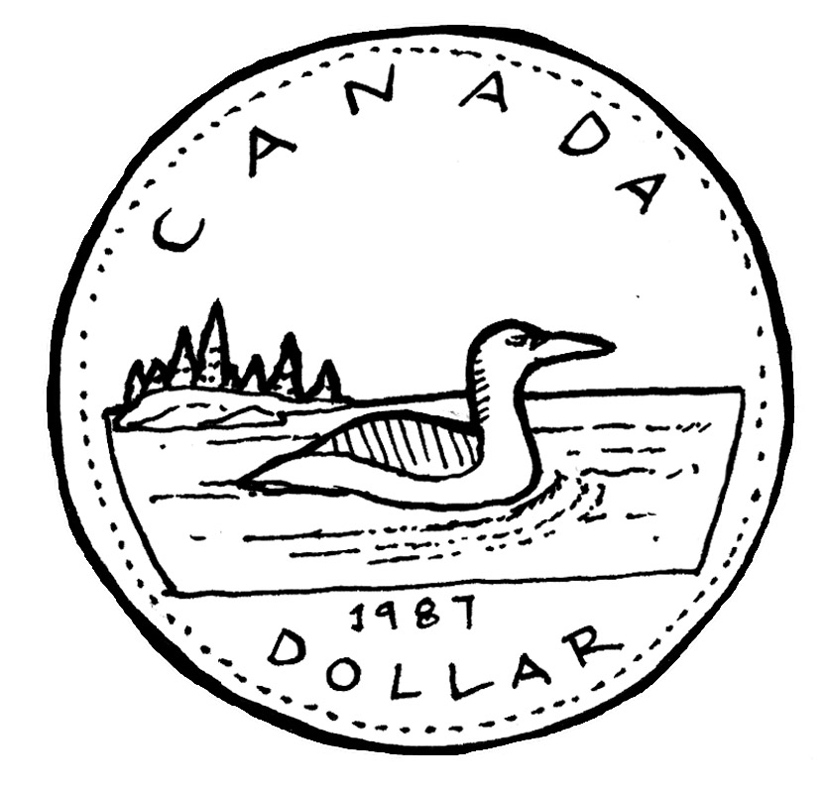

2) A tree house is 1.2 m high. If each step is 20 cm high, will you need more or less than seven steps reach the tree house?

3) Nora needs 35 tiles for a floor. She finds a stack of tiles that is 0.5 m high. If each tile is 1.2 cm thick, are there enough tiles in the stack for her project?

4) William wants to put Christmas lights along the peak and edges of his roof. (bolded edges - see below)

a) How many metres of lights will he need? 5 m

5 m

28 m

b) Express this length in cm.

**Part D**

State the length in cm and mm for all the objects measured on the rulers below.

1)

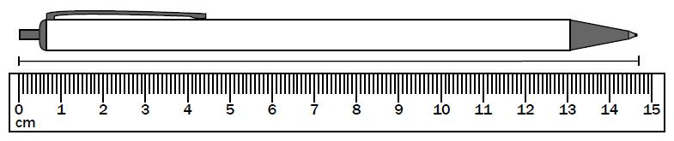

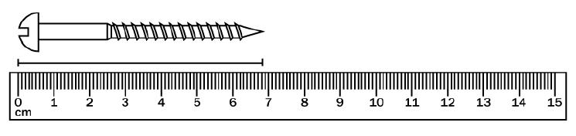2)

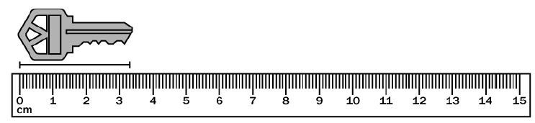3)

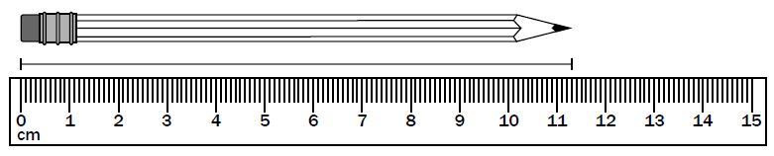

4)

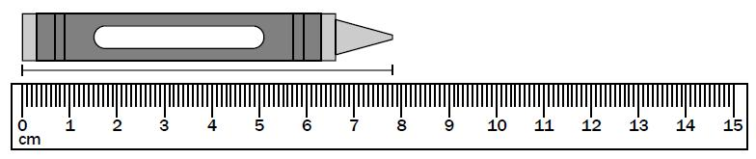5)

**THE IMPERIAL SYSTEM**

The **Imperial System** of measurement or **Imperial units** is a set of units, with the foot being the base unit. The units were introduced in the United Kingdom and the Commonwealth countries, but most countries now use the metric system. The exception is the United States. For measurements of length, the imperial system uses inches, feet, yards, and miles. It is important to be familiar with imperial measurements because they are still used in many areas like construction, and because the United States is so close to Canada.

**Referents** for these units include: inch – the width of an adult thumb, foot – the length of an adult foot, yard – the length from the nose to the end of the outstretched fingertip

The relationship between the units in the imperial system is not as friendly as the metric system. To convert between units requires knowledge of the divisions as shown below.

÷ 12 ÷ 3 ÷ 1760

inches  feet  yards  miles

inches  feet  yards  miles

× 12 × 3 × 1760

1 mile = 1760 yd

1 mile = 5280 ft

1 yd = 3 ft = 36 in

1 ft = 12 in

The standard units used in the metric system (for length) are shown below.

|  |  |
| --- | --- |
| **UNIT** | **SYMBOL** |
| inch | " or in. |
| foot | ' or ft. |
| yard | yd. |
| mile | mi. |

This imperial ruler shows inches which are divided into 16th. Often, rulers show the first inch divided into 32nd of an inch. Each inch on the ruler is marked with a long line and is labeled 1, 2, 3, 4, and so on. In between each inch marker is another long line which marks each half inch. In between each of these divisions is a slightly longer line which marks each quarter (¼) of an inch.

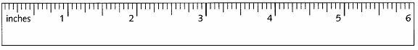

**ASSIGNMENT 2 – IMPERIAL SYSTEM**

**Part A**

To measure a length using an imperial ruler, count the whole number of inches, and then count the number of 16th of the next inch until the mark is reached. For example, letter H below is pointing at a measurement of 5  in.

1. State the length (to the closest  th of an inch) for all the points on the ruler below.

A B C D E F G H



2. Find the length of the lines below to the closest th of an inch.

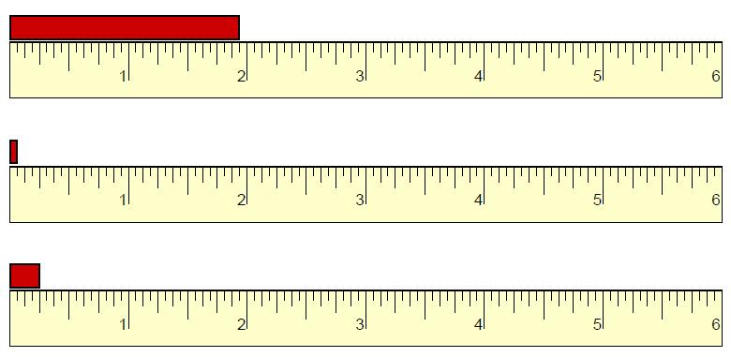a)

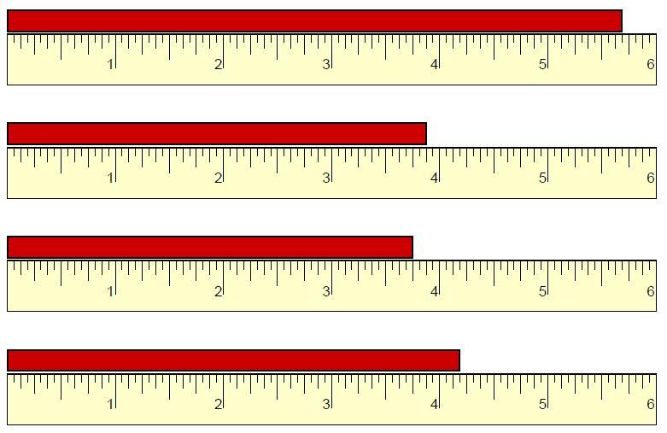b)

c)

d)

3) Convert the following measurements. SHOW YOUR WORK!

1. 38 ft _________________________________ = ___________________ in
2. 0.4 mi ________________________________ = __________________ yd
3. 7.5 mi _________________________________ = _________________ ft
4. 72 in __________________________________ = _________________ ft

4) Ray is building a fence around his yard using pre-made panels that are sold in 8 ft lengths. The perimeter of the yard is 32 yd. How many fence panels should he buy?

---------------------------------------------------------------------------------------------------------------------

Often Imperial Units are used in combination. These need to be converted to only one unit.

Example, Jan might say she is 5 ft 10 in tall.

How tall is Jan in inches? How tall is Jan in feet?

Jan’s height in inches is: Jan’s height in feet is:

**Part B**

5) Convert the following measurements.

1. 7 yd 2 ft _______________________________________ = ____________ ft
2. 3 yd 1 ft _______________________________________ = _____________ in
3. 9 yd 11 ft ______________________________________ = _____________ ft
4. 7 mi 2 yd ______________________________________ = _____________ ft
5. 5 mi 16 yd 2 ft __________________________________ = ______________ in

6) The Olympic Marathon is a running race that is 26 miles 385 yards long. If Sebastian’s stride is about 1 yard long, how many strides will he take in a marathon run?

7) If each board in a fence is 6 inches wide, how many boards will Josée need to fence all 4 sides of a playground that is 60 ft wide by 125 feet long?

8) Riley bought 50 ft of rope. He cut off pieces that total 34’ 8” so far. How much rope does he have left?

9) A circular garden has outside circumference (perimeter of a circle) of 23 feet. If a geranium is planted every 6 inches around the garden, how many geraniums are needed?

10) A pet store has 10 cages for sale. They are 5 cages that are 2’8” wide, 3 cages that are 4’6” wide, and 2 cages that are 1’8” wide. Can these cages fit side by side along a wall that is 30’ long?

Imperial Units are also stated in fraction form, but can be converted to decimal form. Using decimal form is easier when converting measurements.

Example: A staircase is 4 ¾ feet long. What is this height in inches?

**Part C**

11) Convert the following measurements.

1. 6 ¼ yd _______________________________________ = ______________ ft
2. ¼ ft _________________________________________ = ______________ in
3. 2 ¾ mi _______________________________________ = ______________ ft
4. 4 ½ mi _______________________________________ = _____________ yd

**CONVERTING MEASUREMENTS BETWEEN SYSTEMS**

It is important to be able to convert metric units to imperial units, and vice versa. Below are the common conversions used in the Data Pages for units of length. Note that the sign “≈” means approximately. These conversions are not exact but are what will be used for this course. Online conversions calculators give more precise conversions if needed.

**1 inch ≈ 2.54 centimetres**

**1 foot ≈ 30.48 centimetres**

**1 foot ≈ 0.3048 metres**

**1 yard ≈ 0.9144 metres**

**1 mile = ≈ 1.609 kilometres**

These conversion factors came from your **DATA PAGES.** Use them to help you make conversions!.

Example 1: Convert 24 ft ___________ = __________ m

Example 2: Andrea’s height is 5’8”. What is her height in centimetres?

Solution:

Example 3: Convert 675 in. ___________ = _________ m

Solution:

**ASSIGNMENT 3 – CONVERTING MEASUREMENTS BETWEEN SYSTEMS**

1) Convert the following measurements. SHOW YOUR WORK! Round your answers to **two** decimal places. The first one is done for you.

1. 8 in × 2.54 = 20.32 cm f) 27 cm __________ = ________ in
2. 9.5 mi __________ = ________ km g) 1.5 m __________ = _________ ft
3. 25 yd __________ = _________ m h) 123 km __________ = _________ mi
4. 67 ft __________ = __________ m i) 145 in __________ = _________ cm
5. 24 ft __________ = _________ cm j) 55 cm __________ = _________ ft

2) Mount Logan is Canada’s highest mountain. It measures 19 551 ft. What is that height in metres? Round your answer to **one** decimal place.

3) The Capilano Suspension Bridge in North Vancouver is 173 m across and 70 m above the river. What are these distances in feet? Round your answers to **one** decimal place.

4) Jiri’s boat and trailer is 20 ft 6 in. long. His garage is 6.2 m long. Will the boat and trailer fit in his garage? Round your answer to **4** decimal places. (Change ft & in to metres)

5) Charlie drove from Calgary to Saskatoon. If this distance is 620 km, how far is this in miles? Round your answer to **one** decimal place.

6) Carla needs 3.5 m of cloth. However, the cloth she wants to buy costs $9.79 per yard. How much will this cloth cost? Round the yards to 2 decimal places.

7) A nickel is 1.95 mm thick. About how long is a $2.00 roll of nickels in inches? Round your answer to the nearest whole inch. Hint: How many nickels (5¢) are in $2.00?

8) An airline has size limits for checked baggage. The length, width and height of alll luggage must add up to no more than 157 cm. Will the airline accept a suitcase that measures 17 in. by 26 in. by 14 in.?

**ASSIGNMENT 4 – Metric and Imperial Estimation**

Different units are appropriate to be used when estimating or stating the size of something. For example, you wouldn’t say that the desk you are sitting at is so many kilometres long, or the distance you live from school is that many millimetres. These are not appropriate units.

1. Complete the following chart. Write the appropriate **units** for each measurement. **Choose from the following: metric – mm cm, m, km**

**imperial – in., ft., mi. (yds are used in sports)**

|  |  |  |
| --- | --- | --- |
| Item | Metric | Imperial |
| Length of a Translink bus |  |  |
| Length of a $20 bill |  |  |
| Height of a 1-story building |  |  |
| Width of your pencil |  |  |
| Size of your big screen TV |  |  |

2. Estimate the following lengths in both metric and imperial. Give both a number and the appropriate units.

|  |  |  |
| --- | --- | --- |
| Item | Metric | Imperial |
| Length of a your desk |  |  |
| Length of a pencil |  |  |
| Height of a flagpole |  |  |
| Width of an eraser |  |  |
| Distance from Surrey to Vancouver |  |  |

Quiz next class.**PERIMETER**

*The distance around any geometric shape* is known as the **perimeter**. To calculate the perimeter, simply add the lengths of all the sides together. Perimeter is always in linear units: cm, in, ft, m, etc.

4 m 5m

6 m 6 m

4 m

The perimeter of this figure is:

*P* =

---------------------------------------------------------------------------------------------------------------------

A rectangle has a special formula that can be used to calculate its perimeter. The perimeter is two of the length plus two of the width. It doesn’t matter which side is called the length and which one is called the width. In math terms, this means times the length plus two times the width.

*P* = **2 × *l +* 2 *× w***

4 cm

6 cm

*P* = **2 × *l +* 2 *× w***

*P* =

*P* =

*P* =

The perimeter of **EVERY** figure is always calculated in the units given in the question. If the units in the figure are cm, the perimeter is cm; if it is in inches, the perimeter is in inches, and so on.

**When solving word problems, ALWAYS draw a diagram to help you!**

**ASSIGNMENT 5 – PERIMETER**

Calculate the perimeter of the following figures. Show your work and include the proper units in your answer.

1a)

18.3 cm

8.5 cm

b)

12.3 cm

9.6 cm

6.2 cm

5.1 cm

10.3 cm

c)

0.9 m

1.2 m

0.9 m

2.3 m

2) Darlene is adding lace to the edge of a tablecloth. The tablecloth is 210 cm by 180 cm. How many centimetres does she need to go all the way around the tablecloth?

3) Chandra is building a fence around her swimming pool to completely surround it. The pool is 25 feet long and 12 feet wide. There is a 6 ft walkway around the entire pool. How much fencing will she need?

walkway

POOL

6 ft 6 ft

4) A rectangular city pool is 40 ft wide and has a perimeter of 230 ft. What is the length of the pool?

*l*

40 ft P = 230 ft

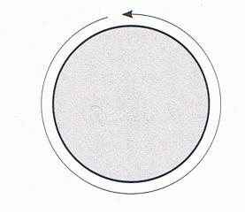**CIRCUMFERENCE**

The perimeter of a circle has a special name and formula as it is impossible to “measure” a circle’s sides! The special name for perimeter of a circle is the **circumference**.

The formula for circumference of a circle is:

**C = 2π*r***  OR **C = π*d***  where ***r*** = radius of a circle

***d*** = diameter of a circle

π = pi, a constant found on your calculator.

It has a value of approximately 3.14159

The diameter is ***twice*** the size of the radius, or the radius is ***half*** the size of the diameter. In this circle, the diameter d = 14 m so the radius = 7 m.

***d* = 14 m**

***r* = 7 m** Thus the circumference calculation is:

**C = 2π*r*** OR **C = π*d***

**C = C =**

**C = C =**

Use the **π** button on your calculator. If you have difficulty finding it, please ask your teacher.

Just like straight edged shapes, the perimeter of circles is always calculated in the units given in the question. If the units in the figure are cm, the perimeter is cm; if it is in inches, the perimeter is in inches.

**ASSIGNMENT 6 – CIRCUMFERENCE**

Use the π button on your calculator. Include the proper units in your answer. Round each answer to one decimal place. SHOW YOUR WORK!

tunnel

1) Simon works for Surrey Water Department. He is ordering the liner for

a new overflow tunnel at the pumping station. The tunnel is shown to the right.

a) What is the radius of the tunnel? 24 ft

Radius = diameter ÷ 2

= _______ ft ÷ 2

= _______ ft

b) What is the circumference of the tunnel? Show these 2 ways to calculate it.

Circumference = 2 × π × radius Circumference = π × diameter

= 2 × π × _________ ft = π × _________ ft

= ____________ ft = _________ ft

The circumference of the tunnel liner should be _______________ ft.

2) Calculate the circumference of the following circles. (2 decimal places)

a) b)

6.7 cm 18.5mm

3) A circular fountain has a radius of 10.6 m. What is its circumference? (one decimal place)

4) Michelle is a cake decorator. Her icing bag holds enough icing to make 22 cm

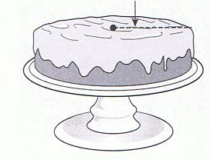a line 4.6 m long. She wants to draw circles around the top edges on some

cakes like seen here.

a) What is the circumference of this cake? (one decimal place)

b) How many whole cakes like this one can Michelle draw these circles on with one full icing bag?

5) The sides of a flower garden are shown in the diagram below. What is the perimeter of the flower garden? (one decimal place)

 4 m

6) Mike sells tires. A customer told him the circumference of the wheel rim on his tires, but Mike needs the diameter to get the correct tire size. If the circumference of the customer’s rim is 66 in., what is the diameter? (closest whole number)

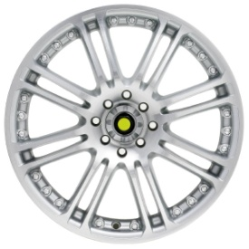

Practice Test Next Class

Test:___________________