**Unit 1**

**Proportional Reasoning**

Objectives:

* to draw enlargements and reductions to scale
* to identify scale diagrams and interpret the scale factor
* to determine the scale factor from scale diagrams
* to determine similar triangles and similar polygons
* to solve problems using the properties of similar triangles and similar polygons

**Lesson 1 – Enlargements and Reductions (4.1)**

Sometimes it is necessary to enlarge or reduce a figure such as when you want a picture to fit into a smaller space, or to increase the dimensions of an object to fit in a larger space

Use the grid paper below and:

1. enlarge the square three times;
2. reduce the rectangle by ½;
3. double the size of the triangle.

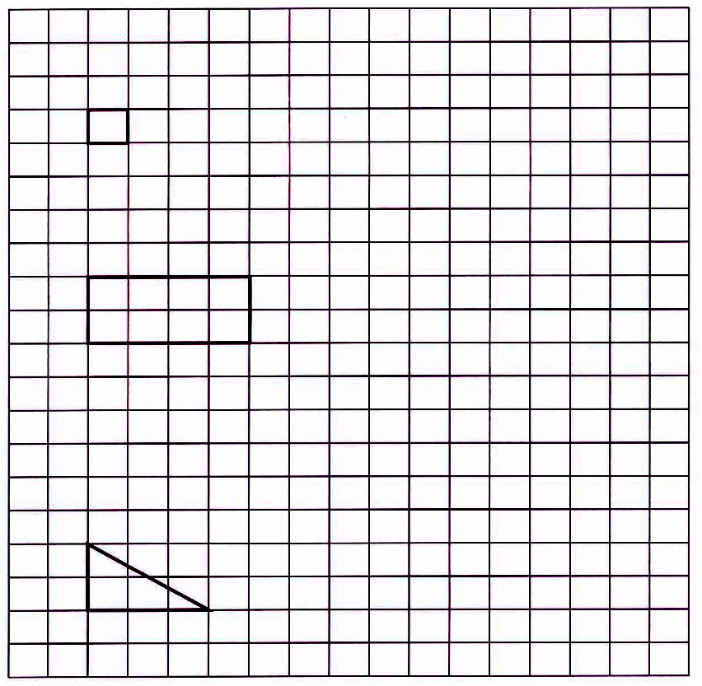

**Scale Factors:** The constant factor by which *all* dimensions of an object are \_\_\_\_\_\_\_\_\_\_\_\_\_\_\_\_\_\_\_\_\_\_\_\_\_\_\_\_\_\_\_\_\_\_\_\_\_\_\_\_\_\_\_\_\_\_\_\_\_\_\_\_\_\_\_\_\_\_\_\_\_\_\_\_\_.

If the scale factor is 1 then that means there was \_\_\_\_\_\_\_\_\_\_\_\_\_\_\_\_\_\_\_\_\_\_\_\_\_\_.

If the scale factor is greater than 1 then that means there was \_\_\_\_\_\_\_\_\_\_\_\_\_\_\_\_.

If the scale factor is between 0 and 1then that means there was \_\_\_\_\_\_\_\_\_\_\_\_\_\_\_.

Ex. A scale factor of 4 means \_\_\_\_\_\_\_\_\_\_\_\_\_\_\_\_\_\_\_\_\_\_\_\_\_\_\_\_\_\_\_\_\_\_\_\_\_\_\_\_\_\_. In another words, all the dimensions of the object were multiplied by four to create the image.

Using the above examples, determine the scale factors of each of the figures:

Square: Rectangle: Triangle:

*Example 1: Use a scale factor of 2 to draw an enlargement of the letter V.*

*Enlargement*

**Actual Drawing**

|  |  |
| --- | --- |
| ta04_01_14  2-cm grid | **ta04_01_13**  1-cm grid |

The scale factor can be found by comparing a measurement on the drawing (new image) to the same measurement taken from the actual (original) diagram or object.

ta04_01_32

Drawing🡪 Actual Length of this Flag 🡪 100 cm

1. Express as a proportion (**units must be the same**)

2. The scale factor is $D÷A$ or $\frac{D}{A}$ expressed as a fraction in lowest terms

3. The *scale* is D : A = 1:\_\_\_\_\_\_\_\_.

*Homework*:

**Lesson 2– Scale Diagrams (4.2)**

In this section, you will learn how to determine the scale factor or the original size of a given diagram using *proportions*.

**Proportion:** is a relationship that shows \_\_\_\_\_\_\_\_\_\_\_\_\_\_\_\_\_\_\_\_\_\_\_\_\_\_\_\_\_\_\_\_.

It can be written as a \_\_\_\_\_\_\_\_\_\_\_\_\_\_\_\_\_ or as a \_\_\_\_\_\_\_\_\_\_\_\_\_\_\_\_\_\_.

**Solving proportions**: there are many methods you can use. A useful method is to cross-multiply the numbers that fill the diagonal and divide by the number left to find the missing number.

Practice with Proportions – Find the missing number.

(a) 4 : 7 = \_\_\_\_\_ : 35 (b) 2 : 3 = 24 : \_\_\_\_\_

(c) \_\_\_\_\_ : 5 = 18 : 30 (d) 

(e)  (f) 

**Scale Diagram**: is a proportionally \_\_\_\_\_\_\_\_\_\_\_\_\_\_\_\_\_ or \_\_\_\_\_\_\_\_\_\_\_\_\_\_\_\_\_\_ version of the actual object.

**Scale:** a comparison \_\_\_\_\_\_\_\_\_\_\_\_\_\_\_\_\_\_\_\_\_\_\_\_\_\_\_\_\_\_\_\_\_\_\_\_\_\_\_\_\_\_\_\_\_\_\_\_\_:

scale can be expressed as a \_\_\_\_\_\_\_\_\_\_\_, as a \_\_\_\_\_\_\_\_\_\_\_, as a \_\_\_\_\_\_\_\_\_\_\_, in words, or in a diagram.

Example: the scale 1:15 means that 1 cm on the diagram represents 15 cm on the actual image.

If the scale is 1:15, the scale factor is 1divided by 15, which equals, 0.0666…

****

Example 1: Calculate the actual length of each object.

**a)** The scale for the image of the scooter is 1: 20.

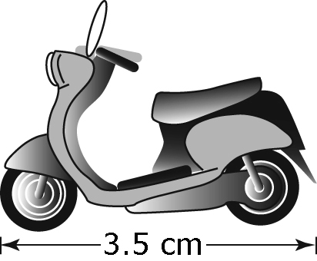

**b)** The scale for the enlarged image of a housefly is 1: 0.3.

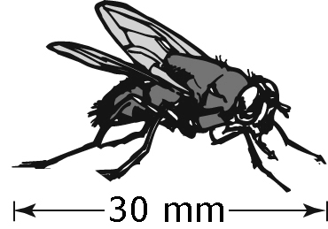

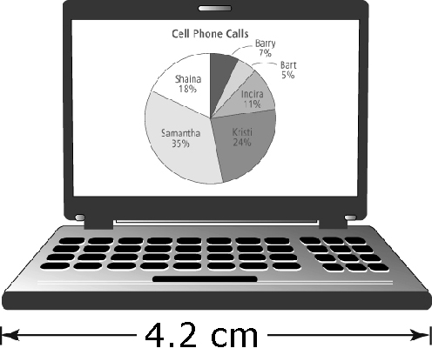Example 2:An actual laptop has a width of 39.5 cm.Calculate the **scale** and **scale factor** used in the image   
of the laptop. Express the answer to the nearest tenth.

*Homework*:

**Lesson 3 - Metric Conversions and Determining the Scale and Scale Factor when Units Differ**

King Henry Died, Mary Didn’t Care Much

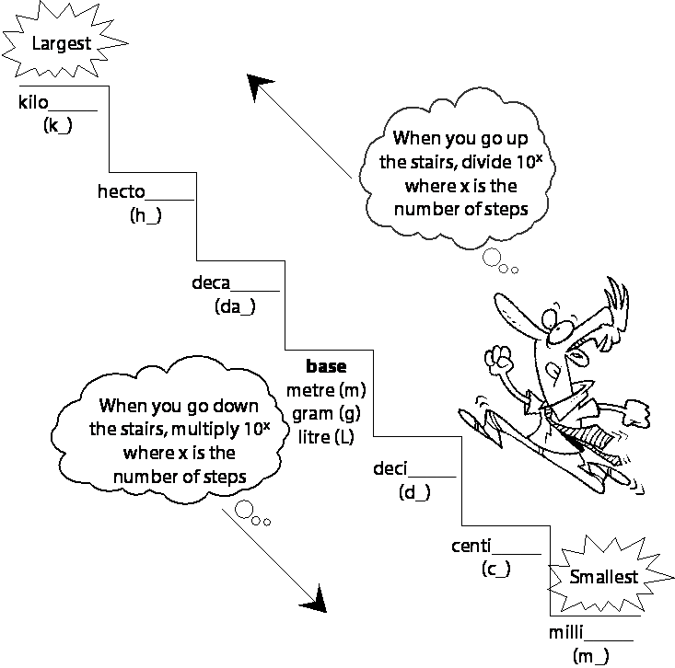Kilo Hecto Deca  *(metre)*  Deci Centi Milli  
 *(litre/gram)*

1. 19 km =\_\_\_\_\_\_\_\_\_\_\_\_m 7. 200hm =\_\_\_\_\_\_\_\_\_\_cm
2. 0.05 cm =\_\_\_\_\_\_\_\_\_\_\_\_dam 8. 3.4 cm =\_\_\_\_\_\_\_\_\_\_mm
3. 0.37 km =\_\_\_\_\_\_\_\_\_\_\_\_\_cm 9. 0.4 dm =\_\_\_\_\_\_\_\_\_\_hm
4. 25 m =\_\_\_\_\_\_\_\_\_\_\_\_\_mm 10. 245 m =\_\_\_\_\_\_\_\_\_\_dam
5. 2258 cm = \_\_\_\_\_\_\_\_\_\_\_\_m 11. 51 cm =\_\_\_\_\_\_\_\_\_\_\_m
6. 58 mm = \_\_\_\_\_\_\_\_\_\_\_\_cm 12. 5.64 km=\_\_\_\_\_\_\_\_\_dm

The flying distance from Dawson City to Whitehorse is 540 km. The distance on the map is 3 cm.

ta04_02_04

**a)** Find the scale of the map.



$$\frac{3 cm}{540 km} =\frac{1 cm}{_______ km}$$

scale: 1 cm represents km

**b)** What is the scale factor? If the scale is 1cm represents \_\_\_\_\_\_km

1 km = 100 000 cm

So, 180 km = cm.

***Note: to determine scale factor must have same units!***

So, 1 cm on the map represents cm of actual distance.

The scale is 1: . The scale factor is .

***Homework*:**

**Lesson 4 – Similar Triangles (Part 1) (4.3)**

Two conditions that indicate that a pair of triangles is similar are:

1. \_\_\_\_\_\_\_\_\_\_\_\_\_\_\_\_\_\_\_\_\_\_\_\_\_\_\_\_\_\_\_\_\_\_\_\_\_\_\_\_\_\_\_\_\_\_\_\_\_\_\_\_\_\_\_\_\_\_\_
2. \_\_\_\_\_\_\_\_\_\_\_\_\_\_\_\_\_\_\_\_\_\_\_\_\_\_\_\_\_\_\_\_\_\_\_\_\_\_\_\_\_\_\_\_\_\_\_\_\_\_\_\_\_\_\_\_\_\_\_

For Example:

|  |  |
| --- | --- |
| D  E  F  G  H  K | Corresponding angles  Corresponding sides |

The symbol used for similar is “~” (tilde)

In the example above we could say that ∆HGK ~ ∆FED

NOTE: Order is very important when working with similar triangles.

The following pair of triangles is similar. Write the corresponding sides.

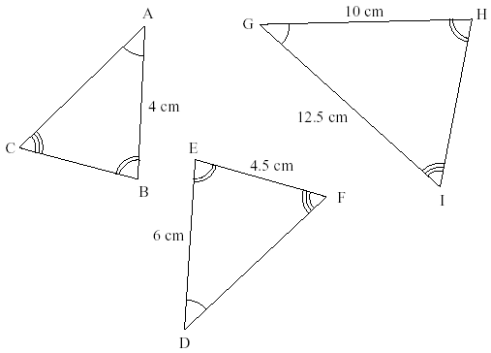



The following pair of triangles is similar. What are the measures of the all the angles?

Polygon4

Check to see if these are similar triangles.

4.4 cm 6.6cm

5 cm

7.5 cm

3 cm

4.5 cm

4.5 cm

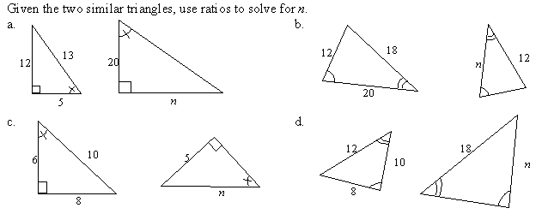



*Homework*:

**Lesson 5 – Similar Triangles (Part 2) (4.3)**

Recall: properties of parallel lines and a transversal line

Transversal:\_\_\_\_\_\_\_\_\_\_\_\_\_\_\_\_\_\_\_\_\_\_\_\_\_\_\_\_\_\_\_\_\_\_\_\_\_\_\_\_\_\_\_\_\_\_\_\_\_\_\_\_\_\_\_\_

Corresponding angles (F-rule):

Alternate interior angles (Z-rule):

Vertically opposite angles (X-rule):

Co-interior angles (C-rule):

Angles on a line:

Angles in a triangle:

|  |  |
| --- | --- |
| Calculate and write the values for x using the similarity of the triangles shown below. | |
| Polygons5 | Polygons6 |
| Polygons7 | Polygons8 |

A pole 3.8 m high casts a shadow that measures 1.3 m. A nearby tree casts a shadow 7.8 m long. Find the length of the tree.

Determine the height of the building using the length of the shadow produced by the 3.5 m flagpole at the top of the building and using the shadow produced by the building.

3.5m

4.2 m

h

21 m

*Homework*:

**Warm up – Similar Triangles and Scale Factor**

1. ta04_02_10Find the scale factor for each enlargement or reduction. Use D/A

|  |  |
| --- | --- |
| **a)** from A to B | **b)** from A to C ta04_02_10 |
| **c)** from B to A | **d)** from C to A |

2. Are the triangles similar? *Find the third angle! Then answer question!*

**a)** The angles of the first triangle are 45° and 75°.

The angles of the second triangle are 45° and 60°.

\_\_\_\_\_\_\_\_\_\_\_\_\_\_\_\_\_\_\_\_\_\_\_\_\_\_\_\_\_\_\_\_\_\_\_\_\_\_\_\_\_\_\_\_\_\_\_\_\_\_\_\_\_\_\_\_\_\_\_\_\_\_\_\_\_\_\_\_\_\_\_\_\_\_

**b)** The angles of the first triangle are 60° and 70°.

The angles of the second triangle are 50° and 80°.

\_\_\_\_\_\_\_\_\_\_\_\_\_\_\_\_\_\_\_\_\_\_\_\_\_\_\_\_\_\_\_\_\_\_\_\_\_\_\_\_\_\_\_\_\_\_\_\_\_\_\_\_\_\_\_\_\_\_\_\_\_\_\_\_\_\_\_\_\_\_\_\_\_\_

**3.** Use a **scale factor** to determine if these triangles are similar.

**ta04_03_17**

VW

                  

  

Are the triangles similar? Circle YES or NO. Give 1 reason for your answer.

\_\_\_\_\_\_\_\_\_\_\_\_\_\_\_\_\_\_\_\_\_\_\_\_\_\_\_\_\_\_\_\_\_\_\_\_\_\_\_\_\_\_\_\_\_\_\_\_\_\_\_\_\_\_\_\_\_\_\_\_\_\_\_\_\_\_\_\_\_\_\_\_\_\_

1. ΔGHI ~ ΔKLM.

ta04_03_13

Find the missing side length using a proportion.

 🡪

*x* = The missing side length is units.

**Lesson 6 – Similar Polygons (4.4)**

Polygons: A two-dimensional closed figure made up of three or more line segments e.g. triangle, rectangle, trapezoid, pentagon, hexagon, etc.

Similar Polygons: Figures with the same shape, but not necessarily the same size. Like similar triangles, similar polygons must satisfy 2 conditions:

1. \_\_\_\_\_\_\_\_\_\_\_\_\_\_\_\_\_\_\_\_\_\_\_\_\_\_\_\_\_\_\_\_\_\_\_\_\_\_\_\_\_\_\_\_\_\_\_\_\_\_\_\_\_\_\_\_\_\_\_
2. \_\_\_\_\_\_\_\_\_\_\_\_\_\_\_\_\_\_\_\_\_\_\_\_\_\_\_\_\_\_\_\_\_\_\_\_\_\_\_\_\_\_\_\_\_\_\_\_\_\_\_\_\_\_\_\_\_\_\_

Example: Is the following pair of quadrilaterals similar? Support your answer.

A

B

C

D

A’

B’

C’

D’

78o

78o

102o

102o

3

5

8

4

5.1

4.8

6.4

8.16

1. The polygons below are similar. Determine the missing side length.

Polygon2

Polygon1

1. Polygon3
2. These two octagons are similar. Determine the length of the diagonal of the octagon to the right.

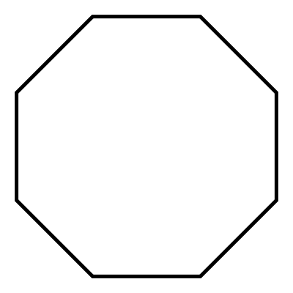

3.4 cm 1.3 cm 2.0 cm

*Homework*: