**WORKPLACE 10 – UNIT 1 – RIGHT ANGLE TRIANGLES**

**Vocabulary: Unit 1**

angle of depression

angle of elevation

cosine

hypotenuse

leg

Pythagorean Theorem

Pythagorean Triple

right triangle

sine

tangent

**TRIANGLES**

In this unit, you will be looking at triangles, specifically right angle triangles, also called right triangles. You will learn about Pythagorean Theorem and the basic trigonometric ratios. But first it is necessary to start with some facts about triangles.

Fact 1: Every triangle contains 3 sides and 3 angles or vertices (plural of vertex).

Fact 2: The measurements of these angles always total 1800. Remember this from the

last unit??

Fact 3: To identify the side or vertex in a triangle, it is important to label the triangle following a standard routine. Each vertex of a triangle is labeled with a capital case letter – like “A” - and each side is labeled with the lower case letter that matches the opposite vertex. An example is below.

A

c b

B a C

Another way to label the sides is with the capital letters of the two vertices the side connects. An example is below.

A

c b

B a C

Side *a* can be called BC.

Side *b* can be called AC.

Side *c* can be called AB.

**ASSIGNMENT 1 – LABELLING TRIANGLES**

1) Label each side of the triangles below using a single lower case letter matching the opposite vertex.

a) X b)

R

Y Z S T

c) d)

D A

E

B C

F

2) Label each vertex of the triangles below using a single capital letter matching the opposite side.

a) b)

f

a b d e

c

c) d)

x

p

w

q

r y

**PYTHAGOREAN THEOREM**

Pythagorean Theorem states the relationship between the sides of a right triangle. So, more facts about triangles are necessary.

Fact 4: A triangle that contains a 900 angle (a right angle) is called a right triangle (or right-angle triangle).

Fact 5: The side of the triangle that is opposite the 900 angle is always called the **hypotenuse**. It is labelled in the triangle below. The other two sides of the triangle are called legs.

hypotenuse

Fact 6: The hypotenuse is always the longest side in the triangle. It is always opposite the largest angle which is the 900 or right angle.

Fact 7: Pythagorean Theorem states that in any right triangle, the sum of the squares of the lengths of the legs is equal to the square of the length of the hypotenuse. So in ΔABC with the right angle at C, the following relationship is true:

c2 = a2 + b2

where a and b are the other 2 legs of the triangle.

c

b

a

Often Pythagorean Theorem is illustrated as the square of the sides as follows:

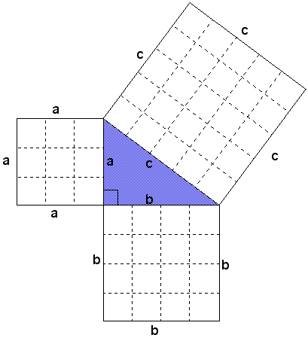Notice that the length of side a is 3 boxes, side b is 4 boxes, and side c is 5 boxes. So if we calculate the area of each square, the following is true:

c × c = c2 = 5 × 5 = 25

b × b = b2 = 4 × 4 = 16

a × a = a2 = 3 × 3 = 9

And we know that

c2 = a2 + b2

So 25 = 9 + 16 which is a true statement!

We can also rearrange the equation to find the length one of the legs;

c2 = a2 + b2

a2 = c2 – b2

b2 = c2 – a2

When we use Pythagorean Theorem to find a length of the hypotenuse or a leg, you need to have a calculator that has the square root function on it. The computer symbol looks like this: √ or

**ASSIGNMENT 2 – EXPLORING PYTHAGOREAN THEOREM**

1) Using the following triangles, use lettering provided to state the Pythagorean relations that apply.

a) b) E F

X

z y

D

Y x Z

2) Find the missing value in each of the following to 2 decimal places. Remember to use the square root to solve for each final side length. An example is done for you.

Example: b2 = 52 + 122

b2 = 25 + 144

b2 = 169

b = = 13

a) p2 = 62 + 92 b) m2 = 42 + 72

c) y2 = 82 – 52 d) z2 = 102 – 52

3) Calculate the missing side length (x) in each triangle to 1 decimal place (as needed).

a) b)

x

x 15 15

8

9

6

c) d)

12 16

20 x x

34

**MORE PYTHAGOREAN THEOREM**

Pythagorean Theorem can be used to solve for an unknown side in a right triangle. It is important to recognize if you are trying to solve for the hypotenuse or one of the legs. If you are solving for the hypotenuse, you will add the squares of the other two sides, getting a larger side length (the hypotenuse is the longest side length). But if you are given the hypotenuse, subtract the square of the leg from the square of the hypotenuse in order to get a smaller side (than the hypotenuse).

Example 1: Use Pythagorean Theorem to find the length of the missing side to one decimal place.

P

Solution:

3.8 cm q

Q 5.2 cm R

Example 2: Use Pythagorean Theorem to find the length of the missing side to one decimal place.

A

Solution:

b 12.8 in

C 8.78 in B

**ASSIGNMENT 3 – USING PYTHAGOREAN THEOREM IN PROBLEM SOLVING**

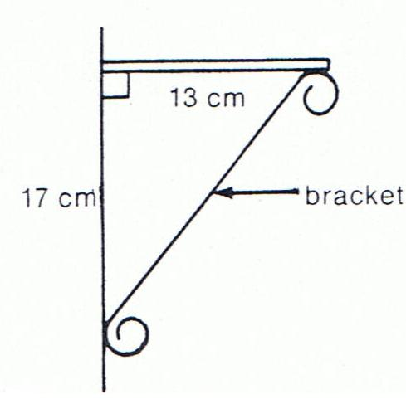

1) Solve for the length of the bracket in the picture, to one decimal place.

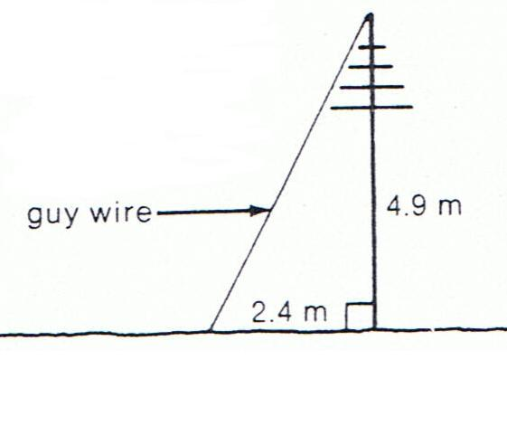2) What is the length of the guy wire in the picture below, to one decimal place?

3) A ramp into a house rises up (↑) 3.5 meters over a horizontal distance (→) of 10.5 metres. How long is the ramp? Use the triangle below and show your work.

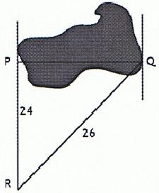4) You need to find the width of a lake, **PQ**, as shown. The measurements of the other sides are given on the diagram. You are certain that ∠P = 900. What is the width of the lake?

5) A ladder is leaned against a house. The base of the ladder is *d* feet away from the house. Draw a diagram and then write the Pythagorean relationship that exists for these lengths. Use *l* for the ladder, *h* for the house, and *d* for the distance the ladder is from the house. You are *not* required to solve this question.

6) A 40 foot ladder reaches 38 feet up the side of a house. How far from the side of the house is the base of the ladder? Draw a diagram and show your work.

7) A flagpole is 12 metres tall. It makes a shadow on the ground that is 15 metres long. How long is a line that joins the top of the flagpole with the end of the shadow? Draw a diagram and show your work.

8) The size of a flat screen TV is given by the length of the diagonal of the screen (joining opposite corners). What is the length of a diagonal if the sides are 40.5 inches by 22.625 inches? Draw a diagram and show your work.

**PYTHAGOREAN TRIPLES**

A **Pythagorean Triple** is a set of three numbers that satisfy the Pythagorean Theorem and are all whole numbers (no decimals). If a set of numbers satisfies the Pythagorean relationship, then the triangle must be a right triangle. An example is shown below.

A

13

5

C 12 B

Left Side = c2 Right Side = a2 + b2

Therefore, Left Side = Right Side. This triangle is a right angle triangle, and the set of numbers, 5, 12, and 13 are a **Pythagorean Triple**.

**ASSIGNMENT 4 – PYTHAGOREAN TRIPLES**

1) Which of the following triangles are right triangles? Show your work as proof.

a) b)

21

4 5 9

23

3

c) d)

15

25 24 17 8

7

**TRIGONOMETRY**

Trigonometry is one of the most important topics in mathematics. Trigonometry is used in many fields including engineering, architecture, surveying, aviation, navigation, carpentry, forestry, and computer graphics. Also, until satellites, the most accurate maps were constructed using trigonometry.

The word ***trigonometry*** means *triangle measurements*. It is necessary to finish our triangle facts here.

Fact 8: In trigonometry, the other two sides (or legs) of the triangle are referred to as the **opposite** and **adjacent** sides, depending on their relationship to the angle of interest in the triangle.

In this example, if we pick angle DEF – the angle labelled with the Greek letter θ theta – then we are able to distinguish the sides as illustrated in the diagram below.

D

opposite hypotenuse

θ

F adjacent E

The side that is opposite the angle of interest, in this case θ, is called the **opposite** side. The side that is nearest to angle θ and makes up part of the angle is called the **adjacent** side. To help you, remember that adjacent means beside. Although the hypotenuse occupies one of the two adjacent positions, it is **never** called the adjacent side. It simply remains the hypotenuse. This is why it is identified first. It is recommended to label the side in the order hypotenuse, opposite, and finally adjacent. You may use initials for these side, h, o, and a, but always use lower case letters to avoid mixing up the labelling with a vertex.

Example 1: Using the triangle below, answer the questions.

15

9

θ

12

1. What is the hypotenuse? __________
2. What is the opposite side to θ? __________

This example uses the same triangle as in Example 1; however, this time, the *other* acute angle is labelled as θ. This is done to show that the opposite and adjacent sides switch when the other angle is the angle of interest. The hypotenuse **always** stays the same.

Example 2: Using the triangle below, answer the questions.

θ

15

9

12

1. What is the hypotenuse? __________
2. What is the opposite side to θ? __________
3. What is the adjacent side to θ? __________

**ASSIGNMENT 5 – TRIGONOMETRY**

For each of the right triangles below, mark the hypotenuse, and the sides that are opposite and adjacent sides to θ as shown in the example.

Example:

h = hypotenuse

h o o = opposite

a = adjacent

θ

a

1) 2)

θ

θ

3) 4)

θ

θ

Quiz Next Class

**Trigonometric Ratios**

In the previous unit about similar figures, you learned that the ratios of corresponding sides of similar triangles are equal. When the angles of different triangles are the same, the ratio of the sides within the triangle will always be the same. They depend only on the measure of the angle of interest, not the size of the triangle. These ratios are the trigonometric ratios.

There are three trigonometric ratios we are concerned with: sine, cosine, and tangent.

**The Sine Ratio**

The *sine* *of angle* *θ* means the ratio of the length of opposite side to the length of the hypotenuse. It is abbreviated as **sin θ** but read as sine θ. It is written like this:

sin θ =  or sin θ = 

Example 1: Find the sine of θ in this triangle. Round to 4 decimal places.

13

5

θ

12

Solution:

Note: Rounding to 4 decimal places is standard when calculating trigonometric ratios.

Example 2: Use your calculator to determine the following sine ratios. Round to 4 decimal places.

a) sin 150 b) sin 670 c) sin 420

**\*\*\*\*\* REMEMBER TO SET YOUR CALCULATOR ON DEGREES (DEG) \*\*\*\***

Solution: Type “sin” followed by the angle, and then “=” to solve

a) b) c)

**THE COSINE RATIO**

sin 420 = 0.

The co*sine* *of angle* *θ* means the ratio of the adjacent side to the hypotenuse. It is abbreviated as **cos θ** but read as cosine θ. It is written like this:

cos θ =  or cos θ = 

Example 1: Find the cosine of θ in this triangle.

13

5

θ

12

Solution:

The adjacent side is ____ and the hypotenuse is ____. So

Note: Rounding to 4 decimal places is standard when calculating trigonometric ratios.

Example 2: Use your calculator to determine the following cosine ratios. Round to 4 decimal places.

a) cos 150 b) cos 670 c) cos 420

**\*\*\*\*\* REMEMBER TO SET YOUR CALCULATOR ON DEGREES (DEG) \*\*\*\***

Solution: Type “cos” followed by the angle, and then “=” to solve

1. b) c)

**The Tangent RATIO**

The *tangent* *of angle* *θ* means the ratio of the opposite side to the adjacent side. It is abbreviated as **tan θ** but read as tangent θ. It is written like this:

tan θ =  or tan θ = 

Example 1: Find the tangent of θ in this triangle.

13

5

θ

12

Solution:

The opposite side is ____ and the adjacent side is ____. So

Note: Rounding to 4 decimal places is standard when calculating trigonometric ratios.

Example 2: Use your calculator to determine the following tangent ratios. Round to 4 decimal places.

a) tan 150 b) tan 670 c) tan 420

**\*\*\*\*\* REMEMBER TO SET YOUR CALCULATOR ON DEGREES (DEG) \*\*\*\***

Solution: Type “tan” followed by the angle, and then “=” to solve

1. b) c)

**ASSIGNMENT 6 – THE TRIGONOMETRIC RATIOS**

1) Calculate the value of **sin θ** to four decimal places.

θ 5.2 in 8.1 in

θ

6.9 m 9.6 in

4.3 m

2) Use your calculator to determine the value of each of the following sine ratios to four decimal places.

a) sin 100 = ______________ b) sin 480 = ______________

c) sin 770 = ______________ d) sin 850 = ______________

3) Calculate the value of **cos θ** to four decimal places.

θ 5.2 in 8.1 in

θ

12.4 cm 7.9 cm 9.6 in

4) Use your calculator to determine the value of each of the following cosine ratios to four decimal places.

e) cos 100 = ______________ f) cos 480 = ______________

g) cos 770 = ______________ h) cos 850 = ______________

5) Calculate the value of **tan θ** to four decimal places.

θ

5.2 in 8.1 in

6.5 m

θ

9.6 in

5.1 m

6) Use your calculator to determine the value of each of the following tangent ratios to four decimal places.

i) tan 100 = ______________ j) tan 480 = ______________

k) tan 770 = ______________ l) tan 850 = ______________

7) There are two special sine ratios. Calculate the following.

a) sin 00 = ______________ b) sin 900 = ______________

8) There are two special cosine ratios. Calculate the following.

a) cos 00 = ______________ b) cos 900 = ______________

9) There are some special tangent ratios. Calculate the following.

a) tan 00 = ______________ b) tan 450 = ______________

c) tan 890 = ______________ d) tan 900 = ______________

Note what the answer key says that the tan 900 equals. Just because your calculator says one thing, doesn’t mean the calculator knows what is going on!

**Using THE Sine RATIO**

Whenever one side and one angle of a right triangle are already known, the remaining sides can be found using the trigonometric ratios. The sine ratio can be used to find missing parts of a right triangle.

Example 1: Use the sine ratio to solve for ***x*** in the triangle below.

***x***

9

θ = 350

Solution:

Step 1: Label the sides of the triangle with **h**, **o** and **a**

***x***

9 m

θ = 350

Step 2: Circle the number with the side it represents and the unknown (***x***) with the side it represents.

Step 3: Identify the ratio required to solve for ***x***

Since **o** and **h** are being used, the correct ratio is **sin θ**

Step 4: Substitute the correct values into the correct ratio.

Step 5: Solve using the process Cross Multiply and Divide.

Example 2: A ladder 8.5 m long makes an angle of 720 with the ground. How far up the side of a building will the ladder reach?

Solution:

Sketch a diagram and place the information from the question on this diagram. Remember that there will always be a right triangle in your diagram. It is often helpful to draw that triangle and copy the key information from the sketch.

Step 1: Label the sides of the triangle with **h**, **o**and **a**

Step 2: Circle the number with the side it represents and the unknown (***x***) with the side it represents.

Step 3: Identify the ratio required to solve for ***x***

Since **o** and **h** are being used, the correct ratio is **sin θ**

Step 4: Substitute the correct values into the correct ratio.

Step 5: Solve using the process Cross Multiply and Divide.

**Using THE Cosine RATIO**

Whenever one side and one angle of a right triangle are already known, the remaining sides can be found using the trigonometric ratios. The cosine ratio can be used to find missing parts of a right triangle.

Example 1: Use the correct trig ratio to solve for ***x*** in the triangle below.

5 cm

θ = 300

***x***

Solution:

Step 1: Label the sides of the triangle with **h**, **o** and **a**

5 cm

θ = 300

***x***

Step 2: Circle the number with the side it represents and the unknown (***x***) with the side it represents.

Step 3: Identify the ratio required to solve for ***x***

Since **a** and **h** are being used, the correct ratio is **cos θ**

Step 4: Write down the chosen ratio and substitute the correct values into the correct ratio.

Step 5: Solve using the process Cross Multiply and Divide.

**Using THE TANGENT RATIO**

Whenever one side and one angle of a right triangle are already known, the remaining sides can be found using the trigonometric ratios. The tangent ratio can be used to find missing parts of a right triangle.

Example 1: Use the correct trig ratio to solve for ***x*** in the triangle below.

2 mm

θ = 150

***x***

Solution:

Step 1: Label the sides of the triangle with **h**, **o** and **a**

2mm

θ = 150

***x***

Step 2: Circle the number with the side it represents and the unknown (***x***) with the side it represents.

Step 3: Identify the ratio required to solve for ***x***

Since **o** and **a** are being used, the correct ratio is **tan θ**

Step 4: Substitute the correct values into the correct ratio.

Step 5: Solve using the process Cross Multiply and Divide.

**ASSIGNMENT 7 – FINDING SIDES IN Right Triangles**

1) Calculate the length of the side indicated in the following diagrams. Round to **one** decimal place.

a)

***x*** 5.2 m

230

b) ***x***

580

9.7 cm

c) ***x***

680

19.3 cm

d)

***x***

110

12.3 m

e)

9.2 m

***x***

370

f) 6.5 cm

480

***x***

**ANGLE OF ELEVATION AND DEPRESSION**

*When you look up at an airplane flying overhead for example, the angle between the horizontal and your line of sight* is called the **angle of elevation**.



*When you look down from a cliff to a boat passing by,* *the angle between the horizontal and your line of sight* is called the **angle of depression**.

When you are given the angle of depression, it is important to carefully use this angle in your triangle.

Example 1: You are standing at the top of a cliff. You spot a boat 200 m away at an angle of depression of 550 to the horizon. How far is the boat from the coast? Draw a diagram to illustrate this situation.

Solution: Draw a diagram, label it with the information, and then solve the triangle.

horizon

550 Angle of depression

θ

200 m The angle inside the triangle is the complement to the angle of depression.

To find that angle, do the following:

θ =

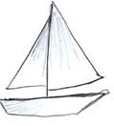 θ =

***x***

**ASSIGNMENT 8 – USING ANGLE OF ELEVATION AND DEPRESSION**

Check that your calculator is on degrees “DEG”.

1) in the triangle below, what is the measure of the angle of elevation?

650

Measure _______________

250

2) Write the angle of elevation in each diagram. Then find the length of the unknown side, to one decimal place.

a) Angle of elevation = 430 b) Angle of elevation = 210

w5.6 m

18.5 ft

x

3) In the diagram below, name the angle of depression. What is the measure of this angle?

A D

Name _________________

630

Measure _______________

B C

4) Find the length of the unknown side, to one decimal place.

610 180

8.2 in.

*y* 6.4 cm *z*

4) The angle of elevation from the ground to the top of a flagpole is 140. Draw a sketch to illustrate this situation.

5) From a building, the angle of depression to a fountain is 620. The fountain is 75 metres away (along the ground) from the building. Draw a sketch to illustrate this situation.

6) From the top of a 45 metre tall pole, the angle of depression to the ground is 120. Draw a sketch to illustrate this situation, and then find the distance from the top of the pole to the ground along the sight line.

7) A ramp makes an angle of 220 with the ground. If the end of the ramp is 1.5 m vertically (**↑**) above the ground, how long (↔) is the ramp?

8) A weather balloon, which is blowing in the wind, is tied to the ground with a 15 m string. How high is the balloon (***x***) if the angle between the string and the ground is 380?

balloon

15 m

*x* string

380

9) A child’s slide makes a 200 angle to the ground as it rises to a platform. If the

horizontal distance that the slide covers is 25 m long, how long is the slide?

platform

200

10) A flagpole is anchored to the ground by a guy wire that is 12 m long. The guy wire makes an angle of 630 with the ground. How far from the base of the flagpole must the guy wire be anchored into the ground?

11) A man stands 15 m from the base of a tree. He views the top of the tree at an angle of elevation of 580. How tall is the tree?

12) How far from the side of a house is the base of a ladder if the angle of elevation is 700 and the ladder reaches 15 feet up the side of the house?

Quiz Next Class

**FINDING ANGLES in right triangles**

So far in this unit, you have used the trigonometric ratios to find the length of a side. But if you know the trigonometric ratio, you can calculate the size of the angle. This requires an “**inverse**” operation. You can use your calculator to find the opposite of the usual ratio provided you can calculate the ratio. To do this you need 2 sides in the triangle.

You can think of the inverse in terms of something simpler: addition is the opposite or inverse of subtraction. In the same way, trig functions have an inverse.

To calculate the inverse, you usually use a 2nd function and the sin/cos/tan buttons on your calculator in sequence. If you look at your calculator just above the sin/cos/tan buttons, you should see the following: sin-1, cos-1, tan-1. These are the inverse functions. If you use these buttons, you will be able to turn a ratio into an angle.

Example 1: Calculate each angle to the nearest whole degree.

a) sin X = 0.2546

b) cos Y = 0.1598

c) tan Z = 3.2785

Solution: Use the appropriate inverse function on your calculator.

NOTE: Every calculator is different in how the buttons are keyed in order to achieve the desired outcome. Most calculators will need to key “**2ndF sin**” or “**Shift sin**” in order to get sin-1 displayed. Then key in the value with or without brackets as necessary.

a) sin X = 0.2546

.

b) cos Y = 0.1598

c) tan Z = 3.2785

Example 2: Determine the angle θ in the following triangle.

5 m

θ

3 m

Solution:

1) h, o, a the triangle

2) Circle the letters with their partner numbers

3) Choose the appropriate trig ratio. In this case, 5 m

it is tangent.

4) Write down the ratio and fill it in.

θ

3 m

5) Use the inverse function to solve for θ.

**ASSIGNMENT 9 – FINDING ANGLES in right triangles**

1) Calculate the following angles to the nearest whole degree. Show your work!

a) sin D = 0.5491 b) cos F = 0.8964

c) tan G = 2.3548 d) sin P = 0.9998

e) cos Q = 0.3097 f) tan R = 0.4663

2) After an hour of flying, a jet has travelled 300 miles, but gone off course 48 miles west of its planned flight path. What angle, θ, is the jet off course?

48 mi

300 mi

θ

3) At what angle, θ, to the ground is an 8 m long conveyor belt if it is fastened 5 m from the base of the loading ramp?

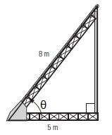

4) If a boat is 150 m from the base of a 90 m cliff, what is the angle of elevation from the boat to the top of the cliff?

5) In a right triangle, ΔXYZ, the ratio of the opposite side to ∠X to the hypotenuse is 7:8 or  . What is the approximate size of ∠X?

6) What is the angle of depression, θ, from the top of a 65 m cliff to an object 48 m from its base?

θ

Practice Test Next Class

Test:___________________