Math 11 AWP Unit 1 – Graphical Representation
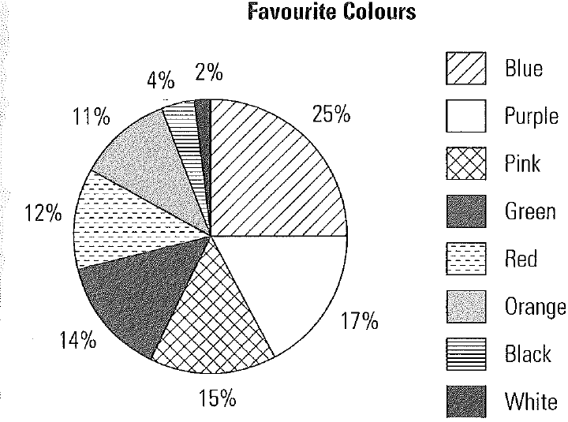
Assignment 7 – Circle Graphs
- The circle graph to the right shows the results of a student survey: 171 students were asked their favourite colour.

- How many student chose green as their favourite colour?

- What is the most popular colour? Approximately how many students chose it?

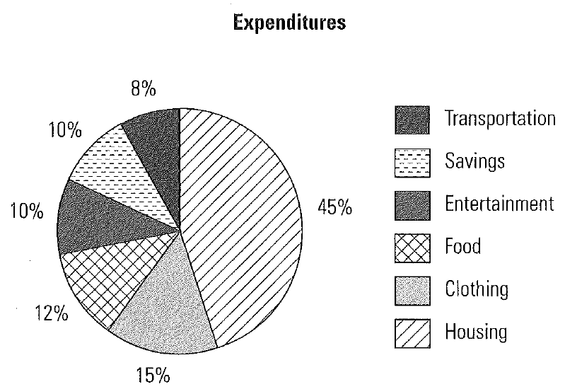
- The circle graph to the right indicates the percentage of his income that Frank spends on different items.

- On what two items does he spend the same amount?

- If he puts $250.00 per month into savings, what is his total income?

- Draw a bar graph depicting the same information. Which graph gives a better picture of his expenditures? Why?

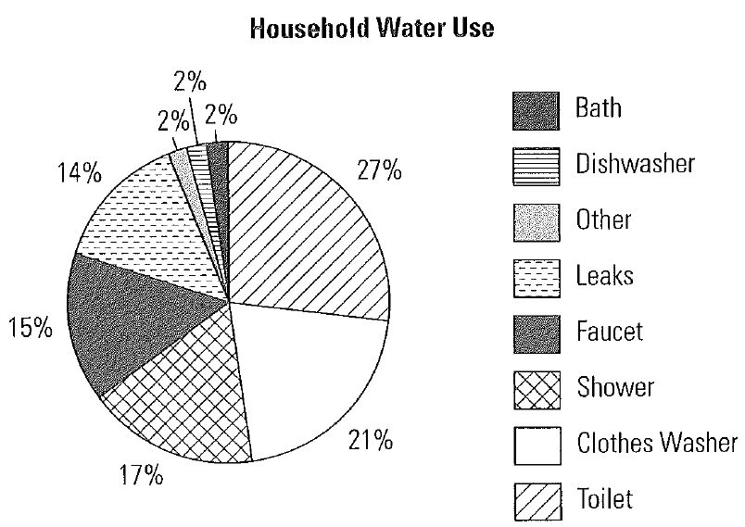
- The circle graph to the right shows a typical household’s water use.

- What is the total percentage of water used for the faucet, shower and bath?

- What percentage is used by the dishwasher and the clothes washer?

- Which two uses together account for about half of the water used per day?

- Patty surveyed students at her school to find out what kind of pets they have. The following table shows the survey results.
Pet | Number of students | Percent | Angle
Dog | 39
Cat | 44
Rodent (gerbil/mouse) | 21
Total

- Draw a circle graph

- Gerrard says that the graph does not accurately display the data as there were 24 students who did not have pets and that this should be recorded. If this data is included, what difference will it make to the size of the sectors? Draw a circle graph to include the sector of students who do not have pets.
Pet | Number of students | Percent | Angle
Dog | 39
Cat | 44
Rodent (gerbil/mouse) | 21
Other
Total

- A school has a fundraiser to help raise money for international disaster relief. The table shows the amounts raised through different activities. Display the information on a circle graph.
Means of fundraising | Amount | Percent | Angle
Parent Donation | $750.00
Chocolate bar sales | $325.00
Hot lunches | $375.00
Concert proceeds | $150.00
Classroom donations | $100.00
Total

- Marjorie is a stockperson at a drugstore. She tracks sales of the different brands of hairspray sold at the store. The table below indicates the number of containers or each brand that sold in the past month.
Hairspray brand | Number of containers | Percent | Angle
A | 68
B | 45
C | 127
D | 93
E | 76
F | 12
Total

- Draw a circle graph to display the data.

- Display the data on one other type of suitable graph

- Before a school dance, the organising committee did a survey of students to find out their music preferences. The graph below shows the number of students who prefer each type of music.
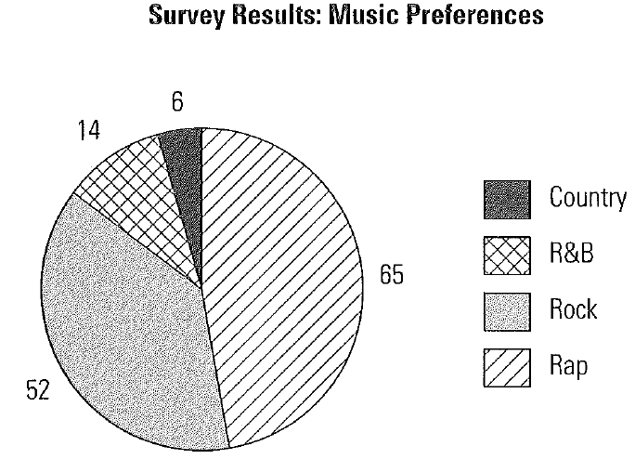
- How many people were surveyed?

- What percentage of the people prefer rock music?

- Calculate the number of degrees in the circle that represents those who prefer R&B music.

- Greg works as a tour guide. He tracks how tourists heard about the tours.
- 60% took the tour as part of a travel package;
- 15% had the tour recommended by the local tourism office;
- 10% came based on the recommendation of a friend; and
- The remainder were walk-ins.
Draw a circle graph to display the data. Show all calculations.

- Given the graph below, create a circle graph that displays the same information.
