Math 11 AWP Unit 1 – Graphical Representation
Assignment 6 – Histograms
- The histogram below shows the amount of money that households in one province spent on home renovations during the past year.
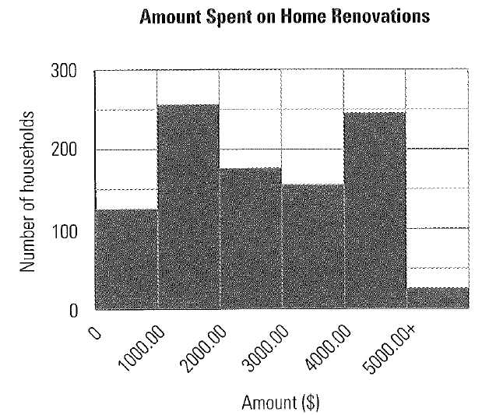
- How many households spent less than $1000.00 on renovations?

- What was the most common amount spent?

- What was the highest amount spent?

- An internet service provided surveyed some of some of its customers across Canada to find out how much time people spend on the internet each week. The following histogram shows the results.
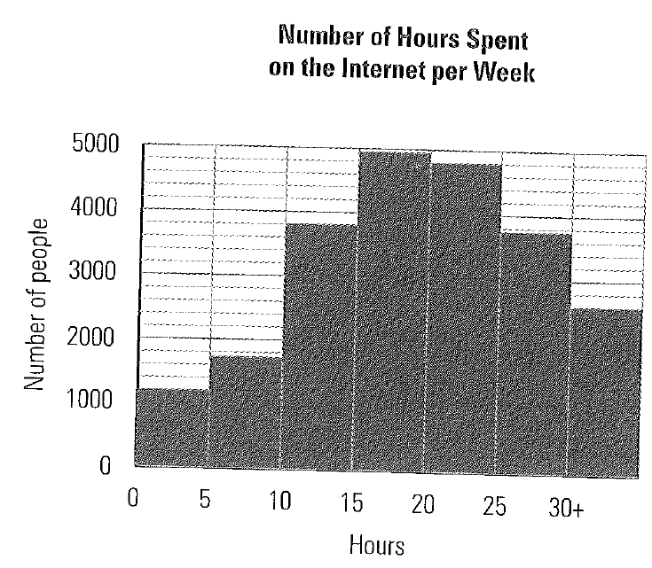
- How many people spend between 10 and 15 hours on the internet each week?

- How many people spend less than 15 hours on the internet each week?

- How many people spend more than 30 hours on the internet each week?

- Approximately how many people were surveryed?

- An insurance company did a confidential survey of the ages of employees in a company, to estimate how many would be retiring in the coming years. The results are shown in the following table. Use the data to draw a histogram.
SURVEY RESULTS, AGES OF EMPLOYEES
Age | Less than 25 | 25-34 | 35-44 | 45-54 | 55-64 | 65 and older
Number | 1 | 6 | 8 | 16 | 24 | 6

- a) Draw a histogram to represent the ages of people attending a theatre presentation.
AGES OF AUDIENCE MEMBERS AT THEATRE PRESENTATION
Age | <20 | 20-29 | 30-39 | 40-49 | 50-59 | 60-69 | >70
Number of people | 35 | 68 | 73 | 92 | 55 | 49 | 21

b) How many people under age 30 attended the presenation/

c) From the table, can you tell the age of the youngest audience member? Why or why not?

- The following histogram represents the scores of a math class on a recent test.
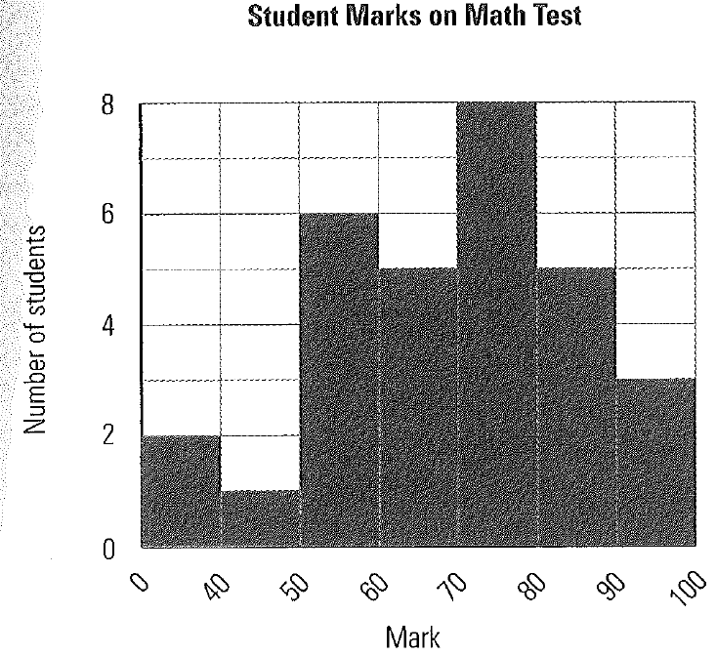
- How many students received a mark between 70% and 80%?

- How many students got below 60%?

- What was the highest mark received by a student?

- The histogram below shows the salaries of the employees at Supersonic Business Inc.
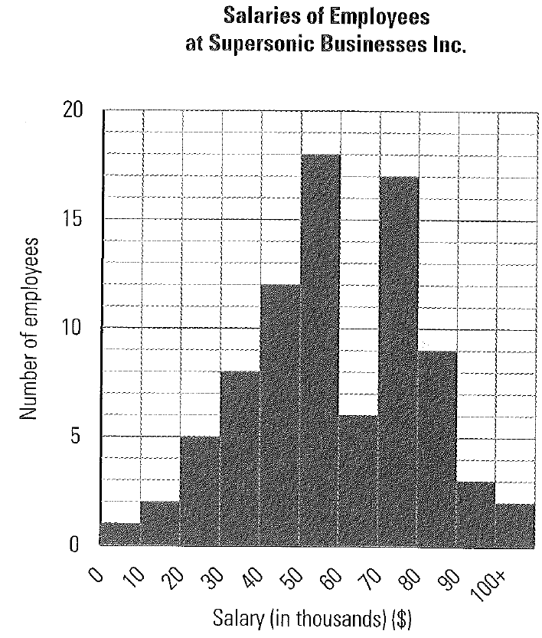
- How many employees earn over $100 000.00?

- How many employees earn between $30 000.00 and $50 000.00?

- Rodney has recorded the housing sales over a period of time for his real estate company, Fixed Rate Real Estate. The data has been grouped based on the selling price.
FIXED RATE REAL ESTATE HOUSING SALES
Selling price (in thousands of $) | Less than 100 | 100-200 | 200-300 | 300-400 | 400-500 | Over 500
Number of Houses | 5 | 2 | 7 | 12 | 5 | 3
- Draw a histogram to represent the data.
- What was the lowest selling price?

- How many houses sold between $100 000.00 and $300 000.00

- Hurricanes are more likely to occur at certain times of the year than at others. The table below indicates the percentage of hurricanes than began at different times of the year.
HURRICANE OCCURANCE, BY TIME OF YEAR
Dates | Mar 21 – Jun 20 | Jun 21 – Jul 20 | Jul 21 – Aug 20 | Aug 21 – Sep 20 | Sept 21 – Oct 20 | Oct 21 – Nov 20
Percentage of hurricane occurances | 5 | 7 | 18 | 35 | 27 | 8
- Draw a histogram to represent the data.
- During what time of the year are hurricanes unlikely to occur?

- At what time of year is a hurricane most likely to occur?

