Math 11 AWP Unit 1 – Graphical Representation
Assignment 4 – Bar Graphs
- A company tracked how new software was obtained and installed on their computers. The results are given in the table below. Draw a bar graph to represent the data.
SOFTWARE INSTALLATION
How software was obtained and installed | Percent of total software installed
In-house IT department | 58
In-house IT help from provider | 16
Outsourced to service provider | 10
Outsourced to development partner | 12
Other | 4

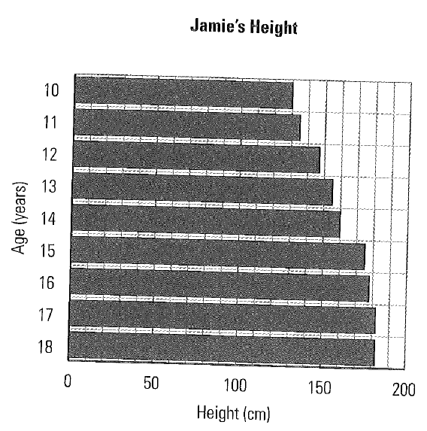
- The graph shows Jamie’s height from age 10 to 18.
- Suggest two ways to improve the way the data is presented.

- Redraw the graph in a way that better represents the data

- Sabine is a staff supervisor at a city fairground. She made the graph below to show the number of employees working at the fair each month. Give two reasons why the graphs may be misread.
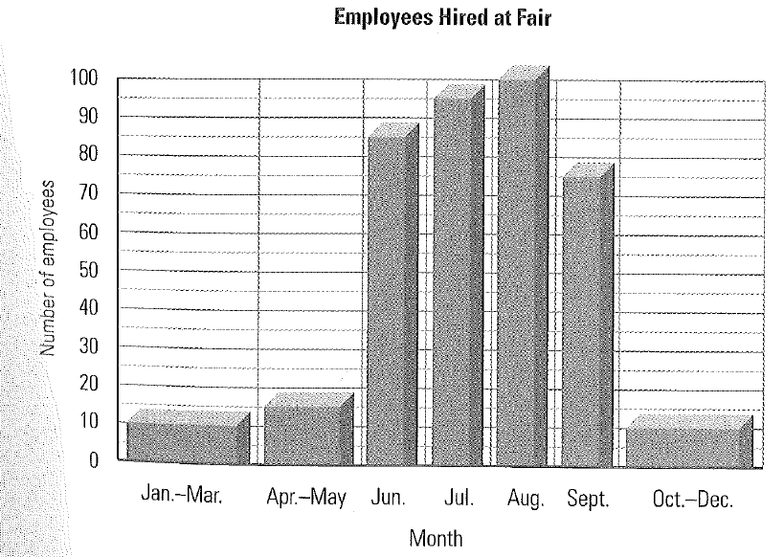

- Carbon dioxide (CO₂) emissions contribute to climate change, and so they are closely monitored by governments and environmental groups. The following two graphs represent CO₂ emissions worldwide from 1995 to 2005
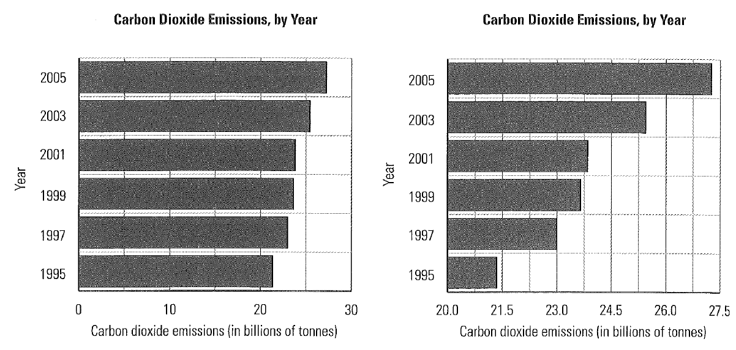
- Which graph is a better representation of worldwide CO₂ emissions? Why?

- What were emissions in 1999?

- What were they in 2005?

- Why might the more misleading graph be used to represent the data?

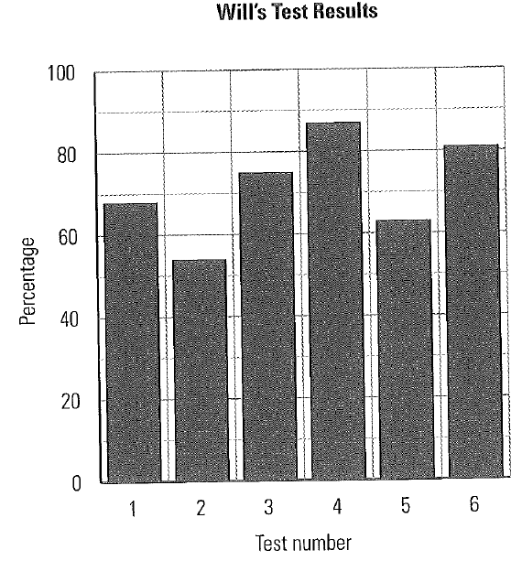
- Given the vertical bar graph to the left, draw a broken line graph depicting the same data. Which graph is a better representation of the data? Why?

- The table below show the number of tickets sold per day until a rock concert is sold out.
NUMBER OF ROCK CONCERT TICKETS SOLD PER DAY
Day | 1 | 2 | 3 | 4 | 5 | 6 | 7 | 8 | 9 | 10
No. of Tickets | 2824 | 2531 | 1456 | 1687 | 1570 | 1280 | 796 | 578 | 329 | 105

- What is the general trend in sales over the 10-day period?

- Darlene used a graphing tool to draw to draw a horizontal bar graph and a broken line graph of the data. Which graph is a better representation and why?
