Math 11 AWP Unit 1 – Graphical Representation
Assignment 3 – Misleading Graphs
- Consider the graph below.
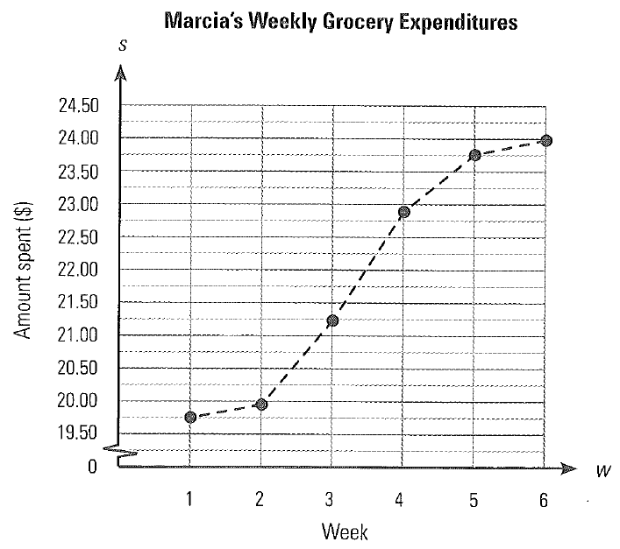
- What does the graph represent?

- What is the general trend in Marcia’s weekly grocery expenditure?

- What is misleading about the graph?

- Draw a graph that better shows her expenditure.

- Consider the two graphs below that show the percentage of the population of Alberta living in rural areas.
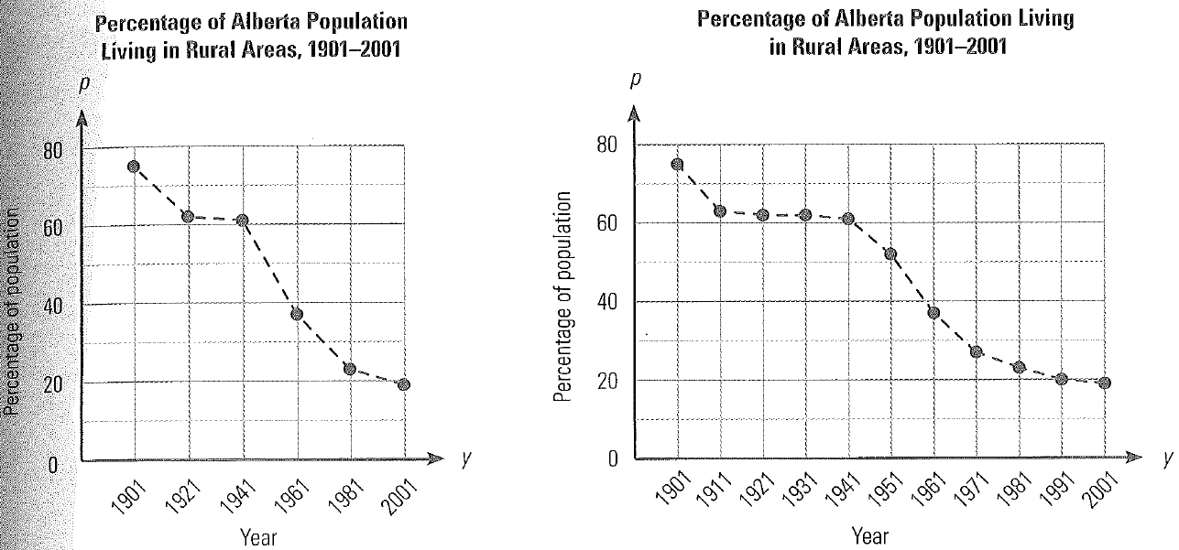
- Which graph makes it appear that the decrease in rural population was more rapid? Why?

- Which graph do you think is a better representation of the actual change in rural population? Why?

- Use the graphs to interpolate what percent of the population was rural in 1916.

- In what year was the population half rural and half urban?

- Use the graph to extrapolate what percent of the population will be rural in 2011.

- Reba has joined a 13-week walking group. The graph below indicates her total steps per week. Use the graph to answer the following questions.
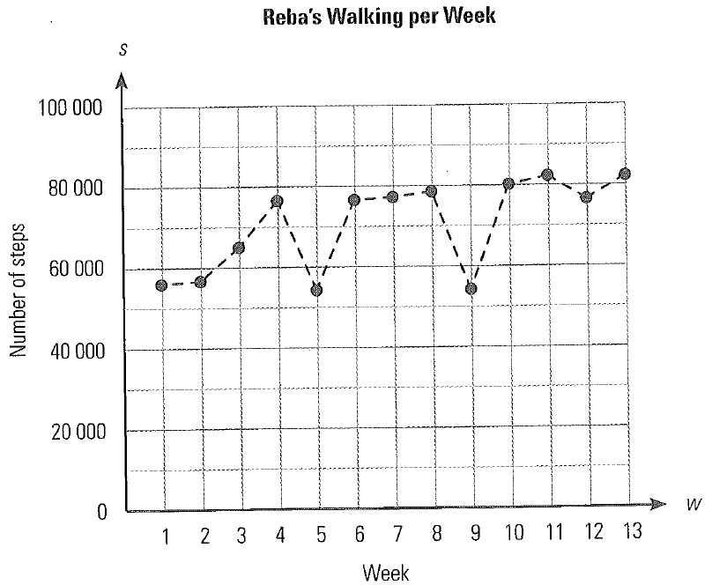
- Approximately how many steps did Reba walk the first week? The last week?

- During what week(s) did she take the lowest number of steps? About how many steps did she take?

- Is there a general trend in the number of steps that she walked per week? If so, what is it?

- The data below indicates the approximate area of forest burned in forest fires in Canada each year from 1999 to 2009. Display the data on a broken line graph and discuss any trends you see in the graph.
Area of Forest Fire in Canada, 1999-2009
Year | 1999 | 2000 | 2001 | 2002 | 2003 | 2004 | 2005 | 2006 | 2007 | 2008 | 2009
No. of hectares burned (in millions) | 1.6 | 0.6 | 0.6 | 2.9 | 1.7 | 3.3 | 1.7 | 2.8 | 1.6 | 1.7 | 0.8
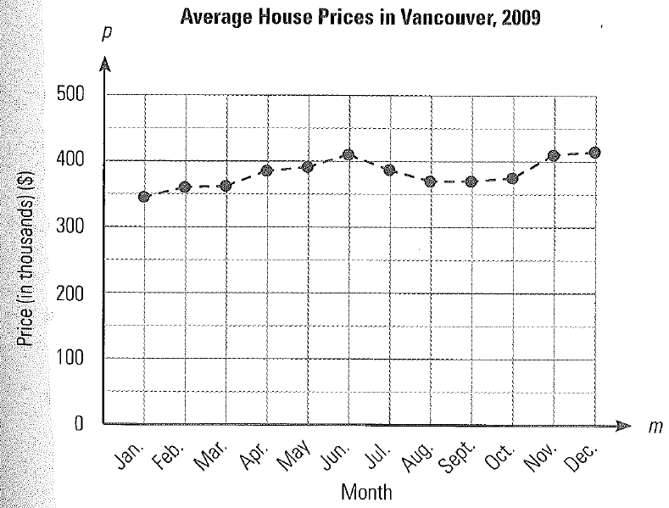
- The graph below shows the average house price in Vancouver in 2009, by month. Describe the trend in house prices in Vancouver during that year. During what month(s) were the prices highest?

- Use the multiple broken line graph provided to answer the following questions.
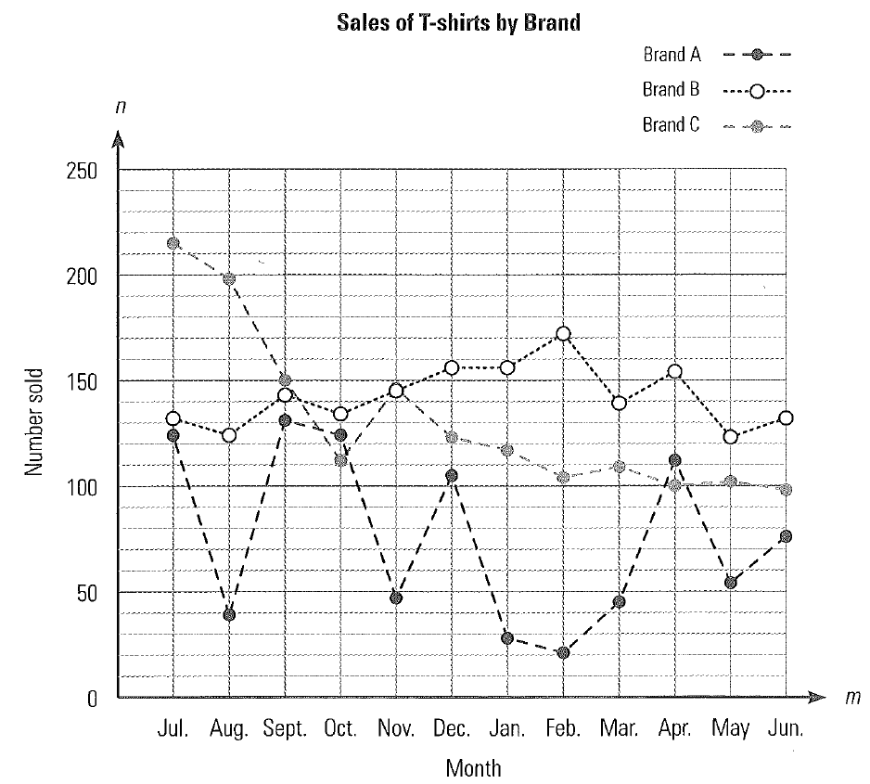
- What is the general trend for sale of each brand of T-shirt?

- If you were to keep only two of the brands for sale, which two would you keep and why?

- Each month, the librarian does inventory to determine the number of different titles of each genre that are available in the library.
Number of Books in the Library, by Genre
Month | Jan | Feb | Mar | Apr | May | Jun | Jul | Aug
Science Fiction | 124 | 132 | 135 | 130 | 145 | 148 | 154 | 150
Historical Fiction | 128 | 154 | 156 | 150 | 153 | 160 | 162 | 162
Love Stories | 123 | 145 | 148 | 145 | 152 | 154 | 159 | 155
- Use the data to draw a multiple broken line graph showing the number of science fiction, historical fiction, and love stories available each month over an 8-month period.

- Explain any trends you see in the data. What might a drop in the number of titles available mean?

