Math 11 AWP Unit 1 – Graphical Representation
Assignment 1 – Broken Line Graphs
- The following graph shows Tom’s spending on lunched for the past week.
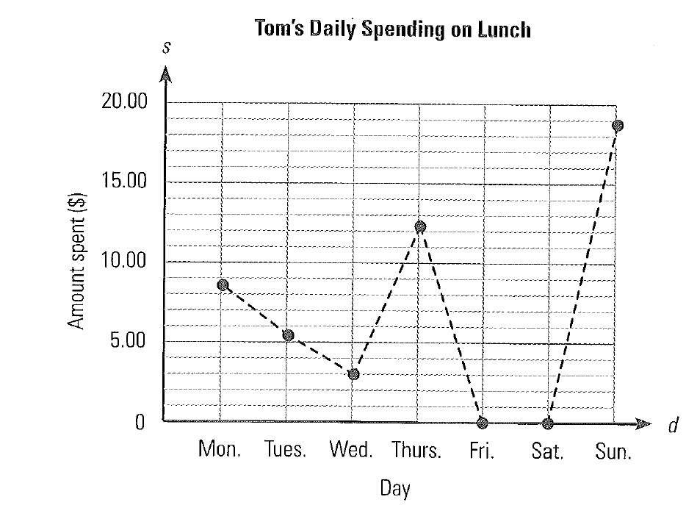
- How much did he spend on lunch on Wednesday? Friday?

- On what day did he spend the most on lunch, and how much was it? Give one possible reason why he might have spent so much that day.

- Use the graph provided to answer the following questions.
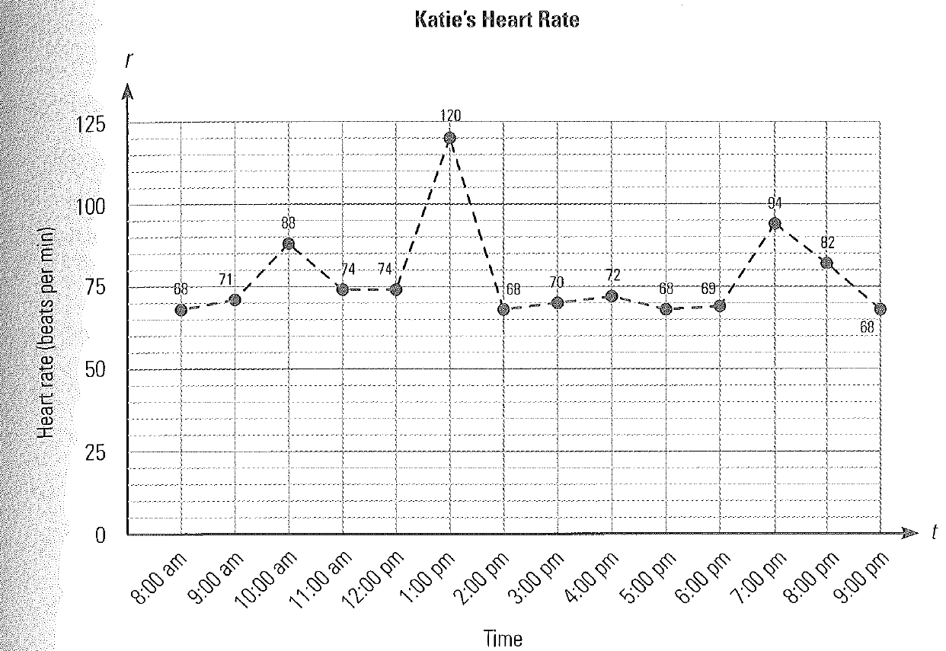
- What does the graph show?

- When was Katie’s heart rate the lowest and what was it?

- When was her heart rate the highest? Why might this have been so?

- The graph shows the value of a particular stock that Vince bought over a 10 week period. If week 1 is when Vince bought the stock, use the graph to answer the following questions.
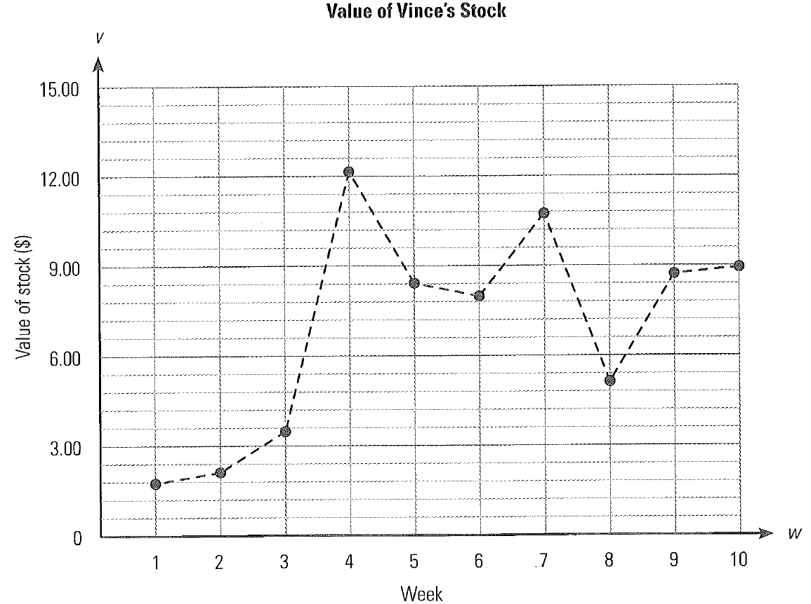
- At what price did Vince buy the stock?

- When was the stock worth the most? If Vince had sold the stock then, what would have been his profit?

- Canadian Review magazine is published once a week. The company keeps track of the number of magazines sold from different outlets to determine the market trend. The following data show the number of Canadian Review sales at a local store over the past eight weeks.
Canadian Review Magazine sales
Week | 1 | 2 | 3 | 4 | 5 | 6 | 7 | 8
Number of copies sold | 20 | 22 | 18 | 15 | 30 | 26 | 32 | 28
Draw a broken line graph to display the data.

Are sales of the magazine increasing or decreasing?

- Stephanie works in a pediatrician’s office. One of her jobs is to track the growth rate of babies the doctor treats. The table below shows baby Jessica’s weight for the first twelve weeks of her life. Draw a broken line graph of the data and discuss the trend.
Weight Chart, Jessica, Weeks 0-12
Age (weeks) | 0 | 1 | 2 | 3 | 4 | 5 | 6 | 7 | 8 | 9 | 10 | 11 | 12
Weight (kg) | 2.4 | 2.2 | 2.6 | 2.9 | 2.9 | 3.1 | 3.5 | 3.6 | 4.0 | 4.0 | 4.2 | 4.4 | 5.1

- A long distance truck drive recorded the distance he drove each day for two weeks.
Distances Driven per day
Day | 1 | 2 | 3 | 4 | 5 | 6 | 7 | 8 | 9 | 10 | 11 | 12 | 13 | 14
Distance (km) | 450 | 235 | 406 | 0 | 0 | 560 | 325 | 386 | 264 | 453 | 0 | 0 | 356 | 289

- Graph the data using a broken line graph

- Are there any data points that seem unusual? What might have caused them?

- Do you think this graph is a good representation of the data?

