**Math 11 AWP: Slope and Rate of Change Unit Project**

**Due: Dec 15, 2016**

You are to take a picture of create a picture and transpose this picture onto a graph.

The picture must have at least 5 straight lines (you can make adjustments to the picture in order to do this.)

Example



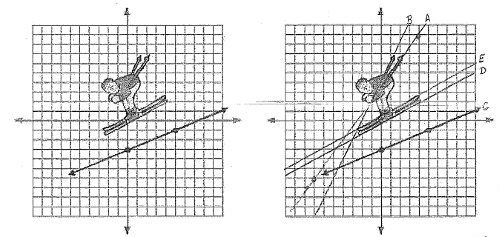



Sample work:



You will hand in 2 pictures, the original and one containing *all* the math shown *neatly.*

Here is the list of the math work you must provide.

-The slope of at least 5 lines written as reduced fractions (10 marks)

-The percent grade of at least 5 lines (2.5 marks)

-The pitch of at least 5 lines (2.5 marks)

-The angle of elevation of at least 5 lines (10 marks)

-5 marks on the presentation and level of difficulty of the picture, (eg a triangle is 1/5 and the Eiffel Tower is 5/5)

You must also investigate the rate of change of a situation related to your picture (use your imagination). Either use real data that you have taken yourself or found from a reliable source. Collect data to draw two lines

Sample work:

Data from FIS Ski Tour Canada 2016. Results from Men 15.0 km Pursuit Classic

|  |  |  |
| --- | --- | --- |
|  | SUNDBY, Martin Johnsrud | USTIUGOV, Sergey |
| Distance | Time (min) | Time (min) |
| 5.9 | 19.47 | 19.69 |
| 9.7 | 31.39 | 31.74 |
| 13.4 | 43.33 | 44.095 |
| 15 | 47.40 | 48.36 |

Here is how you will be assessed and what you need to show:

-Collect data (2 marks)

-Determine the dependent and independent variables (2 marks)

-Graph the information (10 marks)

-Graph must have: a title, labelled axes with units, appropriate scale for each axis, a legend, and data properly plotted

-Draw a line of best fit for each line (2 marks)

-Determine the slope of the lines (show rise and run on graph) (4 marks)