Math 10 Unit 3 – 4 Project TOTAL 38 MARKS

You are to take a picture or create a picture and transpose this picture onto a graph.

The picture must have at least 5 straight lines (you can make adjustments to the picture in order to do this.)

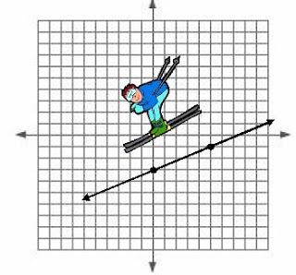Example:







You will hand-in 2 pictures, the original and one containing *all* thelines drawn on and labelled *neatly*. Label any points that you use on the second picture. Complete all the math on a separate sheet of paper

Here is the list of the math work you must provide.

-Equations of at least 5 lines in slope-intercept form and general form. (10 marks)

-Domain and range of at least 5 lines on the original picture (cannot all be all reals). (10 marks)

-Choose at least 2 lines to determine the x-intercept algebraically. (5 marks)

-For at least 2 of the lines, find the equation of the line parallel to your line through the point (2, -5). (4 marks)

-For at least 2 of the line, find the equation of the line perpendicular to your line through the point (-3, 4). (4 marks)

-5 marks on the presentation and level of difficulty of the picture, e.g. triangle vs. Eiffel tower

Due Date: ___________________________________________