NOTES 2.3: The Periodic Table
and Bohr Diagrams

Bohr Model Diagrams

Bohr Models illustrate energy shells and the electron arrangement of a particular atom.
In this model, electrons will fill up each inner shell before flowing into the next shell on the outside.
The capacity of each shell from inside to out is as follows: 2, 8, 8, 18, 18.
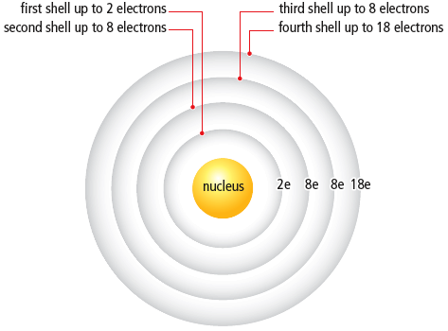

Drawing Bohr ATOMS

- Pick an Element. Write Symbol in nucleus!
- Write the number of PROTONS.
- Write the number of NEUTRONS (atomic mass – atomic number).
There are 2 different ways to draw a Bohr Atom:
- Draw electrons as dots filling up the shells from the nucleus out (remember: 2, 8, 8, 18, 18):
(The total number of electrons is equal to the number of protons in an uncharged atom.)

- Write the number of electrons as symbols and shells as semi-circles from the nucleus out:

_{Element symbol}
_{#protons}
_{#neutrons}

Electron configurations of the first 18 elements in the Periodic Table

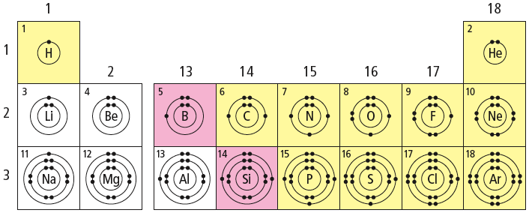

Patterns in the Periodic Table

Elements in each ________________ have the same number of __________________ electrons
(electrons in the ______________ ________________).

Elements in each ________________ have the same number of shells. ________________ number indicates the number of shells that will be occupied by electrons.

DEFINE Valence Electrons: _______________________________________________________________

DEFINE Valence Shell: __________________________________________________________________

Ions

An______ is an atom that has _______or_______ electrons resulting in an electric charge. The number of protons does not change.
    - In an ion the # electrons ____ # protons
Most elements gain or lose electrons in order to be ____________ like Noble gases and have the same e- arrangement as the nearest noble gas.

  - Metals __________electrons to empty their valence shell and form __________ions (Ca²⁺ --> lost 2 e-)
  - Non-metals (except noble gases) _________electrons to fill their valence shell and form ________________ ions (O²⁻ –-> gained 2 e-)
Noble gases are stable and _______________ because their ____________ shells are completely full. They do not form _________.
Charge on an Ion
Cl- charge is _____ vs Be²⁺ charge is ______
The charge on an ion = _______ of charges on its protons and electrons
  - O²⁻ has ______ protons and _______ electrons so Total Charge = ( ) + ( -) =
What pattern in ion charges do you notice on the periodic table?
Elements of the ________________ form ions ______________________________________________
(except transition metals) which form____________________________________________________
Drawing Semi-Circle Bohr IONS
- Follow the same steps for drawing a Bohr atom except:
- Write the element symbol with its __________
- Determine # electrons # electrons $_____$# protons
- Write the number of electrons as symbols (2e, 8e, 8e, 18e, 18e) filling up the shells from the nucleus out
- Draw shells as semi-circles from the nucleus out and put the charge of the ion on the element symbol

_{Charge}
₊
_{#protons}
_{#neutron}

Atom or Ion | Atomic  Number | Atomic Mass | Ion Charge | #  Protons | #  Electrons | # Neutrons
Carbon atom | 6 | 12 | 0 | 6 | 6 | 12 – 6 = 6
Sulphur atom |  | 32 |  |  |  | 16
Ca²⁺ |  | 40.1 |  | 20
Cl – |  | 35.5 |  | 17
Neon atom | 10 |  |  |  | 10 | 10

Do this Now! 1) Complete Note Examples 2) Handout pages!

TRY IT: Use Semi-Circle Diagrams to draw Bohr Diagrams! Refer to notes!
- Potassium Atom Potassium Ion

- Oxygen Atom Oxide Ion

- Sodium atom Sodium ion

- Fluorine atom Fluoride ion

- Aluminum atom Aluminum ion

