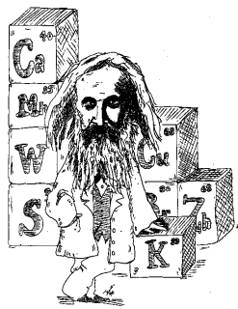
NOTES 2.2: The Periodic Table of Elements

Mendeleev

In 1867, Dimitri Mendeleev found __________ in the elements and organized them into a table

  - Organized elements according to:
    - _______________________
    - grouped elements with similar _______________ into families
  - The resulting table had ______________ for elements not yet discovered

The Periodic Table

Label the parts of the box for Titanium above.
Atomic Mass:

Atomic Number:

Ion Charge:

Metals, Non-metals, and Metalloids (Text p. 55)
Complete this chart:
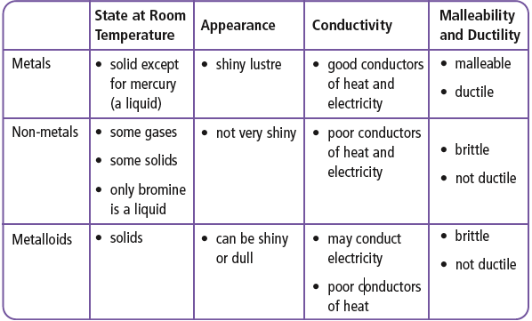
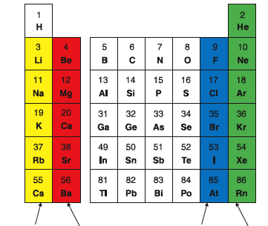
Periods and Families

On a Periodic Table,

Each horizontal row is called a _______________.

Vertical columns are called ________________.

Alkali Metals:

Alkaline Earth Metals:

Halogens:

Noble gases:

Please fill in the blanks for the definitions above. Also don’t forget to label the chart on the right.

Read pg. 52 – 63
Do the Reading Check on pg. 57 and answer the questions here:

Complete: Refer to textbook pages 52-57 and notes to do Workbook 2.2 pages 26 -31.

