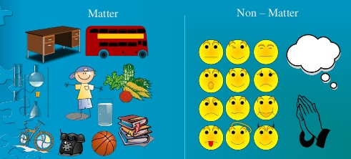
Matter and its Properties

What is matter? Use the following terms as part of your explanation: atom, molecule, element, volume and mass.

Sketch and Label Diagram:

Matter can undergo a Chemical Change
- _______________________ formed by the breaking or formation of new bonds between atoms. New substance has different properties than original substance – Must be chemical
- The change is ____________
- There is a change in ________
- Gas bubbles are present
- ________________ are released
- A participate forms (solid)
Ex. ___________________________________________________________________________________________
Matter can undergo a Physical Change
  - No ____________________________ was created – Must be physical
  - The change can be reversed (________________________)
  - The substance underwent a __________________ due to heating or cooling the substance (solid, liquid, gas)
  - The change is only in ________________________________
The more characteristics of the above, the more likely the substances you are observing have gone through a physical change

Ex. _____________________________________________________________________________________________

Try This: Which of the following everyday activities are physical changes (P) and which are chemical changes (c)?
- Burning leaves b. mixing sand with soil c. an iron nail rusts as it sits on the ground
- using a glue gun e. a cake rises as it bakes f. a window cracks after a rock hits it on the road

Describing Matter

- Physical Properties – characteristics of matter that can be observed or measured table p. 22 text
Examples: _______________________________________________________________
Qualitative Observations
    - The observation describes the look, smell, sound or feel of what is happening.
    - The observation does not involve _______________________what is being observed.
Examples:

Quantitative Observation:
    - The observation describes a ______________________ made of what is happening
    - The observation involves _______________________what has been observed
Examples:

Classify each of the following observations as Qualitative (Qual) or Quantitative (Quan)?
    - The bowling ball is heavier than the basketball____________
    - John is 6 lbs heavier than Claire_______________
    - The temperature increased by 5○C________________
    - The colour changed from blue to green_______________

Matter Can be Classified as either a _____________________ or a ______________________

Pure Substances –a substance made up of only one kind of particle with the same properties throughout.
    - Element - An element is a pure substance that consists entirely of _______type of atom. An atom is the smallest amount of a particular element that retains the properties of the element.
Name 2 elements

    - Molecule – is a pure substance made of atoms that can either come from the same element or different elements in definite proportions
Name 2 molecules
        - (made of one element)
        - (made of two or more elements)
    - Compound - a pure substance composed of at least two elements in definite proportions
Name 2 compounds

Why are all compounds considered molecules but not all molecules are considered compounds?

Mixtures – two or more pure substances mixed together in any proportions.
Example: salt water– ________________________________________
Try This: Identify substance as either a pure substance (pure) or a mixture (Mix). If you know type of pure substance indicate this as well!
a. sodium chloride b. vinegar c . copper d. soup
e. gasoline f. water g. nitrogen gas h. whipped cream
What Physical States exist for matter?

________________________________________________________________________________________

What causes substances to change Physical State?
________________________________________________________________________

What two things happen to particles in a substance when the substance changes state?

1)__________________________________ 2)__________________________________________

Complete the diagram to show the appearance of the particles that make up each state of matter!
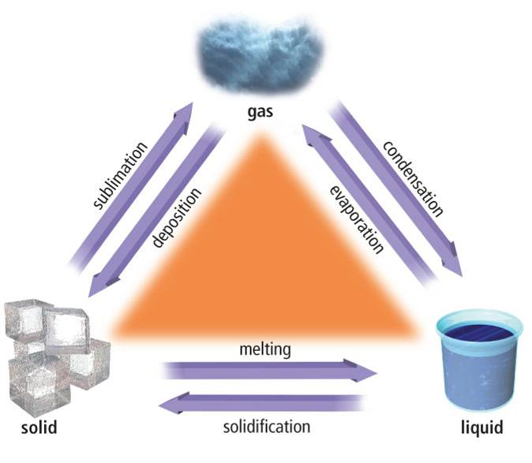

Try This: Mercury is a metal with a melting point of -39°C and a boiling point of 357°C.
What is its state at (solid, liquid, gas):
a. 0°C b. 500°C c. -1°C

Read Bag of Change Lab!

