Machines and Efficiency
What is a machine?

Simple Machines
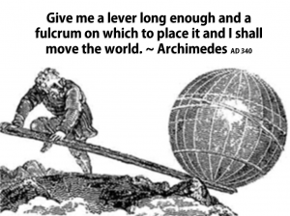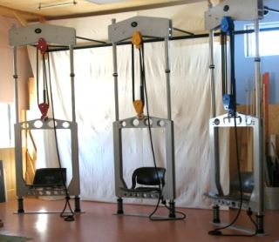

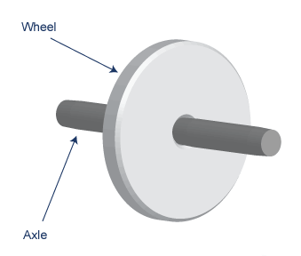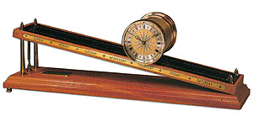

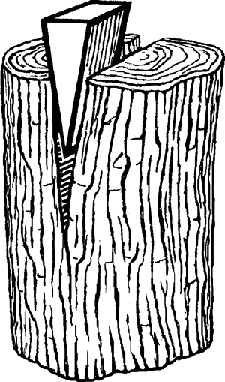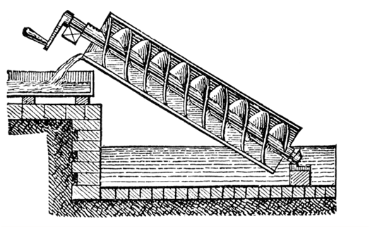
Complex Machines

Efficiency
In an ideal machine ________________________________________________
In the real world __________________________________________________
There are two versions of the efficiency equation

Example (from video clip)
(Assume there is only one boy, because otherwise this problem becomes much harder) If the boy with a mass of ________ moves his end of the lever _________ and the car has a mass of ________ and it is lifted ____________ off the ground, what is the efficiency of the lever?

