Lesson 9 - VOLUME AND CAPACITY OF PYRAMIDS AND SPHERES
The volume of a pyramid is directly related to the volume of a prism with the same base and height. The pyramid relates to this prism in that it is only one third the size of the prism. The formula used to calculate the volume of a pyramid is:
V = $\frac{1}{3}$ A_{base} × h
For a rectangular pyramid, the formula is: V = $\frac{1}{3}$ lwh or V = 1 ÷ 3 × l × w × h

Example 1: Calculate the volume and capacity of the pyramid shown below.
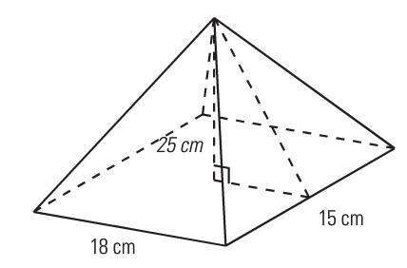

Solution: Use the formula to calculate the volume of the pyramid.

V = 1 ÷ 3 × l × w × h

Since 1 L = 1000 cm³, divide the volume by 1000 to get the capacity in litres.

Capacity =
If given the slant height instead of the height of the pyramid, the height can be calculated using Pythagorean Theorem as in previous assignments.
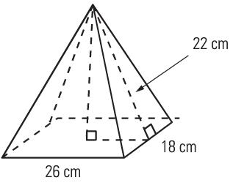

b 22 cm

13 cm

This is the height of the pyramid that can now be used to calculate the volume.
The volume of a sphere is calculated using a formula as well. It is:

V = $\frac{4}{3}$ πr³

Another way of writing this formula that is a little easier to cork with when calculating the volume is:
V = 4 ÷ 3 × π × r³
When using these formulas, do all the calculating at one time without rounding between steps.

Example 2: A tennis ball has a radius of 4 cm. What is the volume and capacity of the tennis ball?

Solution: Use the formula for volume to calculate the volume. Then use the conversion to calculate the capacity.

V = 4 ÷ 3 × π × r³

1000 cm³ = 1 L or 1000 mL
Capacity:

ASSIGNMENT 13 – VOLUME AND CAPACITY OF PYRAMIDS AND SPHERES

1) Calculate the volume of the following pyramids.
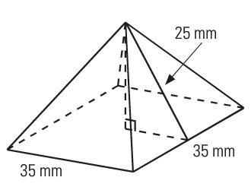
a)

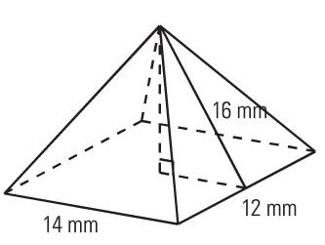
b)

2) Calculate the volume of the pyramid and the prism below. What is the difference in their volumes?
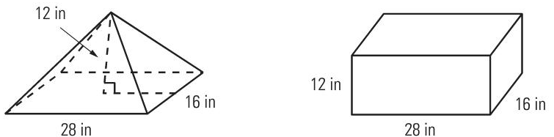

3) Find the volume and capacity of the Omnimax Theatre at Science World which is almost a sphere with a radius of 25 m. (Hint: 1m³ = 1000 L)

4) What is the capacity, in gal (US), of a water tower shaped like a sphere with a diameter of 28.4 feet? Remember, 1 ft³ = 7.48 gal (US).

5) Tennis balls are usually sold in containers shaped like cylinders. One such containers holds 3 tennis balls each with a radius of 3.5 cm. What is the volume of one tennis ball, and what is the volume of the container?

Assignment: Volume-Mixed Shapes

