Day 5: SURFACE AREA OF PYRAMIDS AND CONES
A pyramid is a three-dimensional object with a base that is a regular polygon and lateral sides that are triangles. The triangles join the base along one side, and meet at a point called an apex. In a right pyramid, the apex is directly above the centre of the base.

The net of a pyramid is made up of the base and as many triangles as there are sides on the base.

Example 1: Find the surface area of the square-based pyramid shown below.

15 cm

20 cm
20 cm

Solution

Example 2: Find the surface area of the square based pyramid shown below.
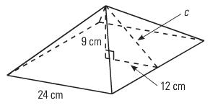

Solution: In this pyramid, the slant height of triangles is not given. Instead the height of the overall pyramid is given. In order to calculate the surface area, the slant height must first be calculated. To do this, use the right angle triangle inside the pyramid and Pythagorean Theorem in order to calculate the slant height.
c
12 cm
9 cm

.
A cone is like a pyramid except that it has a circular base. The net of a cone is a circle for the base (or top depending on the orientation) and a sector of a different large circle.

s h

r

The surface area of the side or lateral region of a cone is calculated using a formula. The components of the formula are the radius of the base of the cone, and the slant height of the cone as shown above.
The area of the base of the cone is calculated using the formula for a circle.

Thus the entire formula for calculating the surface area of a cone is:

SA = πrs + πr²

Example 3: Calculate the surface area of the cone shown below.
18 cm
5 cm

Solution:

14.6 m
15.8 m
r
Example 4: Calculate the surface area of the cone shown below.

Solution: The slant height is not given so it must be determined using Pythagorean Theorem. Also, the diameter is given as 15.8 m so the radius is half that size: 15.8 ÷ 2 = 7.9 m.

ASSIGNMENT 8 – SURFACE AREA OF PYRAMIDS AND CONES
1) Find the total surface area of the square-based pyramid shown below.
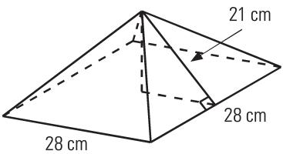

2) Calculate the slant height, and then the surface area of the pyramid below.

height, h = 12 cm
12 cm

18 cm
18 cm

3) The surface area of this square-based pyramid is 680 m². The side lengths are 16 m. What is the height, h, of the pyramid? Hint: subtract the area of the base and work from there.

h

16 m
16 m

Calculate the surface area of the cones shown below.

4)
25 cm

67cm

5)

78 mm

88 mm

6) 22.5 m

18 m

Assignment: Worksheet D-66 and D-55

