Day 2
what is a Prism?
A prism is a three-dimensional object with ends that are called bases, and sides that are called lateral faces. On every prism, the ends are parallel and congruent (the same size) while the sides are parallelograms.

If a prism is a right prism, the sides are perpendicular to the bases and the lateral faces will be rectangles (remember a rectangle is a special parallelogram). A Kleenex box is a right prism – a right rectangular prism that meets these conditions. If the lateral faces are not perpendicular to the bases, the prism is called an oblique prism and the sides will be parallelograms.

A prism is named by two factors: whether it is a right prism or an oblique prism and the shape of its base.

Example: Name the following prisms.

- b)

Solution:

ASSIGNMENT 3 - PRISMS
Complete the following table to help you name the following prisms.

1) 2)

3) 4)

5) 6)

Prism | Shape of base | Right or oblique | Shape of lateral faces | Name
1
2
3
4
5
6

Nets of Prisms
A net (in the geometry sense) is a two-dimensional pattern that can be folded to form a three-dimensional shape. If you think of a pizza box or a box for photocopy paper, they are one piece of cardboard that has been folded into the shape of a right, rectangular prism.

Nets of prisms are useful when calculating the surface area of that prism. If you opened the prism out and laid it flat, it would produce the net. Then it is easier to calculate the area of all the faces to get the total surface area of that prism.

In this section, we will look at what the nets of different prisms look like and deal with learning about calculating the surface area in the next section.

Example: Given the following prism, what would a net look like if it was made from one piece of cardboard?

10 mm

10 mm
40 mm
10 mm

Solution: The prism can be cut along the edges where the base meets the sides, with the exception of the bottom. This will produce a net like this:
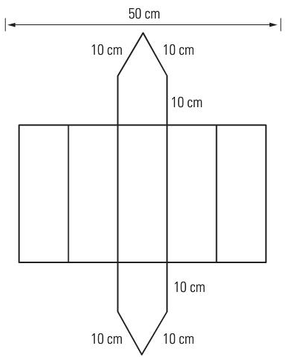

There are often many nets that can be produced that can be re-assembled to make a prism. This is only one of the possibilities. Be careful however, that a net you produce can be put back to make the prism desired. Not always can this be done!

ASSIGNMENT 4 – NETS OF PRISMS
1) Draw nets for each of the following prisms. Label the side lengths. Drawings do NOT need to be to scale.

a)

8 in

8 in
20 in

b)
25 cm

5 cm

2) The net for a right octagonal prism was drawn by two students as shown below. Which is the correct net? Explain your answer.

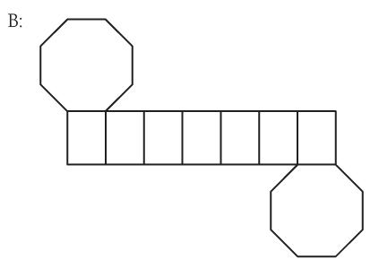
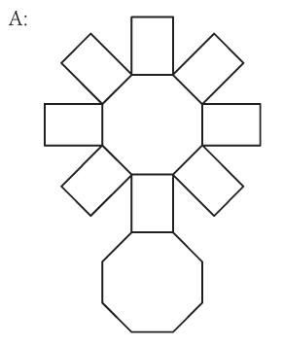

Quiz next class
Assignment: What did the Taxi Driver say About His Daughter?

