Lesson 10
VOLUME OF COMPOSITE FIGURES
As we did with area and surface area, the volume of composite can be calculated. Unlike surface area though, there is no need to make an allowance for surfaces that sit on top of each other. Simply calculate the volume of each part of the figure and add all these parts together.

Example: What is the volume of the figure shown below?

1.0 m

2.0 m

3.0 m
2.5 m

Solution:

ASSIGNMENT 14 – VOLUME OF COMPOSITE FIGURES
Calculate the volume of the following figures. Show all work. Remember to include units for the final answer. Volume is always in cubic units (cm³, m³, in³, etc.)
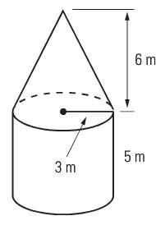
1)

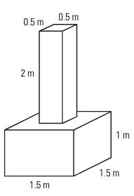
2)

3)
18 cm (diameter)

15 cm

4) A jeweler is making a string of pearls. Each pearl is 0.8 cm in diameter. A hole with a 0.9 mm radius is drilled through each pearl. What is the volume of one pearl on the necklace, to the nearest cubic millimetre (mm³)?

5) A plumber’s plastic pipe is 4 m long, has an inside diameter of 4.0 cm and an outside diameter of 5.0 cm. What is the volume of the plastic in the pipe?

6) A storage container has the shape of a cylinder. At the base of the cylinder is a cone that allows the contents to flow out as show below. What is the volume that the storage container can hold, including the cone? Answer to the closest mm³.

18 mm

15.7 mm

19.3 mm

Assignment: Compound Solids Sheet
Quiz next class
Test:______________________________

