Lab: The Eye

PURPOSE: To examine, identify and describe the various parts of an eye.

MATERIALS: Preserved eye, dissecting tray, dissecting probe, single edged razor blade, dissecting scissors, gloves.

PROCEDURE:

Part I: The Outside of the Eye

- When you have your materials ready, your teacher will come around and give you and your group one eye specimen. Make sure you have your gloves on before you begin.

- Hold the eye firmly. Use the dissecting scissors to carefully cut off the fat and muscle attached to the eye. The fat is white while the muscle is a very light brown.

DO NOT PUNCTURE THE EYE.
This will ruin your lab specimen and make it difficult to examine.

- Locate and examine the following outer parts of the eye and on the diagram below, label these 3 parts: SCLERA, CORNEA, OPTIC NERVE. Below, write 3-4 characteristic points about each part. Consider the questions such as: How does it look? What colour is it? How does it feel? Is it clear? Is it hard? Is it soft? Etc…

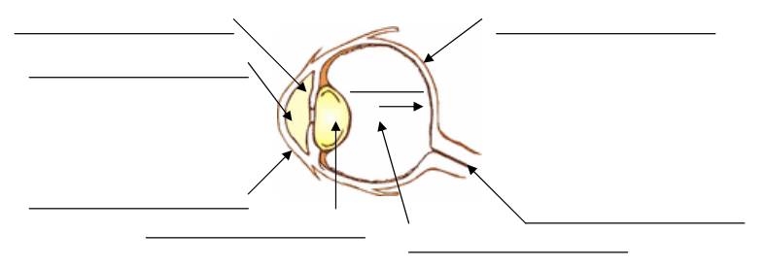

Part II: The Inside of the Eye

- Hold the eye firmly without squeezing the eye (as you know, there is fluid in the eye and if you squeeze, it will come out at you).
- Using the razor, carefully cut through the sclera at the halfway point between the cornea and the back of the eye. Divide the eye in half.

- There is a gel-like substance in the back of the eye which should have come out. This is the VITREOUS HUMOUR. Locate it on the diagram on the next page and label it, then write 3-4 detail characteristic points describing it under its label. Use the probe to remove any remaining vitreous humour from the back of the eye.

- Remove the LENS. It either came out with the vitreous humour or is sitting on the front part of the eye surrounded by the IRIS. Place the lens aside and examine it. In the diagram on the next page identify and label the location of the lens, the iris and the AQUEOUS HUMOUR. Then write 3-4 characteristic points describing each under their label.
Is the lens biconcave or biconvex? ________________________________

- Hold the front part of the eye and look through the PUPIL. Identify it on your diagram and write 3-4 characteristic points of each part under their names
Are you able to see clearly through it to the other side? Why or why not?

- Put the front part of the eye aside and examine the back part (part with the optic nerve). Examine the thin, skin like layer stretched over the inside. This layer is the RETINA. Identify this part on the diagram and write 3-4 characteristic points describing this part of the eye.

- On the retina, there is a part of it that is attached to the optic nerve. This area has no sensory receptors. It is called the BLIND SPOT. Locate this part on the diagram and write 3-4 characteristic points describing it.

- Using blunt probe, lift the retina to see a shiny, iridescent dark layer behind it. This is the CHOROID LAYER. This layer helps absorb light (the dark parts) and reflect light back towards the rods and cones (iridescent part). Identify this part on the diagram and write 3-4 characteristic points describing it.

- CLEAN-UP – Please wash all of your equipment and show it to the teacher before putting it away (all dissection equipment should be dry to prevent rusting). Dispose of all parts of the eye by wrapping them in paper towel and placing them in the garbage.

DO NOT TAKE ANY PART OF THE EYE OUT OF THE ROOM.
This was a living organ and will rot when it is out of its preservative.

Wash your hands thoroughly and carefully before you leave.
Diagram of the Inner Eye

DON’T forget that under each label you have to give 3-4 characteristic points…

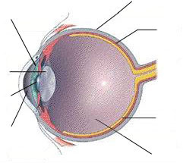
QUESTIONS:

- Why do you think that there are so many muscles attached to the outside of the eyeball? What are they for?

- What in the eyeball do think helps the eyeball maintain its spherical shape?

- Think back to the optic nerve attached to the eyeball. Where do you think this goes and why?

- Why is the eye lens biconvex instead of biconcave? Draw a labelled ray diagram to help explain why it is necessary to have a biconvex lens in the eye.

- You may need to do some research for this. Try this: http://bit.ly/blindspotscience
Why do we have a “blind spot” at the back of our eye? Explain why there is a spot that is “blind”.

CONCLUSION:
Having completed this lab, explain two scientific facts and one interesting one that you learned about the structure and function of the eye?

1. ______

______

2. ______

______

3. ______

______

