**Workplace 11**

**Note Package**

**Delview Secondary School**

Notes to accompany the lesson for

Apprenticeship and Workplace 11 Course

Arranged and edited by

Mrs. D. Couwenberghs

& Mrs. K. Samra

**Table of Contents**

Unit 1 – Understanding and Interpreting Graphs…………………………………………..4

Unit 2 - Budgeting…………………………………………………………………………………………..17

Unit 3 - Financial Services……………………………………………………………………………….43

Unit 4 – Slope and Rate of Change………………………………………………………………….77

Unit 5 – Scale…………………………………………………………………………………………………101

Unit 6 – Probability and Statistics………………………………………………………………….123

**Unit 1 - Understanding and Interpreting Graphs**

**Refer to the following graph to answer the listed questions.** 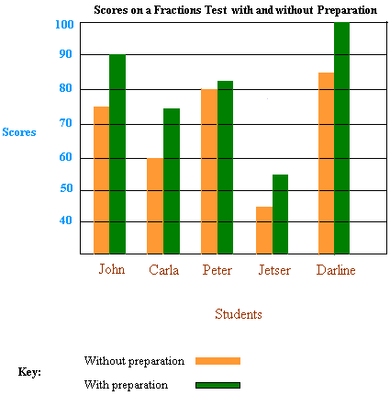

1. This graph is an example of a
   1. Circle graph
   2. Double bar graph
   3. Pictochart
   4. Line graph
2. The purpose of this graph is to

|  |  |
| --- | --- |
| a. | compare data across categories |
| b. | compare two sets of data across categories |
| c. | Compare categories to the whole using percents |
| d. | compare data that can be easily counted and represented using symbols |

3. The message in this graph is

|  |  |
| --- | --- |
| a. | Your test score will not be impacted by studying |
| b. | Jester wrote 55% of the fraction tests |
| c. | Only Carla and John’s test scores improved by preparing for the fraction test |
| d. | Students performed better when they prepared for the fraction test then when they did not. |

4. Use the following graph to answer these questions.

1. What does incidence rate per 100,000 population mean?
2. Which group of people in 2011 was most affected by tuberculosis in Canada?
3. What number of this group are affected per 100, 000 ?
4. How does this rate compare to Canadian-born non-Aboriginal rate?
5. What does the double line between 25 and 170 mean?
6. How does it affect bar heights shown?

**Reported new active and re-treatment tuberculosis cases by Aboriginal status, Canada, 2011**

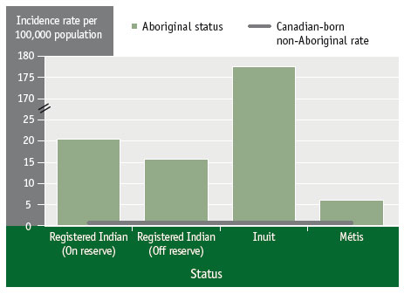

Public Health Agency of Canada. (2013). Tuberculosis in Canada, 2011. Pre-Release. (Ottawa: Public Health Agency of Canada). <http://www.phac-aspc.gc.ca/cphorsphc-respcacsp/2013/tuber--eng.php>

**Misleading Graphs!**

**The bar graph shows the election results for student council president.**

**ta01_02_11**

**a)** How many times taller does the bar for candidate B   
seem than the bar for A?

**b)** How many more votes did candidate B get   
than candidate A?

**c)** What does the graph seem to show about the election results?

\_\_\_\_\_\_\_\_\_\_\_\_\_\_\_\_\_\_\_\_\_\_\_\_\_\_\_\_\_\_\_\_\_\_\_\_\_\_\_\_\_\_\_\_\_\_\_\_\_\_\_\_\_\_\_\_\_\_\_\_\_\_\_\_\_\_\_

**d)** What is wrong with the **scale** on this graph?

\_\_\_\_\_\_\_\_\_\_\_\_\_\_\_\_\_\_\_\_\_\_\_\_\_\_\_\_\_\_\_\_\_\_\_\_\_\_\_\_\_\_\_\_\_\_\_\_\_\_\_\_\_\_\_\_\_\_\_\_\_\_\_\_\_\_\_

**What is wrong with the graph shown below? How could the graph be more informative?**

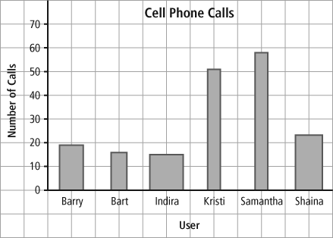

\_\_\_\_\_\_\_\_\_\_\_\_\_\_\_\_\_\_\_\_\_\_\_\_\_\_\_\_\_\_\_\_\_\_\_\_\_\_\_  
  
\_\_\_\_\_\_\_\_\_\_\_\_\_\_\_\_\_\_\_\_\_\_\_\_\_\_\_\_\_\_\_\_\_\_\_\_\_\_\_  
  
\_\_\_\_\_\_\_\_\_\_\_\_\_\_\_\_\_\_\_\_\_\_\_\_\_\_\_\_\_\_\_\_\_\_\_\_\_\_\_  
  
\_\_\_\_\_\_\_\_\_\_\_\_\_\_\_\_\_\_\_\_\_\_\_\_\_\_\_\_\_\_\_\_\_\_\_\_\_\_

**The graphs show the number of each type of apple sold.**

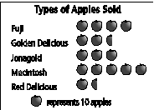 ta01_01_06b

**a)** In your opinion, which graph is easier to read? Give 1 reason for your choice.

\_\_\_\_\_\_\_\_\_\_\_\_\_\_\_\_\_\_\_\_\_\_\_\_\_\_\_\_\_\_\_\_\_\_\_\_\_\_\_\_\_\_\_\_\_\_\_\_\_\_\_\_\_\_\_\_\_\_\_\_\_\_\_\_\_\_\_  
  
\_\_\_\_\_\_\_\_\_\_\_\_\_\_\_\_\_\_\_\_\_\_\_\_\_\_\_\_\_\_\_\_\_\_\_\_\_\_\_\_\_\_\_\_\_\_\_\_\_\_\_\_\_\_\_\_\_\_\_\_\_\_\_\_\_\_\_

**b)** How many more Fuji and MacIntosh apples were sold than Red Delicious apples?

\_\_\_\_\_\_\_\_\_\_\_\_\_\_\_\_\_\_\_\_\_\_\_\_\_\_\_\_\_\_\_\_\_\_\_\_\_\_\_\_\_\_\_\_\_\_\_\_\_\_\_\_\_\_\_\_\_\_

**c)** What type of graph is the graph with the apple pictures? \_\_\_\_\_\_\_\_\_\_\_\_\_\_\_\_\_\_\_\_\_  
 When would this graph be preferable to a bar graph?

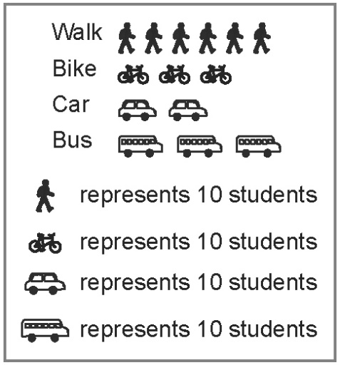**Critiquing Graphs!**

**1.** This graph shows how students get to school.

**a)** Is a pictograph effective to display the data  
 about how students get to school? Explain.

**b)** Is the data represented accurately? Explain.

**c)** What improvement(s) do you recommend for   
representing the data?

**d)** Is the graph informative? Make a suggestion   
for making it more informative.

**e)** Recommend another type of graph to represent the data. Give an advantage of using this graph.

Pair Activity

With a partner come up with one survey question of interest to both of you that you want to survey your classmates with. You must provide 4 categories to choose from. Survey 20 of your classmates and tally results for each category in a table. Then create a both a bar graph and a pictograph using the survey data. Be sure to include all elements discussed in class such as an appropriate scale.

|  |  |
| --- | --- |
|  |  |

**Circle Graphs**

**The graphs show population data for selected provinces.**

ta01_PracticeTest_02b**a)** Do both graphs provide the same information?  
Give 1 reason for your answer.

\_\_\_\_\_\_\_\_\_\_\_\_\_\_\_\_\_\_\_\_\_\_\_\_\_\_\_\_\_\_\_\_\_\_\_\_\_\_

\_\_\_\_\_\_\_\_\_\_\_\_\_\_\_\_\_\_\_\_\_\_\_\_\_\_\_\_\_\_\_\_\_\_\_\_\_\_

**b)** Which graph best shows that Alberta’s population   
is almost 3 times more than Manitoba’s population?  
Give 1 reason for your answer.

\_\_\_\_\_\_\_\_\_\_\_\_\_\_\_\_\_\_\_\_\_\_\_\_\_\_\_\_\_\_\_\_\_\_\_\_\_\_

\_\_\_\_\_\_\_\_\_\_\_\_\_\_\_\_\_\_\_\_\_\_\_\_\_\_\_\_\_\_\_\_\_\_\_\_\_\_

ta01_PracticeTest_02a

1. Which graph best shows the province with the  
    highest proportion of the population compared   
    to the whole population of the Western Canadian  
    Provinces? Explain? \_\_\_\_\_\_\_\_\_\_\_\_\_\_\_\_\_\_\_\_\_\_

\_\_\_\_\_\_\_\_\_\_\_\_\_\_\_\_\_\_\_\_\_\_\_\_\_\_\_\_\_\_\_\_\_\_\_\_\_\_\_

**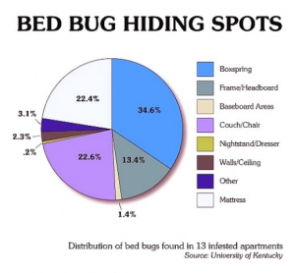Understanding Circle Graphs**

1. Where did this survey take place?\_\_\_\_\_\_\_\_\_\_\_\_\_\_\_
2. How many apartments were searched for bed bugs?
3. How many bed bugs were found in all apartments?  
   \_\_\_\_\_\_\_\_\_\_\_\_\_\_\_\_\_\_\_\_\_\_\_\_\_\_\_\_\_\_\_\_\_\_\_\_\_\_\_\_\_\_\_\_\_\_\_\_\_\_\_\_\_\_\_\_\_\_\_
4. If 200 bed bugs were found, use the graph to estimate how many bedbugs would be found in the boxspring?  
   \_\_\_\_\_\_\_\_\_\_\_\_\_\_\_\_\_\_\_\_\_\_\_\_\_\_\_\_\_\_\_\_\_\_\_\_\_\_\_\_\_\_\_\_\_\_\_\_\_\_\_\_\_\_\_\_\_\_\_\_
5. Of these 200 bed bugs estimate, how many would be found in the walls and/or ceiling? \_\_\_\_\_\_\_\_\_\_\_\_\_\_\_\_
6. If you removed the mattress, bed and boxspring from an bed bug infested apartment, would this remove the infestation? Yes or no, Explain \_\_\_\_\_\_\_\_\_\_\_\_\_\_\_\_\_\_\_\_\_\_\_\_\_\_\_\_\_\_\_\_\_\_\_\_\_\_\_\_\_\_\_\_\_\_\_\_\_\_\_\_\_\_\_\_\_

\_\_\_\_\_\_\_\_\_\_\_\_\_\_\_\_\_\_\_\_\_\_\_\_\_\_\_\_\_\_\_\_\_\_\_\_\_\_\_\_\_\_\_\_\_\_\_\_\_\_\_\_\_\_\_\_\_

**Misleading Circle Graphs**

ta01_02_19

**Which category does the government want   
people to notice the most?**

**b)** How would you redraw the graph to make it   
more accurate?

**Reported new active and re-treatment tuberculosis cases by place of birth, Canada, 2011**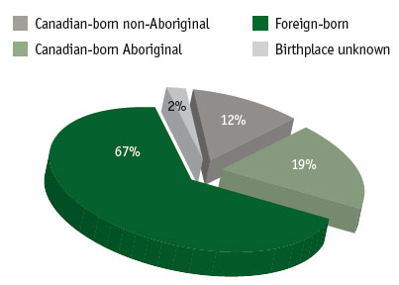

Public Health Agency of Canada. (2013). Tuberculosis in Canada, 2011. Pre-Release. (Ottawa: Public Health Agency of Canada). <http://www.phac-aspc.gc.ca/cphorsphc-respcacsp/2013/tuber--eng.php>

Why do you think the Public Health Agency of Canada also created a graph that might be perceived as misleading?

What information would make both these graphs more informative?

Use the data you gathered for the bar and pictographs to create a circle graph. You will need to use a protractor and compass.

1. Complete the table below *(round percentages to one decimal place)* ***How do you find percent?***

|  |  |  |  |
| --- | --- | --- | --- |
| **Categories** | **Total in each  Category** | **Percent in each Category** | **Degree Measure $$\frac{ \%}{100} = \frac{?}{360}=\%×360 ÷100$$** |
|  |  |  |  |
|  |  |  |  |
|  |  |  |  |
|  |  |  |  |
|  |  |  |  |
|  |  |  |  |
|  | **Total Students:** | **Total %:** |  |

1. ***Use a compass to draw a circle below and a protractor to measure out the degrees. Then label the graph so that it is informative.***

**Other Graphs:**

**1. What type of graph is shown below?\_\_\_\_\_\_\_\_\_\_\_\_\_\_\_\_\_\_**

|  |  |
| --- | --- |
| a. | Line graph showing a change in data over time |
| b. | Pictochart comparing data that can be easily counted and represented using symbols |
| c. | Bar graph comparing data across categories |
| d. | Circle graph comparing categories to the whole using percents |

**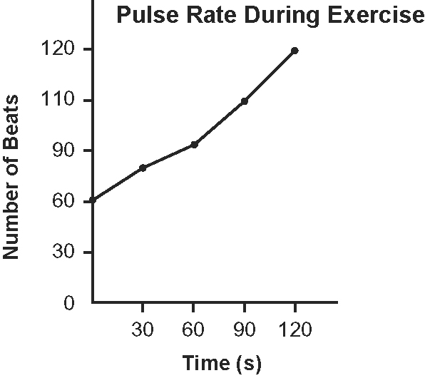**

|  |  |
| --- | --- |
| a. | Pulse rate declines with exercise |
| b. | At rest the individuals heart rate is about 63 beats/min |
| c. | Pulse rate increases with exercise |
| d. | After a minute pulse rate has increased by 20 beats/min |
| e. | After 2 minutes his heart rate has doubled |
| f. | Only b, c and e are correct conclusions |
| e | Only b and d are correct conclusions |

**2. What conclusions can you draw from reading this graph? \_\_\_\_\_\_\_\_\_**

**Reported tuberculosis incidence and mortality rates, Canada, 1924 to 2011**

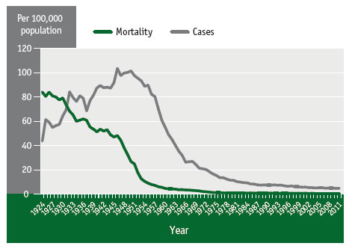

Public Health Agency of Canada. (2013). Canadian Tuberculosis Reporting System [Custom Data File]. Retrieved on April 30, 2013. <http://www.phac-aspc.gc.ca/cphorsphc-respcacsp/2013/tuber--eng.php>

How is the graph above similar to the first line graph?

Do you notice anything strange about this graph that does not make sense?

What do you predict will be the number of cases of tuberculosis per 100,000 people in 2020?

*In a line graph two variables are compared. One variable value depends on the other value. This is the dependent variable. This variable is always listed on the vertical axis. The independent variable is put on the horizontal axis.*

If you were comparing height and weight of people which variable would be the dependent variable? \_\_\_\_\_\_\_\_\_\_\_\_\_\_\_\_Which would be the independent variable? \_\_\_\_\_\_\_\_\_\_\_\_\_\_\_\_\_\_\_\_.

Time is always the \_\_\_\_\_\_\_\_\_\_\_\_\_\_\_\_\_\_\_\_\_variable so it is on the \_\_\_\_\_\_\_\_\_\_\_\_\_\_axis.

To create a line graph what information must be present?

How does one correctly number and space the values on the axes?

|  |  |
| --- | --- |
| Time ( ) | Distance ( ) |
|  |  |
|  |  |
|  |  |
|  |  |
|  |  |
|  |  |

Ask six people in your class the distance they travel to school each day and the time this takes them if they walk. Put the data in the table to the right. Then use this data to create a line graph that meets the requirements listed above.