How to make a histogram in Excel
This is not the easiest way to do this, but it will work.
Step 1: Get numerical data
Open the file: Unit 1 Histogram Starting Data either on google classroom or on my website.
Step 2: Order the numerical values from smallest to largest
Select all of the data including the headings by dragging the mouse over the data so it is highlighted
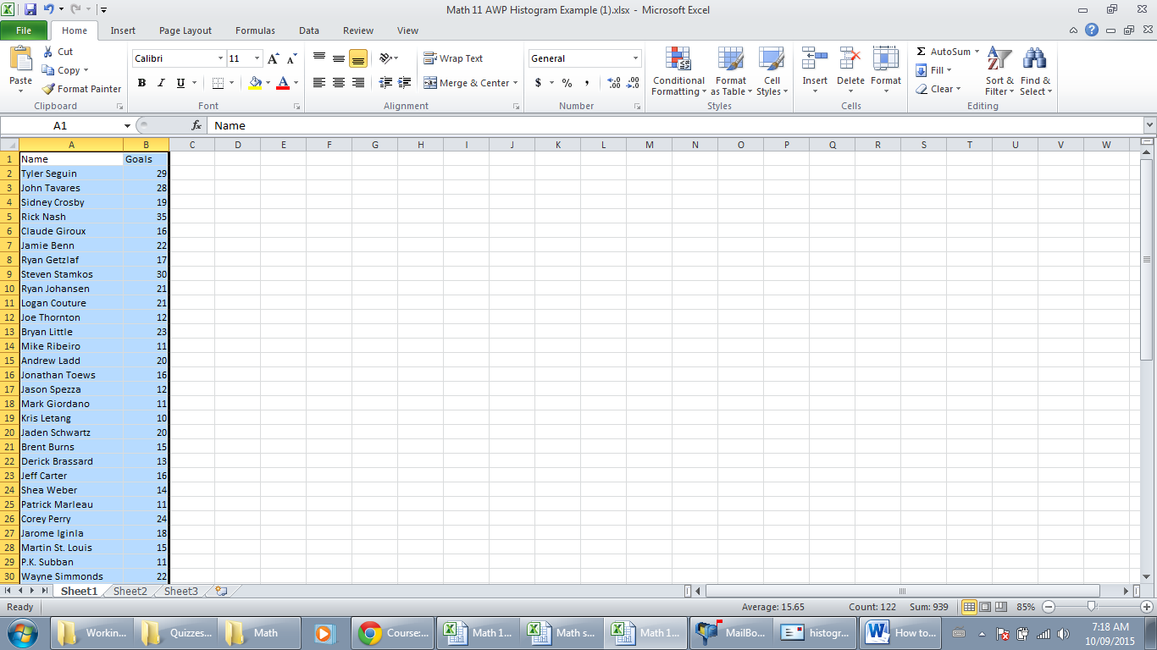
Click sort and filter icon top right corner of screen; select Custom Sort
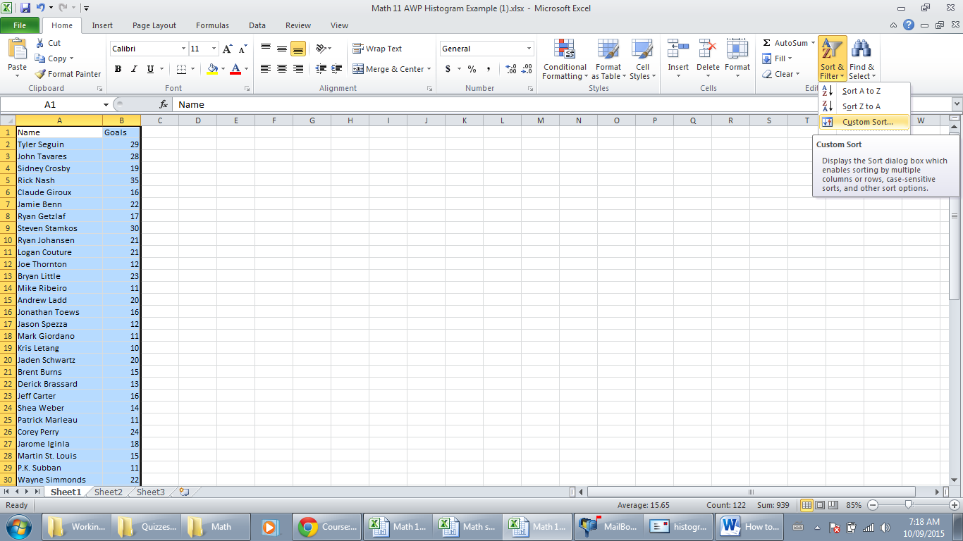
Change the Sort by to goals and the Order to smallest to largest
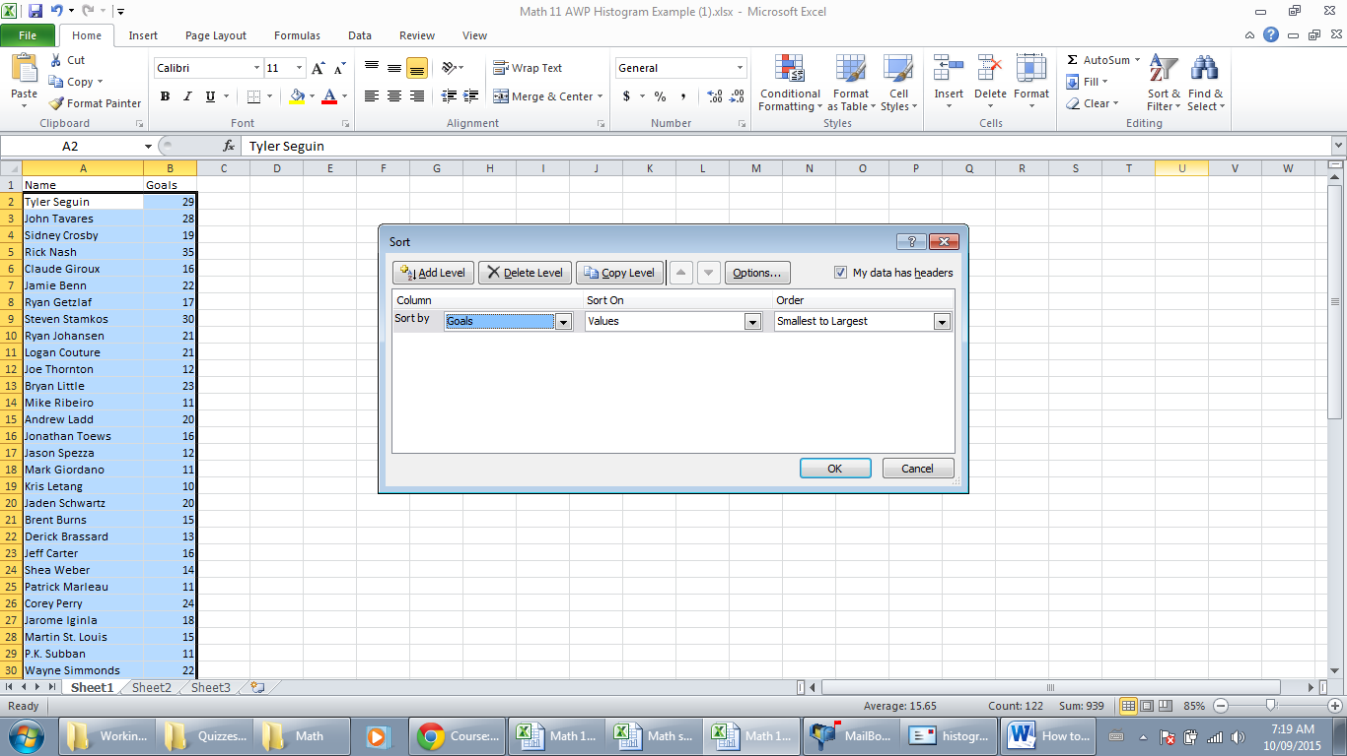

Step 3: Frequency Table
On the same worksheet in two new columns, label the first column (row 1) ”Intervals” and the next column “Frequency.”
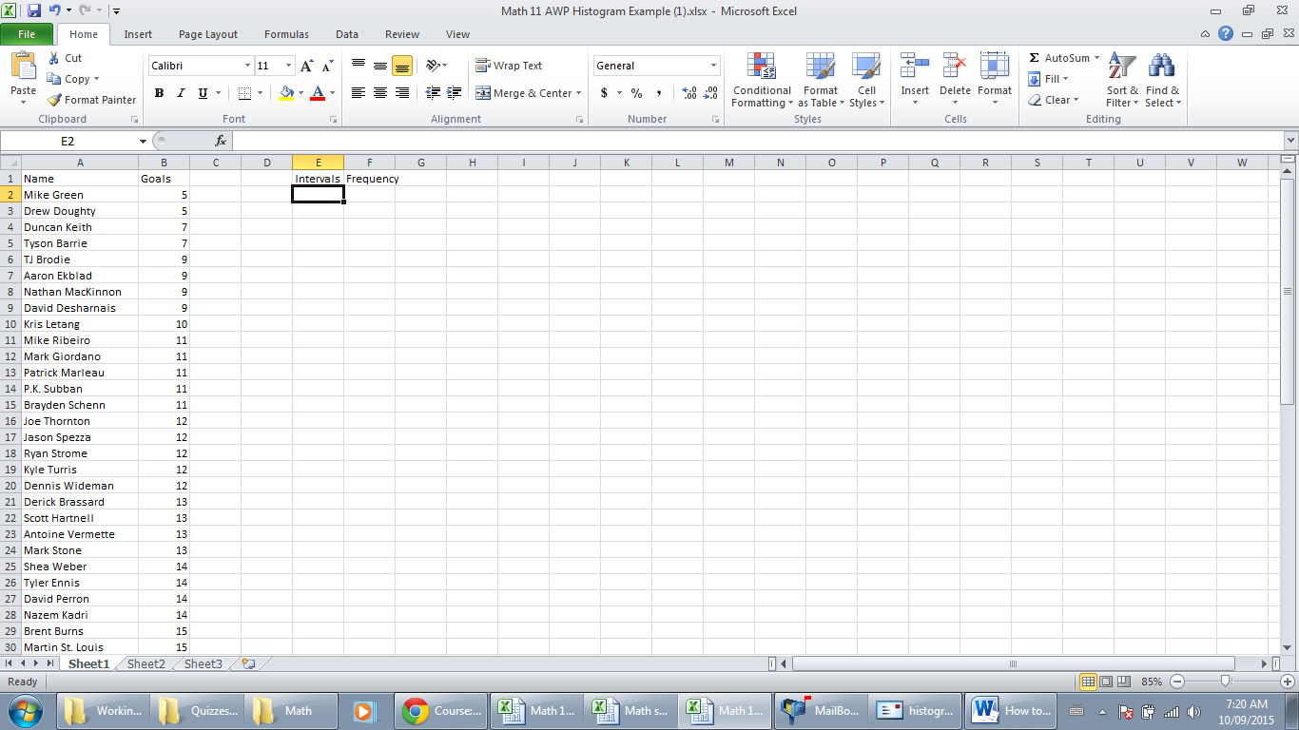
Step 4: Decide on intervals for the horizontal axis
Look at your data and decide what to set up as the intervals for horizontal axis (the range of goals for each bar of your histogram). You should have at least 5 bars. You do not have to use the same intervals as I used i.e 0 to 5; 6 to 10; etc. Type these interval values into the interval column putting one interval in each cell. 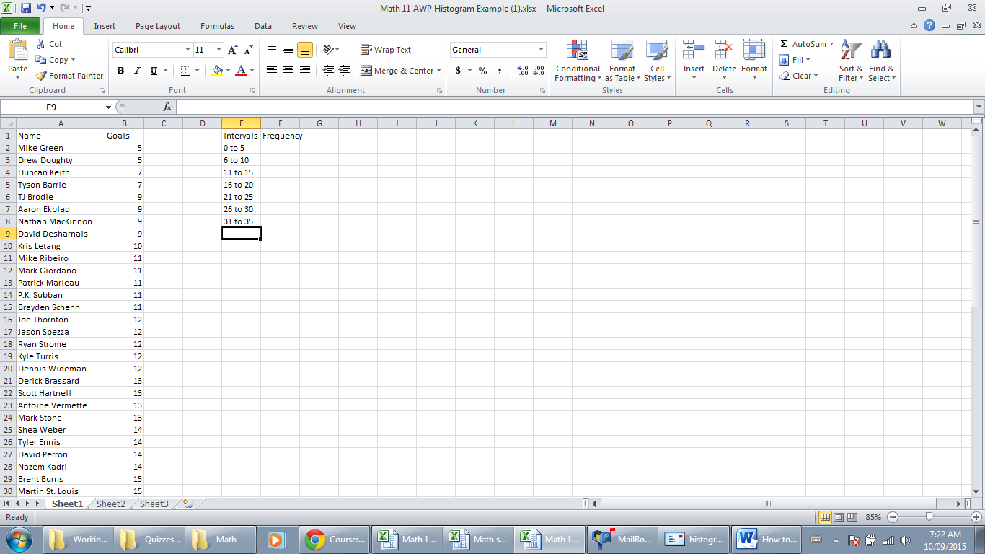
Step 4: Excel will Tally the number of values for each interval (it will make your life easier and lead to less mistakes if you let excel do most of the work)
- In your frequency column beside your first interval write out “ =count( “
- Select all the values in the goals column that fall into the interval range of values and then press enter.
- Repeat the about two steps for all intervals
(refer to the next few diagrams for clarification)
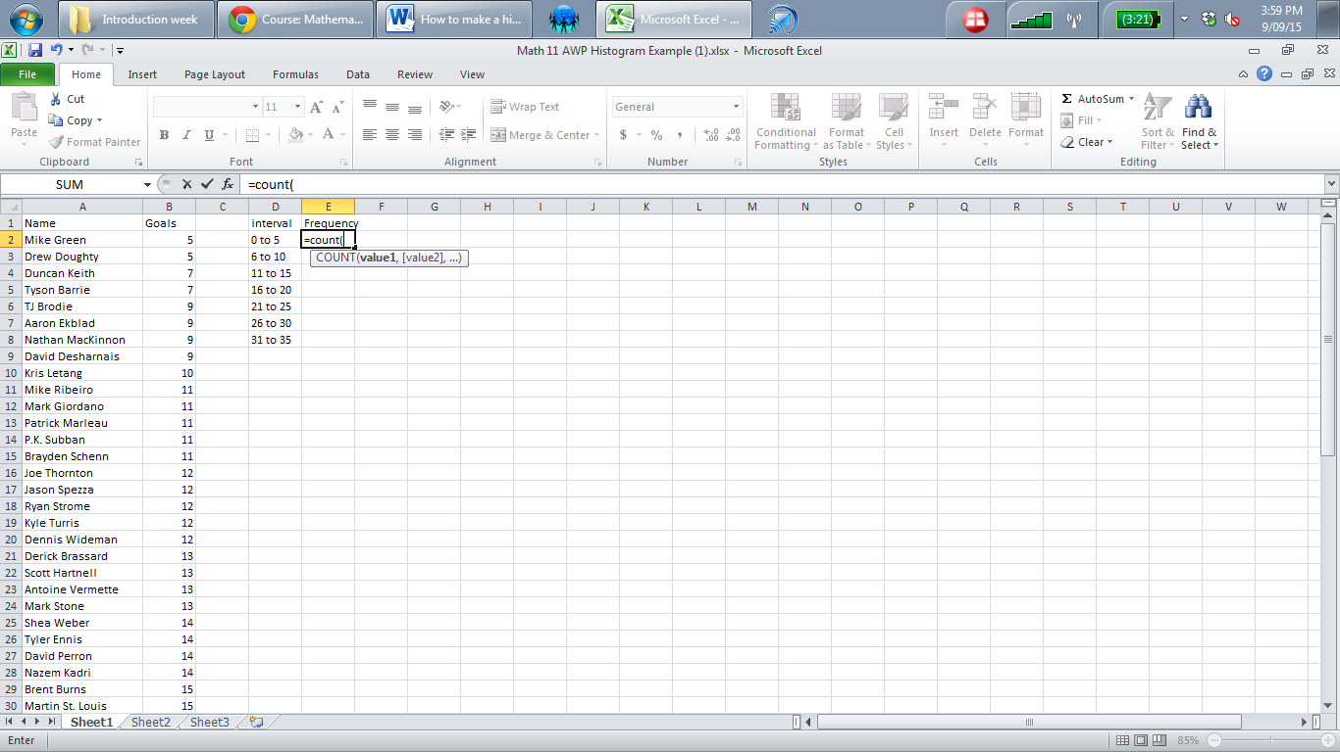

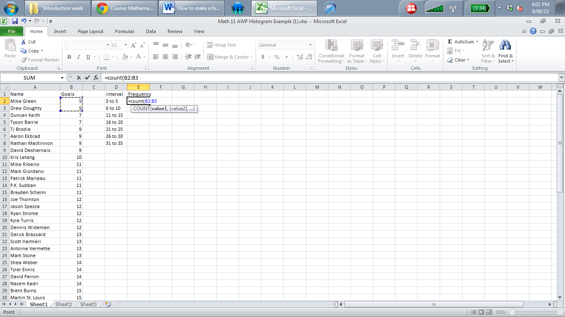
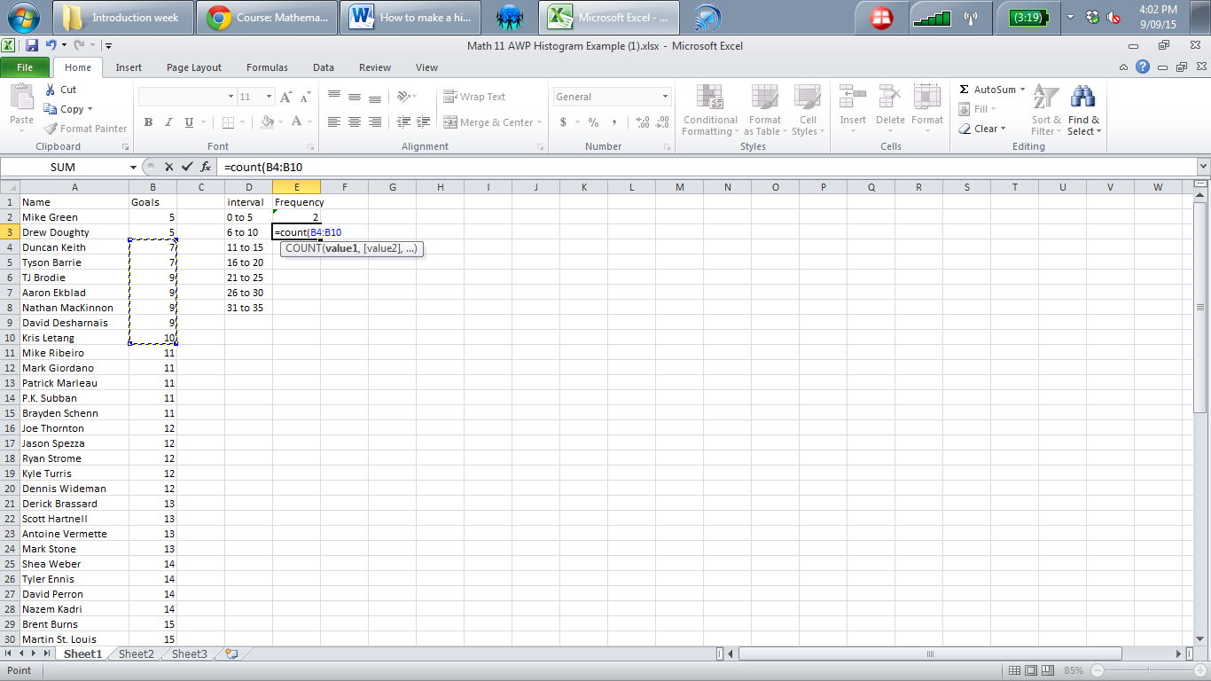
Step 5: Create Graph
- Select the data and title in both the interval and frequency columns.
- Under the insert tab select Column Graph
- Select the first 2-D column graph
(refer to the next few diagrams for clarification)

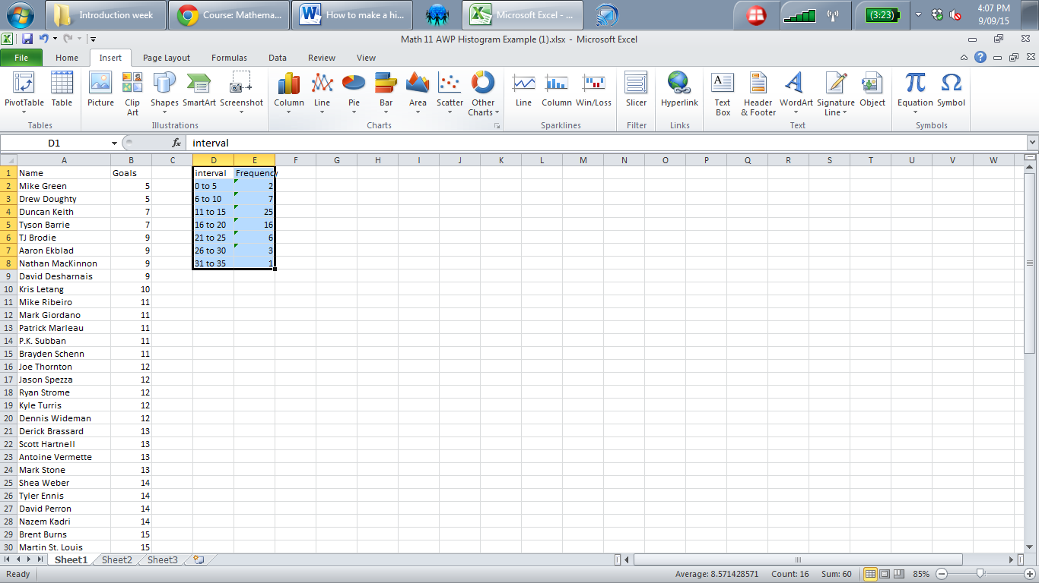
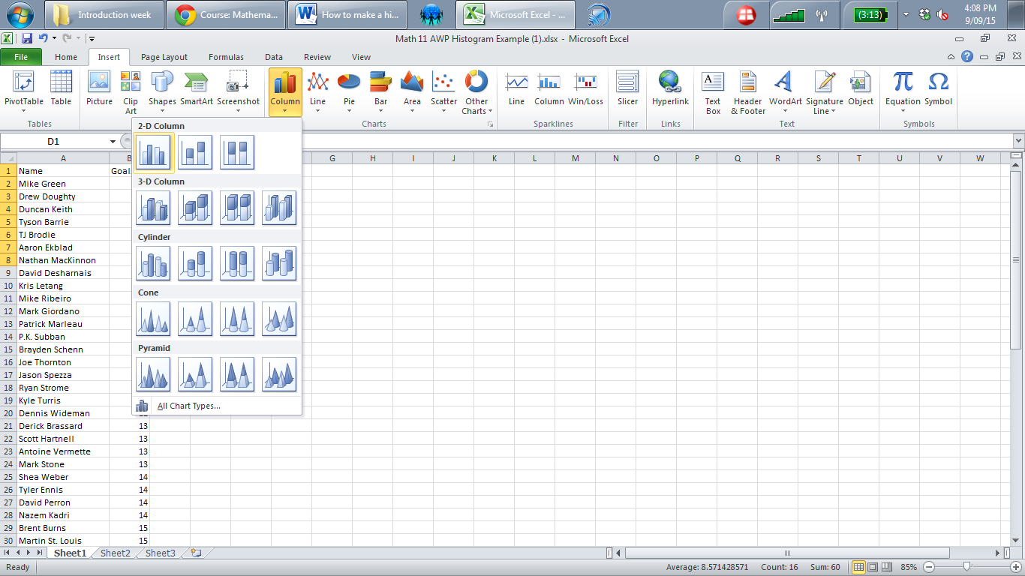

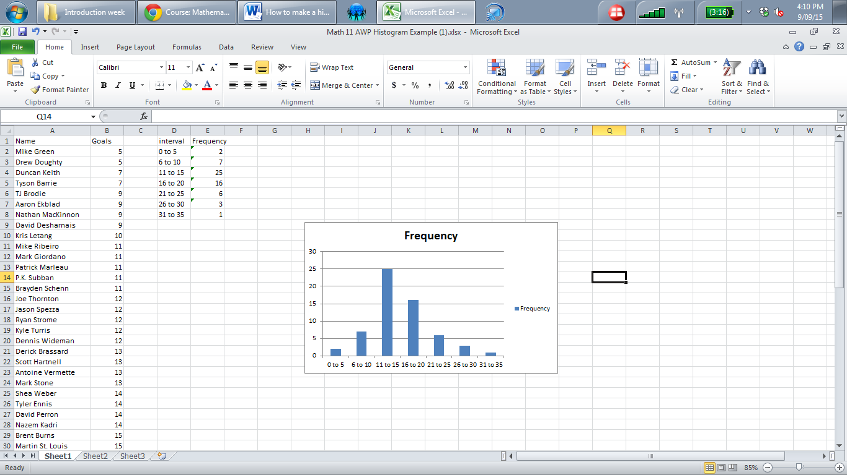
Step 6: Format your graph (your graph must have the axes labelled, an appropriate, descriptive title and the bars must be beside each other)
- Click anywhere on the graph and you will see a green heading at the top saying Chart Tools. Under the layout heading, you will see Axis Titles.
- Choose which title display you would like best for the vertical axis.
- Type in title
- Repeat for the horizontal title
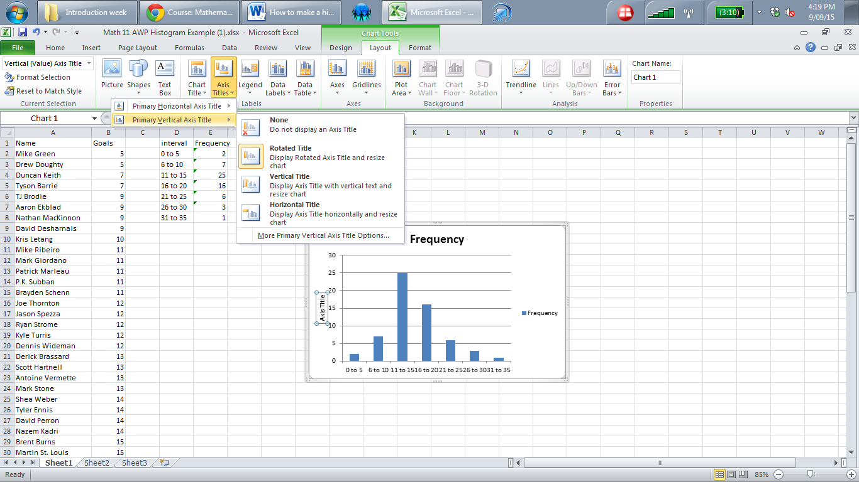

- Select the Chart Title by clicking on the title in the graph. Give your graph an appropriate descriptive title.
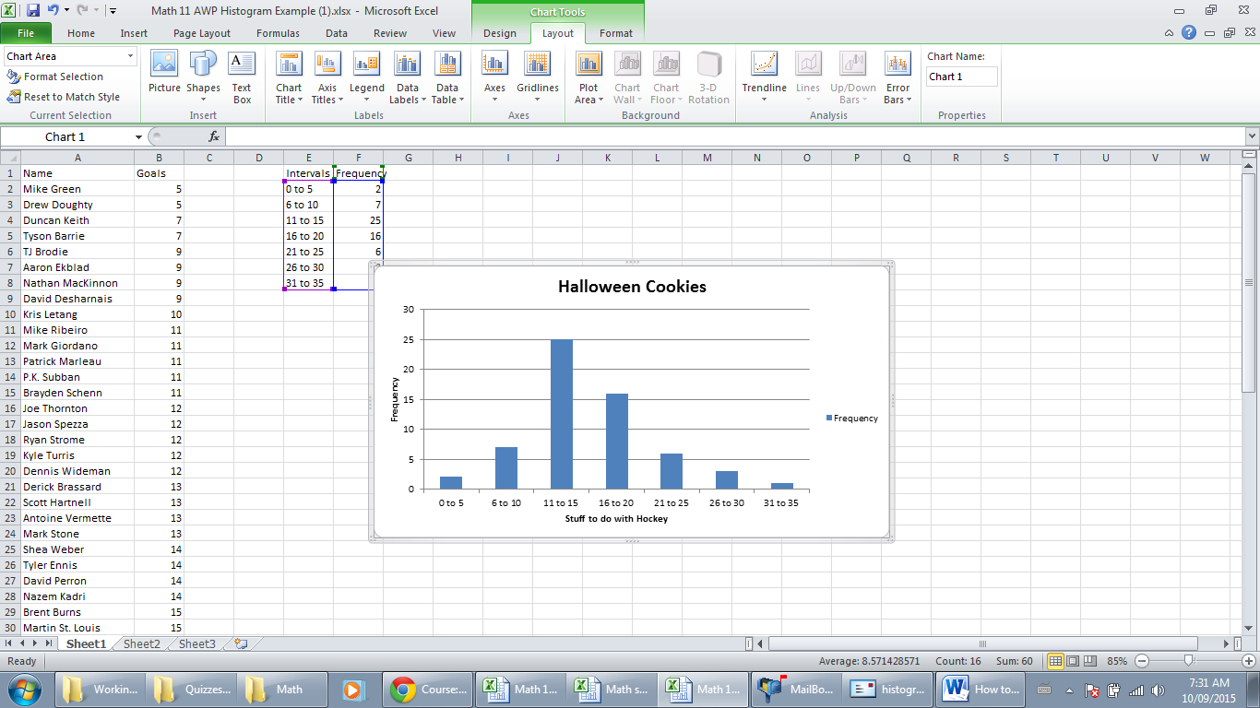
- Select and delete the legend
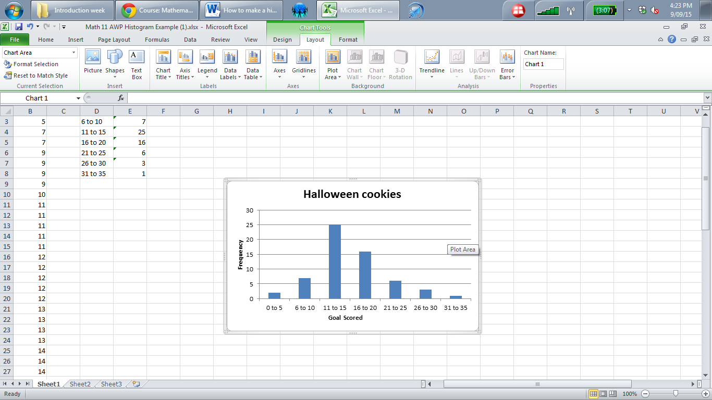

- Click on the bars and left click
- Select Format Data Series
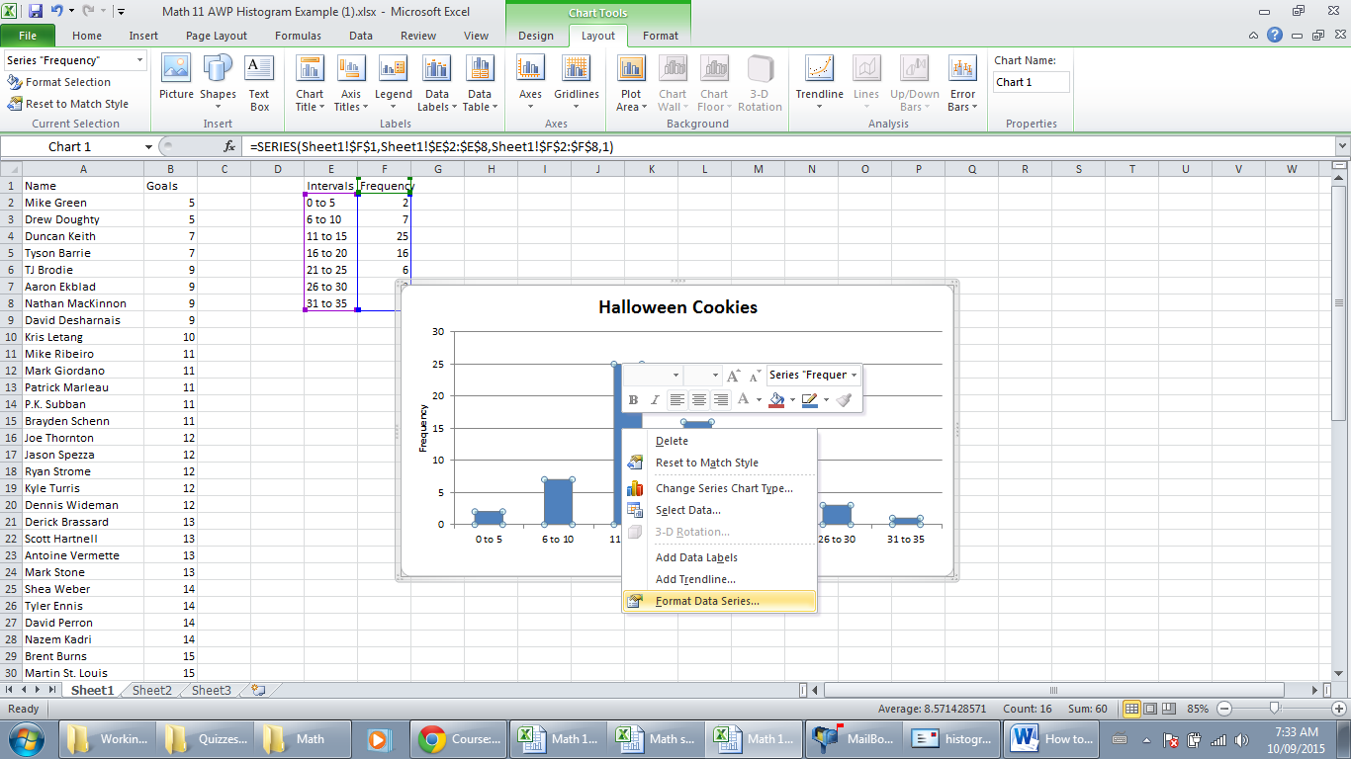
- Under Gap Width, move slider to No Gap
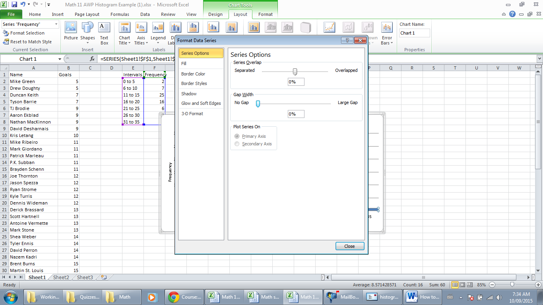

Compare with the person beside you.
Save and submit
