Understanding the Properties of Energy
Energy Skate Park

Purpose: (write after you have had a look at the questions below)

Instructions: Sign into your computer and go onto the internet. Go to this web page: http://phet.colorado.edu/simulations/sims.php?sim=Energy_Skate_Park or, go to Google and search for: phet skate park. Click on the Run Now! Button. Play with the sim for a few minutes: adding track, resetting the skater when he falls off the track, resetting the track, try the different options for graphs as well. Then answer the questions below.
Questions:
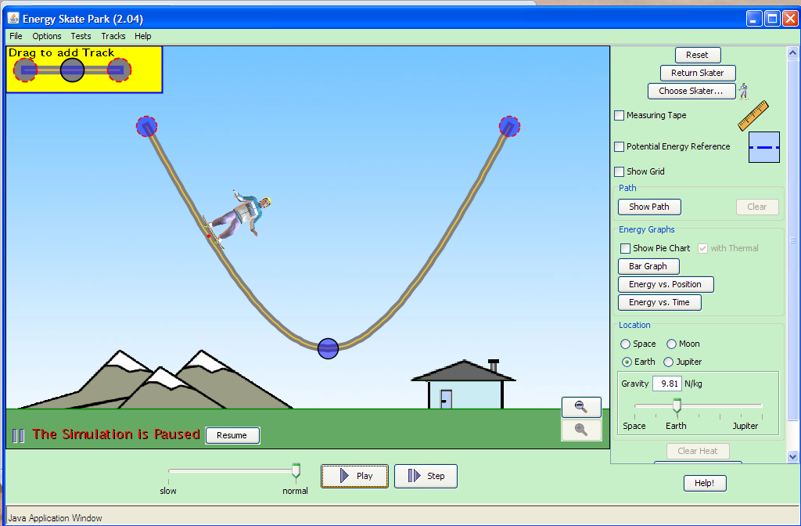
- Reset the track to its original position by hitting the top “Reset” button. How does the height reached by the skater compare to his initial starting height? Explain. (Use the “pause” button and the measuring tape to help you determine this!)

- Drag one end of the track so that it has one steep slope and one gradual slope. How does this affect the height reached by the skater? Explain.

- Click on the “Potential Energy Reference” check box. Move the line to the bottom or the top of the track and note the movement of the skater.
  - Does the position of the reference line affect the motion of the skater?

  - Briefly explain what the potential energy reference line is and its purpose.

- Move the Potential Energy reference line to the bottom of the track. Click on the pie chart button.
  - What rule(s) does Gravitational Potential energy pie section seem to follow (you can use the equation here)? Draw two pie charts to explain.

  - What rules does the Kinetic energy pie section seem to follow? Draw two pie charts to explain.

  - What does the size of the pie represent? How many ways can you find to make the pie bigger or smaller? What rules does it seem to follow?

- Reset the track and increase the amount of friction. What type of energy does friction generate?

- How does going into outer space affect the energy pie charts? Specifically, what happens to the gravitational energy?

- What objects must be in your system in order to have Gravitational energy?

- Reset the track and observe the skater on the Moon and on Jupiter.
  - How does the skater’s speed on the Moon compare to Earth. Explain why this occurs.

  - How does the skater’s speed on Jupiter compare to Earth. Explain why this occurs.

Click on Reset in the upper right corner and Pause the Skater. Click on the three blue dots in the upper left hand corner that says, “Drag to add Track”. Add some sections onto your track and arrange your track until you have one where there are hills and the skater can stay on at both ends. Keep friction turned off, and leave the gravity on Earth.

Sketch your track below:

- What general rule about the hills do you have to follow to get the skater to go all the way from one side of your track to the other? What can affect whether it works or not?

- On the drawing above, sketch the pie chart of the skater’s energy

- Reset the skater and add a little friction. Sketch new bar or pie graphs at the same 4 points on your drawing.

Conclusion: Respond to your purpose above

