Grade 9 Math - Chapter 4 Review Worksheet

1. Determine the length of HK.



2. Are these similar triangles? Explain.



3. For triangles to be similar what do you know about their angles, and their sides?

__________________________________________________________________________

__________________________________________________________________________

4. Are these triangles similar? Explain.

a)



b)



c)



6. The tallest coast Douglas fir measures 94m. Wonita drew a picture of it that measures 11cm tall. Determine the scale factor.

7. Use a scale factor of 2 to draw an enlargement of the figure below.

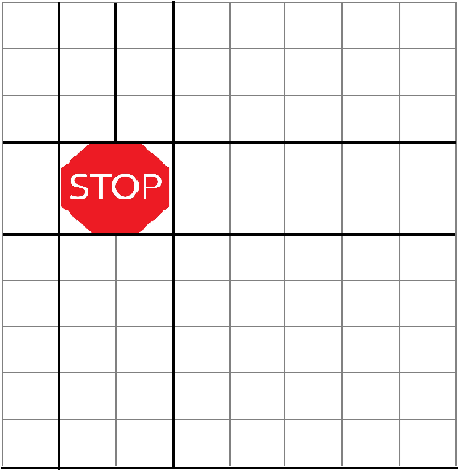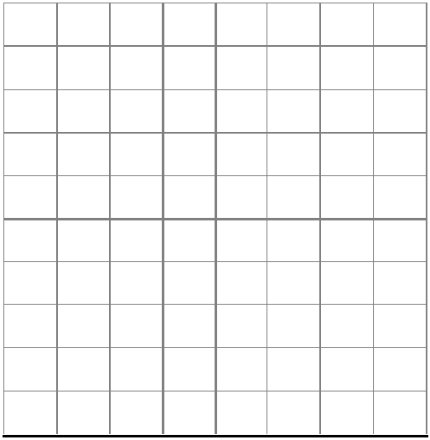

8. Draw ΔABC with vertices A(0,0), B(2,0) and C(1,3).Draw a scale diagram of ΔABC with a scale factor of 3 and one vertex at (0,0).

**y**

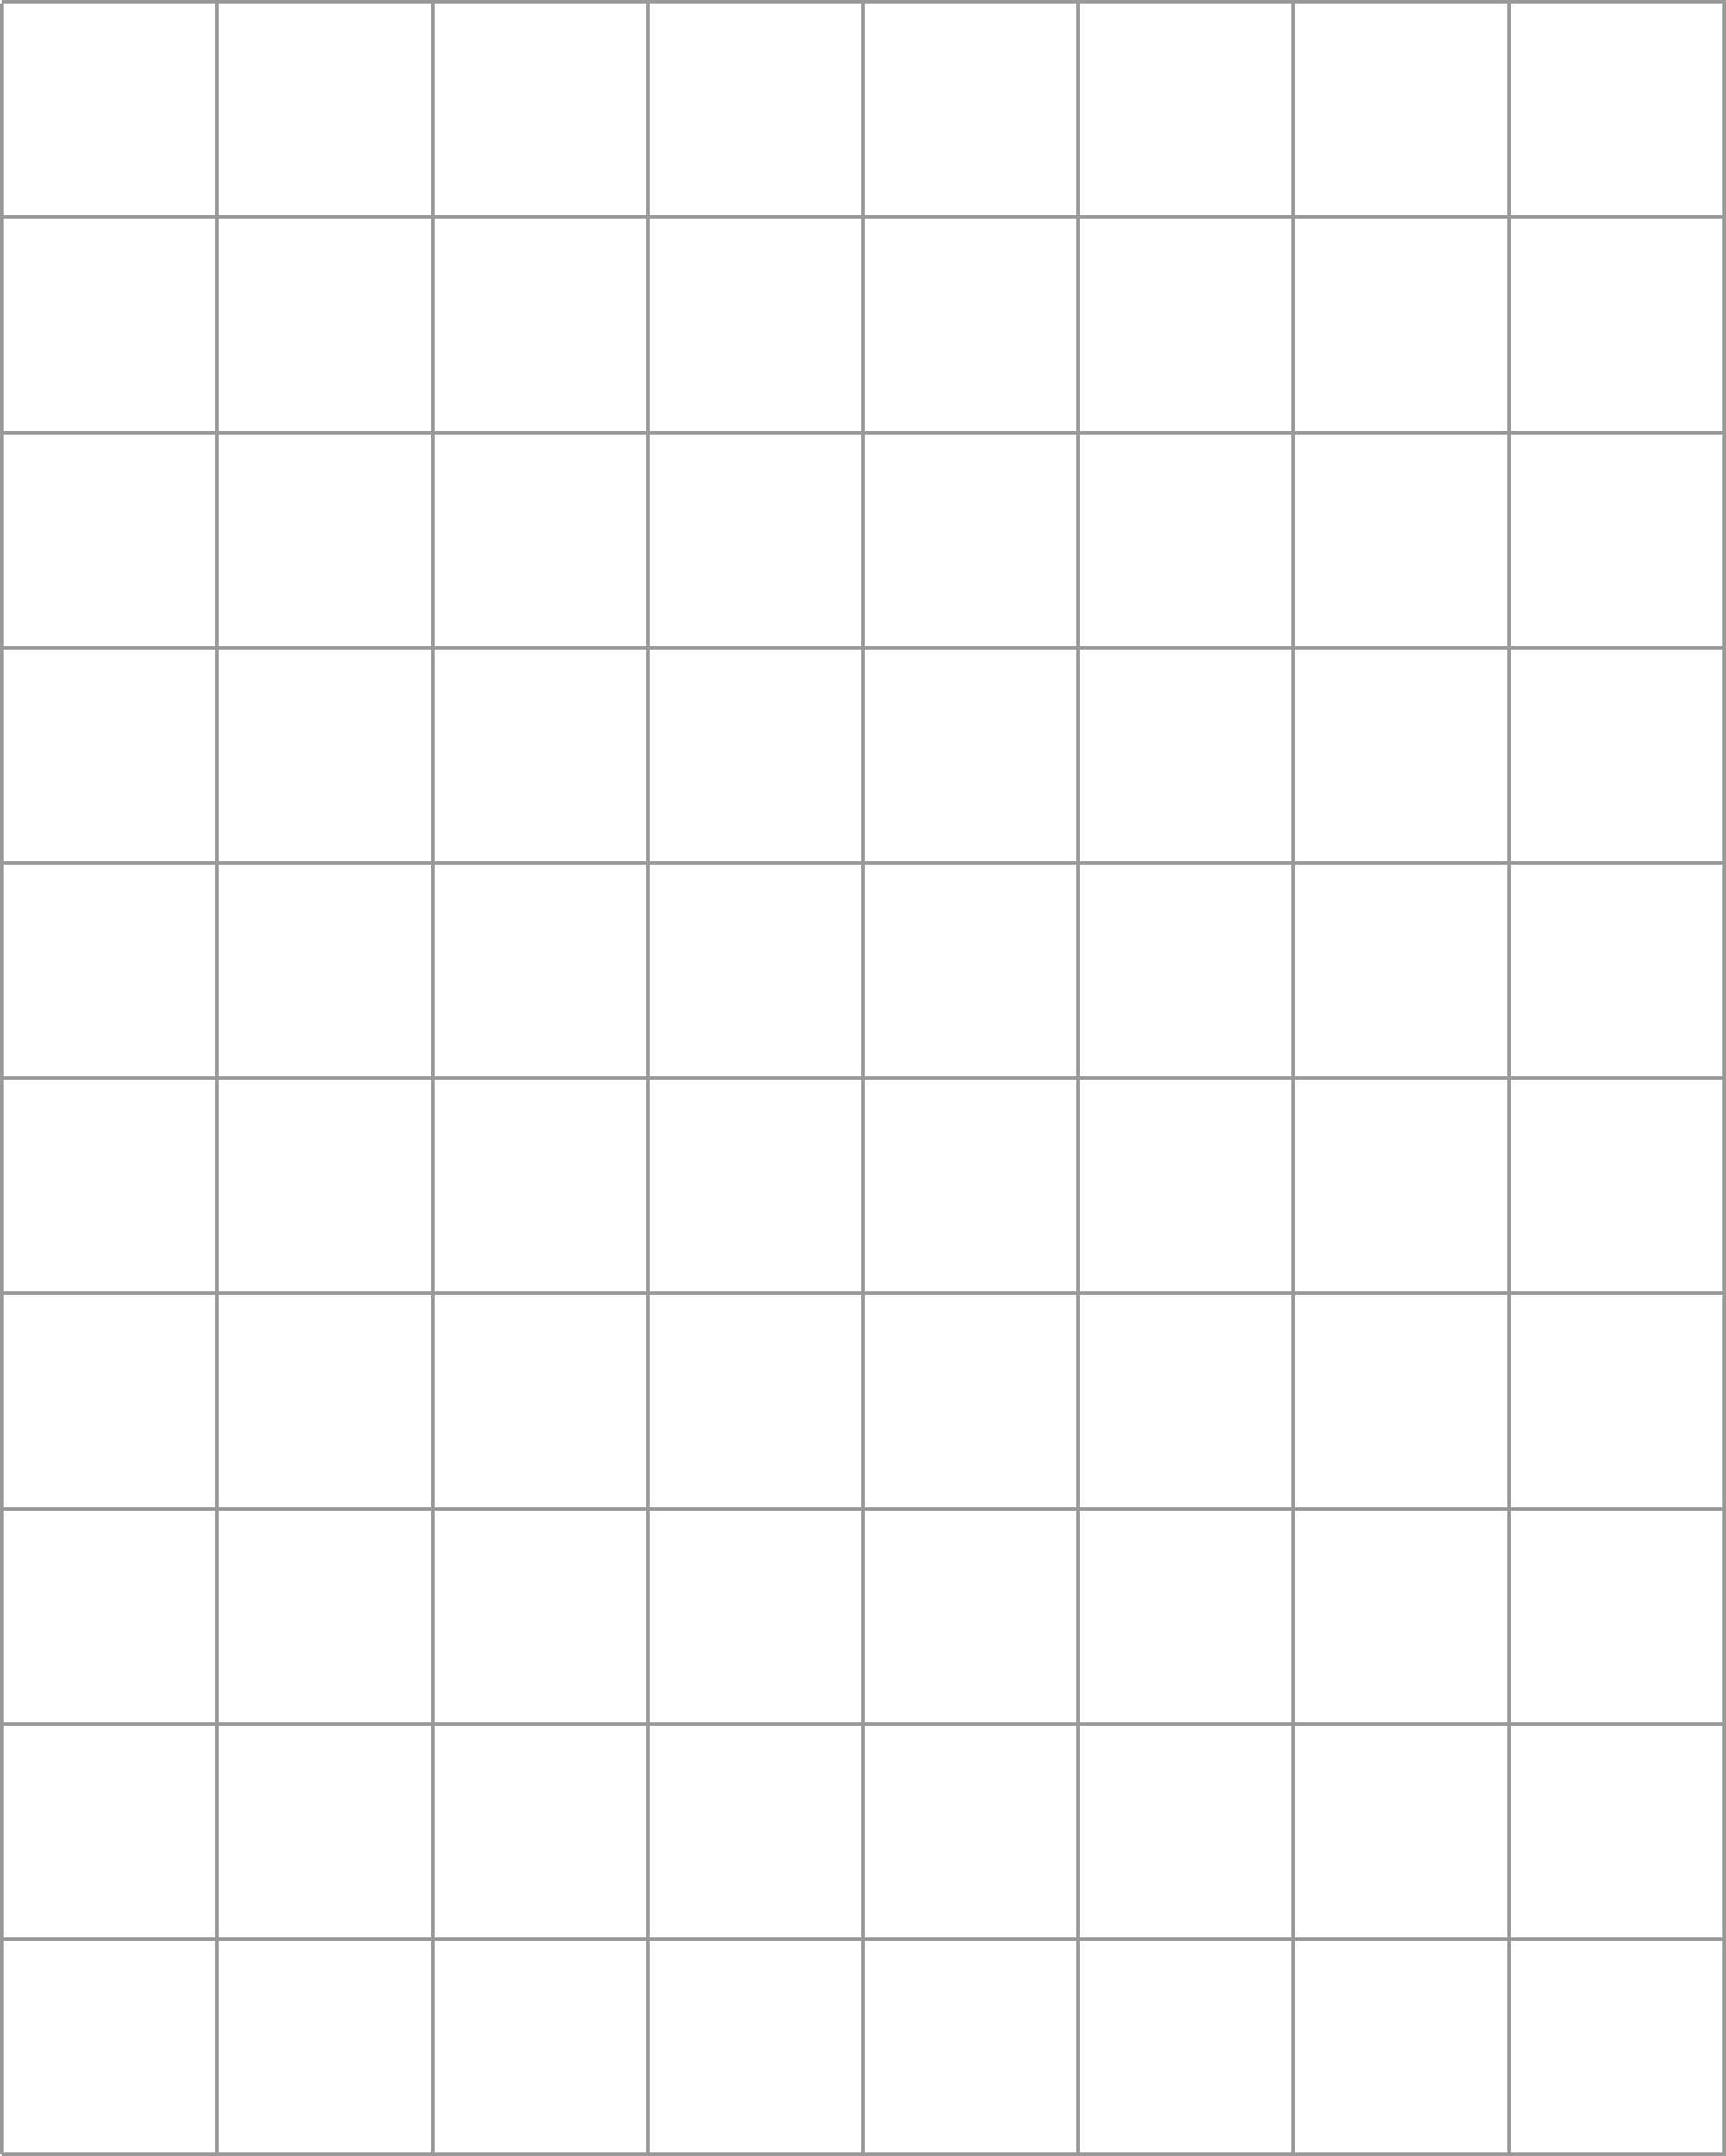**x**

9. A toy truck is scale replica of an actual truck. If the toy truck is 13 cm in length and a scale of 1:50, how long is the actual truck?

10. Metric Conversions:

***King Henry died, Mary didn't care much***

Kilo, Hecto, Deca, (Meter, gram, litre), Deci, Centi, Milli

***Move to the right, move the decimal to the right; move to the left, move the decimal to the left.***

Convert 6325 m to kilometers. Convert 45.6 km to meters.

Convert 59 cm to millimeters. Convert 2890 cm to meters.

Convert 15 cm to kilometers. Convert 32.56 dam to decimeters

Covert 7255 mm to centimeters Convert 32.5 cm to meters

Proportions:

**Solve each proportion for the indicated variable. Show all steps.**

**1.  2. **

3.  4. 

5.  6. 

7.  8. 

9.  10. 