Workplace 11 Name: ____________________
BUYING A CAR PROJECT
Choose 2 new cars you wish you could have and list them below. One car is your dream car, the other a more realistic choice.
Car 1 (dream)–
Car 2 (realistic)–
Research and compare! Look up your top choices by visiting one or some of the following: the manufacturer website of each car, https://carcostcanada.com, www.canadianblackbook.com or www.kbb.com (Kelley’s Blue Book, use 98226 as your zip code).
What is the MSRP (Manufacturer’s Suggested Retail Price) for:
Car 1 –
Car 2 –
What is the cost of these vehicles with 12% tax?
Car 1 –
Car 2 –
Insurance! Obtain a quote for the cost of insurance. You can look at https://www.bcaa.com/insurance/auto/overview/quick-quote or http://www.canadiandirect.com/get-a-quote/. Note that male/female and age make a difference in rates! (Use age 22 since we are ‘pretending’ that we are already finished with college/technical school). Obtain the quote with the following specifications:
-You are the primary driver of the car
-You are 22 years of age (change your year of birth)
-First year licensed as when you were 16
-No at fault accidents
-If you cannot find your car, pick one that is similar in cost and style
-Vehicle use as to work more than 15 km
-High Liability (at least 3 million)
-Low Deductible

Show your work to obtain the monthly insurance cost for:

Car 1 –

Car 2 –
Financing! You must take a 48-month loan with the bank. Assume the interest rate is prime plus 1%. This is currently set by the bank of Canada to be ________%. Calculate how much interest you will be paying over the 48 months using both simple and compound interest and then determine what your monthly payment will be. Show all work!

 | Simple Interest | Compound Interest
Car 1 –

Car 2 –

Assume you were able to pay a 20% down payment on the car and borrowed the rest,
a) How much will you have to borrow to buy the car?
Car 1 –

Car 2 –

b) You can get a loan at 3.75% for 4 years from the car dealership. What would your monthly payment be using the Personal Loan Calculator table?
Car 1 –

Car 2 –
c) What is the total amount you paid for the loan over the 4 years?
Car 1 –

Car 2 –

d) What is your finance charge on the loan?
Car 1 –

Car 2 –

e) How much will you pay in total for the cars?
Car 1 –

Car 2 –

Gas Costs! Determine your gas costs for the month. Based on driving the car 18,000 km per year and the fuel efficiency of the car in litres per 100 km (may have to convert from miles per gallon (mpg)). Show all work!
What is the expected monthly gas cost for:
Car 1 –

Car 2 –
Totaling your monthly expenses! Determine the average monthly cost of your vehicles with lowest payment option, insurance and gas.
Car 1 –

Car 2 –

Savings! Assume you earn approximately a net income of $40 000 and you save 10% of your income to buy a car. How long will it take you to save money to buy each car?
Car 1 –

Car 2 –

Does the monthly cost of your vehicles and the amount you save seem realistic? Why or why not? ___________________________________________________________________________________________________________________________________________________________________________________________________________________________________________________

What are some things that you think you would do differently to help reduce the cost of your car? ___________________________________________________________________________________________________________________________________________________________________________________________________________________________________________________

What have you learned and/or surprised you about this project? ___________________________________________________________________________________________________________________________________________________________________________________________________________________________________________________

COVER PAGE
You need the following information on the cover page of your project:
-Pictures of the cars you chose with a brief description of the make and model
-The price of the vehicles (with or without tax must be mentioned) and reference of the website you obtained the price from
-Finance rate
- Monthly payment
-Monthly Insurance cost
-Monthly gas cost include the fuel economy in L/100 km

Example: 2016 Toyota Rav4 Hybrid
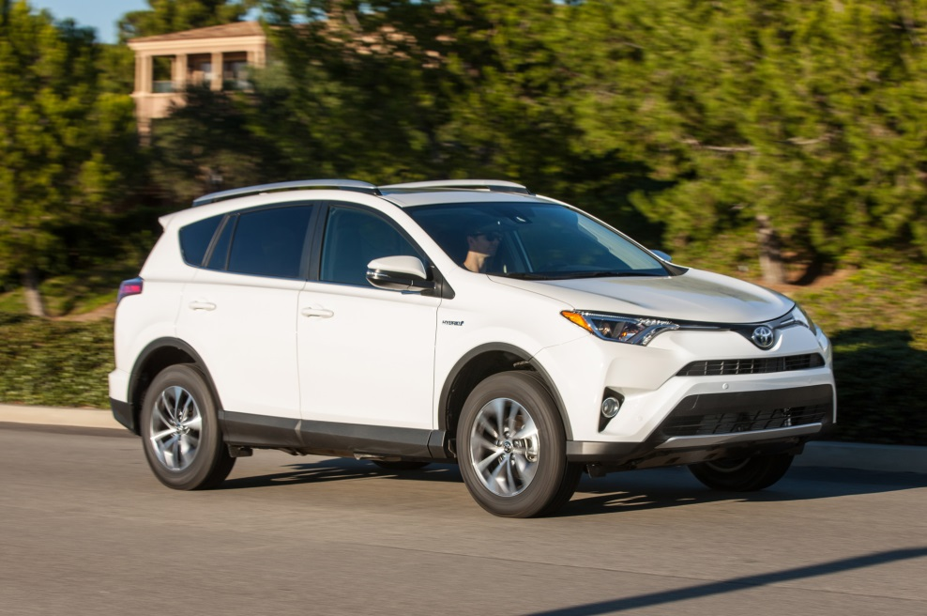

Base Price (http://www.motortrend.com): $29 270 plus taxes
Finance rate: 3.85%
Monthly payments: $788.14
Monthly Insurance cost: $153.44
Monthly gas cost(fuel economy 8.3 L/100 km): $276.88
NOTE: You do not have to use the above format but all information should be included. Be creative!

