Goal • Complete this page to show your understanding of how lenses bend light.
What to Do
Review pages 191–193 of BC Science 8. Then answer these questions and complete the diagrams.

1. Describe a concave lens. ______________________________________________________________________
______________________________________________________________________

2. Light rays _______________ when passing through a concave lens.

3. Describe a convex lens. ______________________________________________________________________
______________________________________________________________________

4. Light rays _______________ when passing through a convex lens.

5. Sometimes people use the phrase double convex or double concave to describe a lens. They are referring to the shape of each surface. To identify concave and convex lenses, it is the thickness of the glass in the middle compared to the thickness at the edges that counts. Classify the following lenses as convex or concave.

6. Draw the paths of the light through each of the following lenses.

Concave lens with small curve  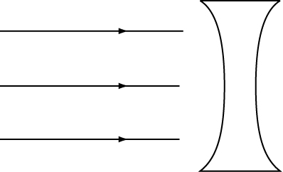 | Concave lens with large curve  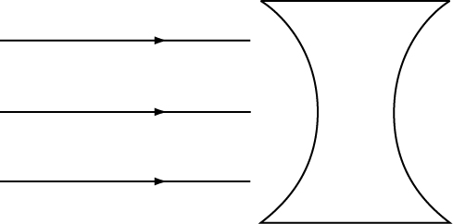
Convex lens with small curve  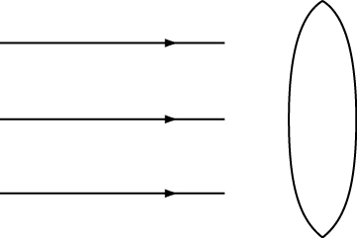 | Convex lens with large curve  