An Algebra Tiles Art Project
Over Chapters 5, we have covered how to add and subtract different types of polynomials.
We’ve learned about degrees of polynomials.
We’ve learned about monomials, binomials, trinomials & polynomials.
We have also learned about algebra tiles and how to determine all of the above using them.
COLOURED = POSITIVE WHITE = NEGATIVE
-XY
-Y
-Y²
-X²
-X
XY
Y²
X
Y
X²

-1
1
Step 1: Designing Your Art
You will design a picture using algebra tiles.
You will make a picture that incorporates both positive and negative terms.
You may change the colours of the tiles, but you must include a LEGEND to indicate what the different colours mean. For example:
Legend
Green = X tiles
Blue = Y tiles
Pink = -X tiles
Have a look at the following for some inspiration!
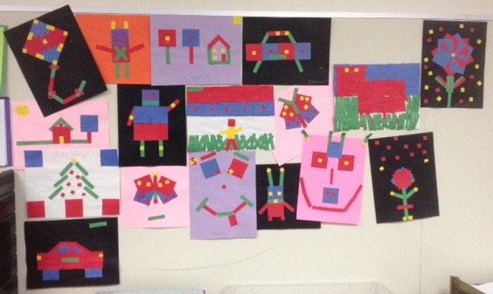

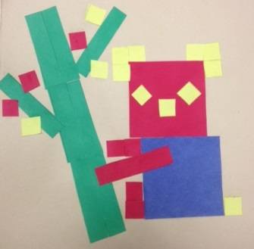

Step 2: Adding & Subtracting with Polynomials
YOU MUST DRAW A LINE THROUGH YOUR ART WORK THAT DIVIDES YOUR ART WORK INTO TWO SECTIONS.
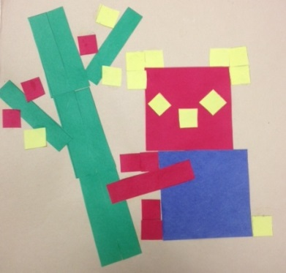
For example, in the following picture, the picture divides the ‘tree’ from the ‘koala’.
A
B
Label one section as ‘A’ and the other as ‘B’.
On a separate piece of paper, set up similar to the following sections, you are going to ADD A and B
together where indicated and then you will SUBTRACT
them.
CLEARLY show your addition and subtraction using
sketched algebra tiles AND using algebra.
ADD A+ B
Section A Section B Result
Visually

Algebraically

SUBTRACT A - B
Section A Section B Result
Visually

Algebraically

Your project will be assessed using the following rubric.
Criteria | Beginning (1) | Developing (2) | Accomplished (3) | Mastery (4)
Art Design | - A simple design is used with only positive or only negative tiles and with only a single variable  - Algebra tiles might not be correctly cut out. | - A simple design is used which incorporates both positive and negative tiles and both x and y variables.  - Some algebra tiles are accurate with square tiles being squares though variable tiles may not be the same length as square tiles and the same width as unit tiles | - A complex design is used which incorporates both positive and negative tiles and both x and y variables.  - Most algebra tiles are accurate with most square tiles being squares and most variable tiles being the same length as square tiles and the same width as unit tiles | - A complex design is used which incorporates both positive and negative tiles and at least two variables.  - All algebra tiles are accurate with all square tiles being squares and all variable tiles being the same length as square tiles and the same width as unit tiles
Legend | - Legend is missing or is inaccurate | - Legend contains some elements and these elements are correct | - Legend includes most elements in drawing and all elements are correct | - Legend contains all elements (positive, negative, squares, x and y and units) and all are correctly depicted
Visual representation of addition and subtraction | - Some attempt at representing the drawing as addition and subtraction but elements may be missing or the answer may not be simplified | - Drawing is presented as addition and subtraction, but answer may not be simplified or may not be correctly simplified | - Drawing is presented as addition and subtraction with small errors in final answer | - Drawing is correctly presented as addition and subtraction with a correct, simplified answer
Algebraic Representation of addition and subtraction | - Some attempt at representing the drawing as addition and subtraction but elements may be missing or the answer may not be simplified | - Drawing is presented as addition and subtraction, but answer may not be simplified or may not be correctly simplified. Or only an answer is given without showing the addition and subtraction | - Drawing is presented as addition and subtraction with small errors in final answer | - Drawing is correctly presented as addition and subtraction with a correct, simplified answer

