NOTES 8.3: Resistance and Ohm’s Law

What is resistance?
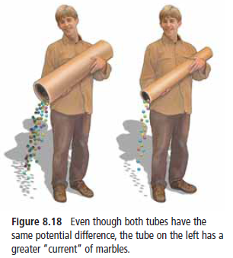
Which tube has more resistance? (circle the correct one)

Resistors

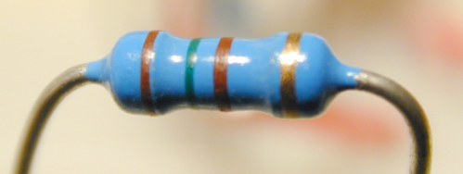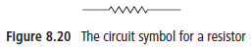

OHMS LAW:_________________
How is voltage related to current?
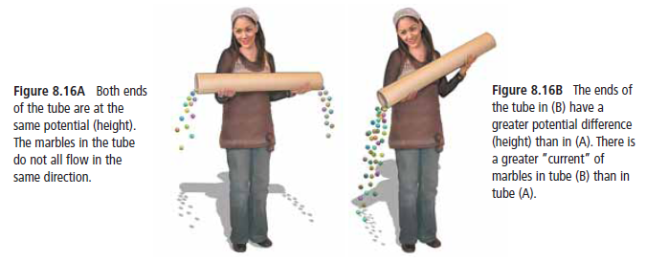
The amount of current that flows through a wire depends on the voltage. The greater the voltage the faster the charges flow.
V = IR
If ↑ V then ↑ I
If ↓ V then ↓ I

How is current related to resistance?
Amount of current also depends on
how the wire resists the flow of the charge.
V = IR
If ↓ R then ↑ I
If ↑ R then ↓ I
Ohm’s Law
Unit for Resistance is called the ___________ ( )
Ohm’s Law is the relationship between Voltage (V), Current (I), and Resistance (R):

Resistor Colour code
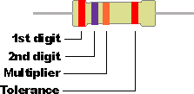
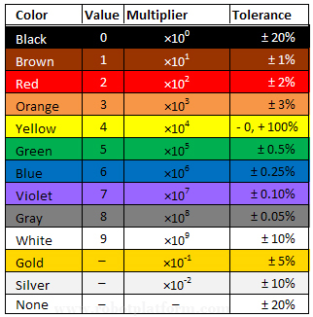

Problem: A vacuum cleaner is plugged into a 120 V outlet. The vacuum cleaner is rated at 12000 mA. What is the resistance of the motor and circuitry of the vacuum? (V=IR)
- Identify the known variables.
- Identify all the unknown variables.
- Adjust formula to solve for unknown.
- Convert all values to standard units!
- Substitute the numbers into the formula and solve.
Practice:
Recall Conversions: To use Ohm’s Law, units must be in the standard volts (V), amperes (A), and ohms (Ω).
Mega = 1 000 000 times, kilo = 1000 times, milli = 1/1000 times (times the base unit)
Current Conversion | Conversion Factors | Conversion | Conversion Factor
1 kA = 1000 A | $\frac{1 kA}{1000 A}$ or $\frac{1000 A}{1 kA}$ | 1 A = 1000 mA | $\frac{1 A}{1000 mA}$ or $\frac{1000 mA}{1 A}$
Conversion | Conversion Factor
1 MA = 1000 kA=$1×10^{6}$A | $\frac{1 MA}{1×10^{6} A}$ or $\frac{1×10^{6} m}{1 MA}$
Conversion practice
3.54 MV x __________________ = __________________ V

1 kV x _____________ = _____________ V

1000 mV x _____________ = _____________ V

CURRENT:

1 MA x __________________ = __________________ A

1 kA x _____________ = _____________ A

1000 mA x _____________ = _____________ A

RESISTANCE:

1 MΩ x __________________ = __________________ Ω

1 kΩ x _____________ = _____________ Ω

1000 mΩ x _____________ = _____________ Ω

Practice Problems Pg. 293 #1 – 3 – Ohm’s Law Calculations –no conversions!

Pg. 294 #1 – 3 (Conversions required before using formula)

Assign: On a separate piece of paper, do pg. 301 #8 – 13; pg. 303 #26 – 31

