Density and the KMT imperative

* A _____________ is any substance that can flow
  + Liquids and gases are _____________ since they do not have a fixed shape.
  + Solids are not ___________.



Density is how closely particles are packed together in a substance

Density helps us to better understand the behavior of fluids

* The density of a substance depends on the size of atoms that make up a substance and the space between the particles
* If the mass of each ball is the same which substance will have a greater density?

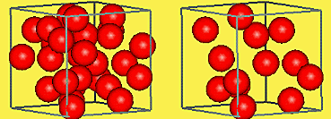

Which of the following, solids, liquids or gases, do you think is the most dense? Explain using the KMT

* When ______________ freezes it actually expands and becomes bigger in volume
* As a result, __________ is less dense than ______________
* This is why __________ floats on ______________

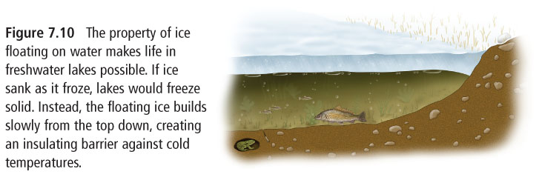

* What would happen to the density of a substance if it is heated? Explain using the KMT
* Fluids that do not mix, layer themselves according to their density.
* Less dense fluids “float” on top of more dense fluids.



oil

ball

water

* Why does it get more difficult to breath as you climb to the top of a mountain
* A fluid of the same substance can layer itself according to density

HW: Worksheet

Quiz on _______________________ Test on _________________________