States of matter

The three familiar states of matter

|  |  |  |  |
| --- | --- | --- | --- |
|  | Fixed Mass | Fixed Volume | Fixed Shape |
| Solid |  |  |  |
| Liquid |  |  |  |
| Gas |  |  |  |

The Kinetic Molecular Theory

* Kinetic energy is the energy due to motion.
* The Kinetic Molecular Theory (KMT) explains what happens to matter when the kinetic energy of the particles changes.
  + A theory provides a scientific explanation based on the results of experimentation.

Main points of the kinetic molecular theory

**Gas: Particles are very far apart and move around quickly.**

**Solid: Particles are so tightly packed together they cannot move freely. They can only vibrate.**

**Liquid: Particles are farther apart and they can move by sliding past each other.**



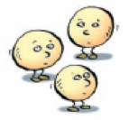

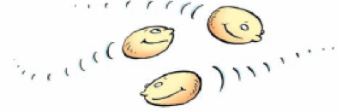

* ______________ is a measure of the average kinetic energy of particles
* Temperature is measured in __________ or ___________
* A _______________is a device used to measure temperature
* When a substance is heated its particles speed up and move farther apart and the volume increases. This is referred to as ________________
* When a substance is cooled its particles slow down and move closer together. This is referred to as __________________
* If a substance is heated or cooled for a long enough period of time then it will eventually change from one state of matter (solid, liquid, gas) to a different state of matter
* This is referred to as a ___________________.

|  |  |  |  |
| --- | --- | --- | --- |
| Name | Change of State | Heat Gained | Heat Lost |
| Melting |  |  |  |
| Evaporation |  |  |  |
| Condensation |  |  |  |
| Solidification |  |  |  |
| Sublimation |  |  |  |
| Deposition |  |  |  |

* Melting point is the temperature at which __________________.
* Boiling point is the temperature at which _________________.

Assignment:

Make a flow chart showing how atoms move in SOLIDS, LIQUIDS and GASES. Make sure to use the KMT. Use both diagrams and descriptions.