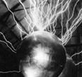
NOTES 7.1: Static Electricity

Electric _________________ that are _____________ in one _____________.
What is it? Static Electricity is the build-up of _________________________that are “static”
(______________________). Static electricity can result in _____________, ______________, or
materials clinging together or repelling each other.
Benjamin Franklin

Franklin discovered that __________________ charge results from a build-up of ___________________

_______________ and that Negative (-) charge results from a ___________________ of

___________________ ____________.

The Atom
Remember that in the atom…

Neutral atoms have __________________numbers of protons and electrons

_____________________ an electron makes the atom or object more POSITIVE

_____________________ an electron makes the atom or object more NEGATIVE

Friction and Electron Transfer
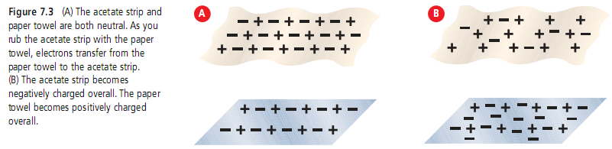

_______________occurs when objects rub against each other

The rubbing can result in _____________hopping from one object to another

How materials are charged (negatively or positively) depends on the ________________ rubbed together.

The Electroscope
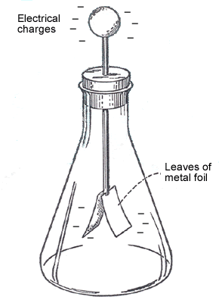
Used for detecting static charge.

Insulators and Conductors

Insulator– materials that ___________________ allow charges to move easily (plastics, glass, wood)

  - Retain a ___________________
  - electrons will accumulate at surface and will stay in one place

Draw the diagram of rod with charges

Conductor- materials that allow electrons to ______________________

  - Electrons will spread out evenly throughout material

Draw the diagram of rod with charges

DO THIS!

- Think About It activity pg. 251

- Read text pages 248-257 and complete questions 1-17

