NOTES 6.3: Reproductive Technologies

Embryonic Development
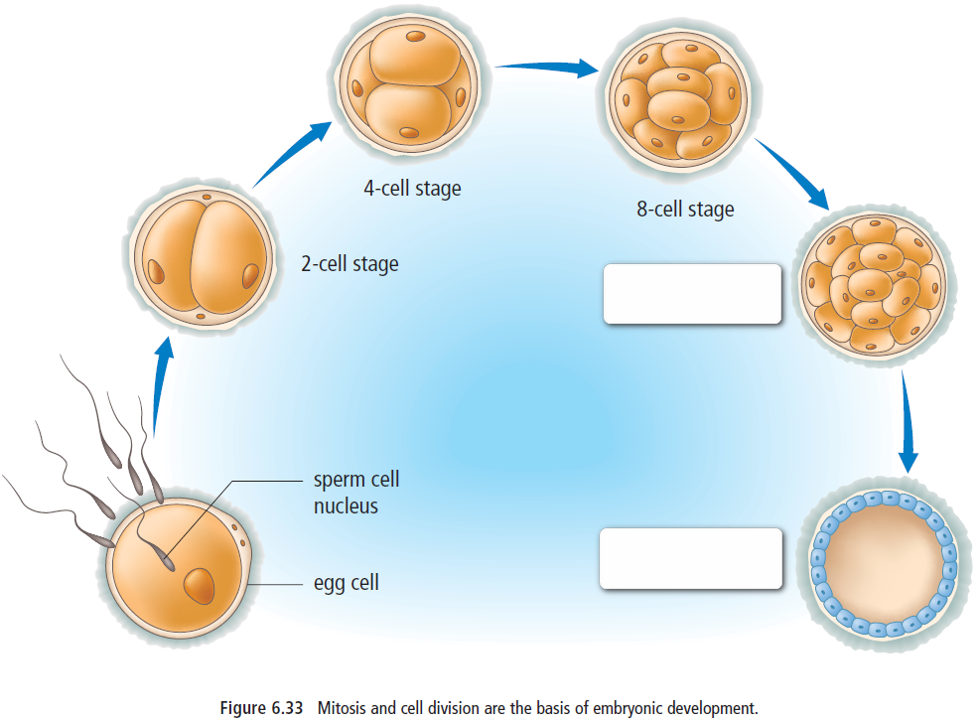
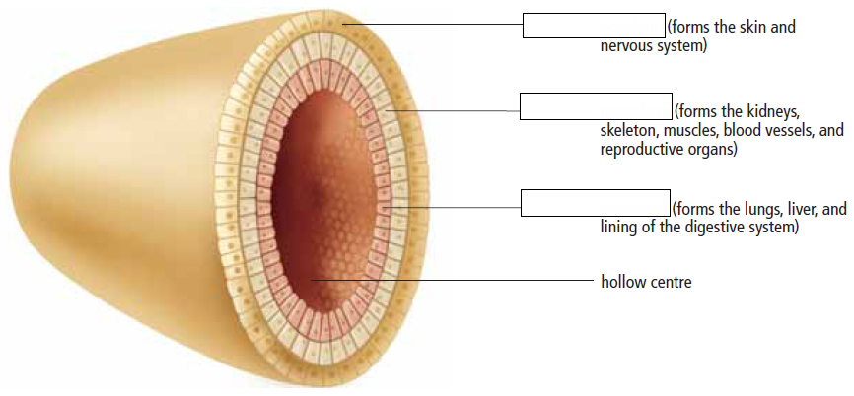
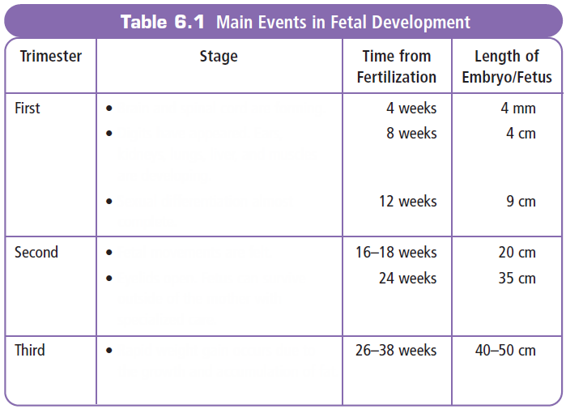
Assisted Reproductive Technologies
Name | Abbreviation | Description
 | AI
In Vitro Fertilization
 | GIFT
Intracytoplasmic Sperm Injection |  | Single egg cell injected with sperm – zygote returning to uterus.

