NOTES 6.1: Human Vision
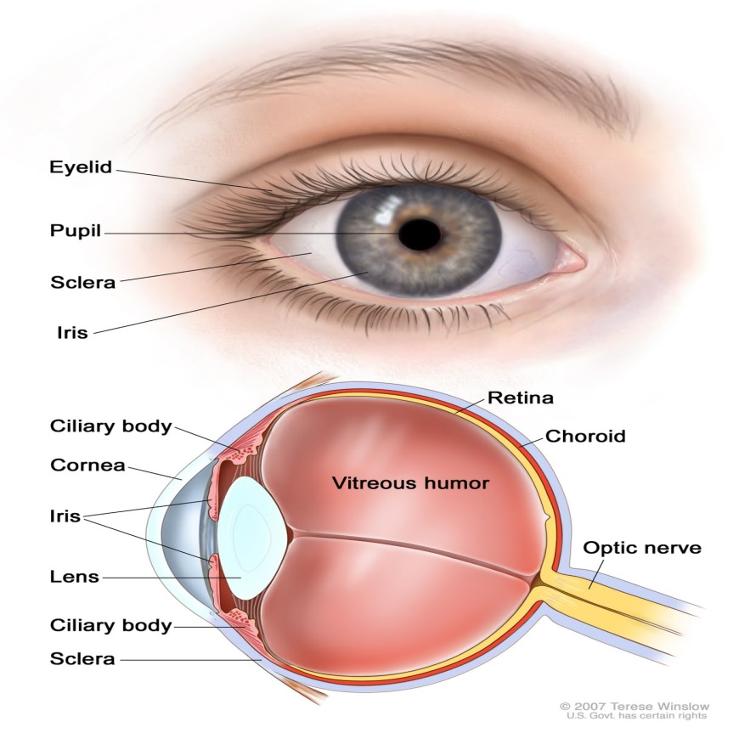
Parts of the eye
The outer eye

The inner eye

The Eye is surrounded by _______________ which help move and protect the eye (pulling on lens when focusing is needed).
Around all these muscles are large quantities of ________ which helps insulate the eye and protect it from knocks and bumps.
The eye is hollow and inside this hollow area is a fluid/gel called the _______________, this helps the eye keep its shape.
A second fluid/gel (similar to the first) is located between the Lens and the Cornea, it is called the __________________ and aids the eye in magnification and also holding its shape.
The only solid part in the eye is the outer coating which is divided into three layers…
______________ – tough outer white region of the eye
______________ – middle region which is blood filled, brings nutrients to the eye
______________ – inside region that contains light-sensitive cells that detect the image

Light enters the eye through an opening called the _____________. The ____________ is the colored circle muscle surrounding the pupil
The iris controls the amount of light entering the pupil.
In dim light the iris _____________ or expands. In bright light the iris _________________ the pupil to reduce the amount of light entering the eye
The white region surrounding the iris is called the _________________
Covering the iris and pupil is a transparent material called the cornea
Forming an image
Light rays begin to refract as soon as they pass through the cornea
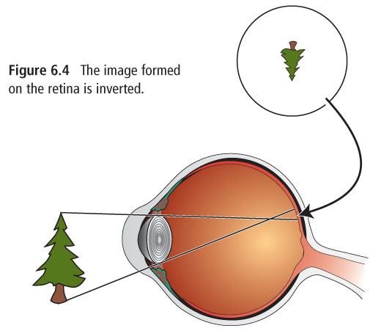
The ________________ does most of the focusing by the eyes
The ___________ does the rest of the focusing
The lens fine tunes the focus by changing its shape
A ___________ lens focuses on objects that are nearby
A __________ lens focuses on images far away
Light rays pass through the lens and are focused at the back of the eye on a layer called the _______________
The image formed by the lens is ____________________
The image is sent to the brain by the ________________________
Your brain interprets the image to be ______________
The point at which all the light rays come together is called the _________.
The Pathway of light
Stimulus (light) -> ____________ -> ____________ -> ____________ -> ____________ -> ____________ -> ____________ -> ____________ -> ____________ -> ____________ ->
Interpret the message and respond (_____________________________)

Blind Spot – area where the optic nerve enters the retina (no light-sensing cells are present)
Activities:

Rods and Cones
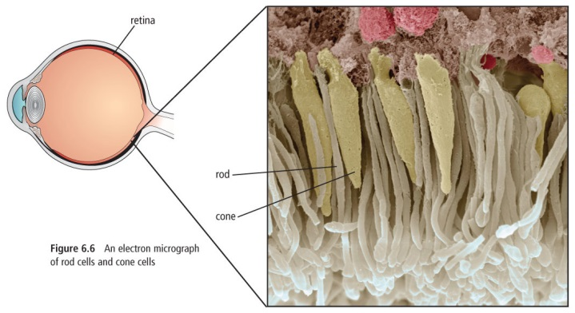
These are the sensory cells in your eyes that detect light.

___________ – detect low levels of light (dim light)
_______________ cells that detect shapes, movement and shades of light and dark (black-and-white vision system)
______________ – detect bright light
______________ that help see the many ___________ of the rainbow. There are three kinds depending on their pigment (red, green and blue)

Complete vision activities

