NOTES 5.3: Using Lenses to form images
Lenses
- A _____________ is a curved piece of transparent material that can refract light
- Concave lenses produce images that are ___________ and ____________ than the object.
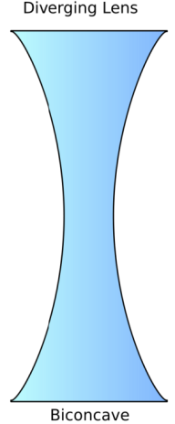
- Concave lenses are sometimes used in ____________ and _____________.

- _______________ lenses are thicker in the _____________ than at the edge.
- _______________ lenses cause light rays to __________________.
  - When parallel rays strike a convex lens they come together at the focal point.

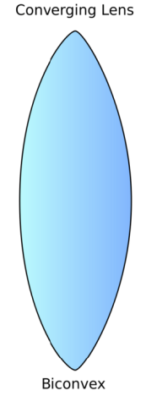

- When an object is really far away the image is _____________ and ____________ (___________)

Object between one and two focal lengths from the lens
- As you move the object closer the image gets _____________ and ____________ (___________)

Object less than one focal length from the lens

- When the object is directly in front of the lens the image _______________ and ______________
- Examples of convex lenses:

HW: Light and Lenses Worksheet, Pg 197 #1-11

