NOTES 5.2: Using Mirrors to form images
Plane mirrors – ray diagram
You must find the image of the ball by following these steps:
- Draw a normal line where the two incident rays strike the mirror
- Measure the angle of incidence for the two rays
- Using the law of reflection draw two reflected rays
- Extend the reflected rays behind the mirror using dotted lines.
- Draw the image where the two rays meet

Object mirror

Discussion
- Measure the object distance (distance from mirror to object) and record
- Measure the image distance (distance from image to mirror) and record your value
- How did the image distance compare to the object distance?

Concave mirrors
- A concave mirror is a mirror that curves inward
- Parallel light rays that strike a concave mirror come together and meet at a single point called the focal point
- Rays that come together are called converging rays
- Concave mirrors obey the law of reflection
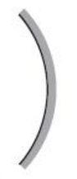
- Ray diagrams can be used to determine the size and orientation of the image

Convex Mirrors
- Convex mirrors are mirrors that curve outward
- Parallel light rays that strike a convex mirror spread apart
- Rays that spread apart are called diverging rays
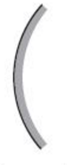

- Images formed by convex mirrors are always smaller and upright
- More objects can be seen in a convex mirror than in a plane mirror of the same size
- Common uses: security mirrors, car side-view mirrors

