**NOTES 4.3: Light and the Electromagnetic Spectrum**

**Light and the Electromagnetic Spectrum**

* The sun is the most important source of _______ on earth
* Light spreads out or ___________ from the sun and other stars in all directions
* Energy such as light that travels by radiation is often called _________________________
* In addition to light, the sun radiates several forms of energy that are not visible to the human eye

**Electromagnetic Radiation**

* In a water wave, ___________________________________ vibrate up and down
* In a light wave _______________________and _________________ fields vibrate up and down
* Visible light and all of the forms of radiant energy emitted by the sun are parts of the _____________________________

**Electromagnetic spectrum**

* The electromagnetic spectrum shows all of the forms of _____________ from ___________ wavelength to ___________ wavelength

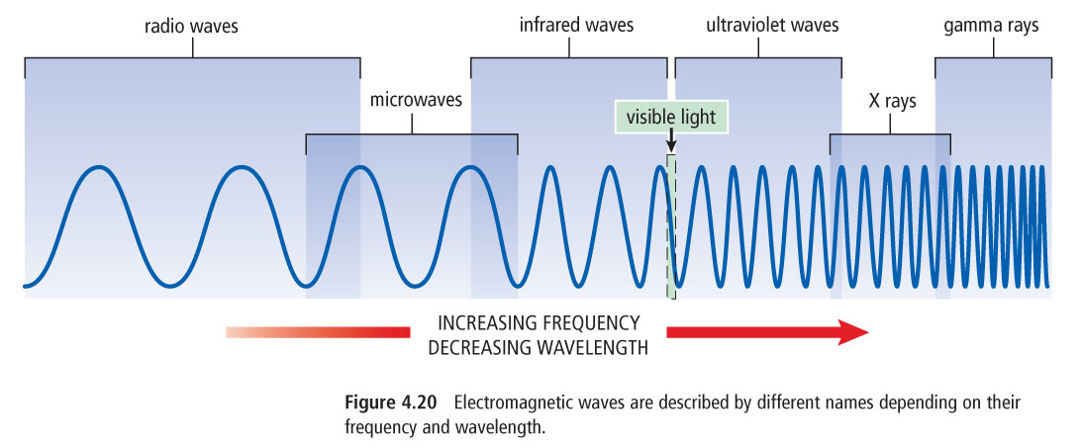

**Wavelengths longer than visible light**

* _________________________waves have the longest wavelength and the lowest frequency
* _________________________ are types of radio waves

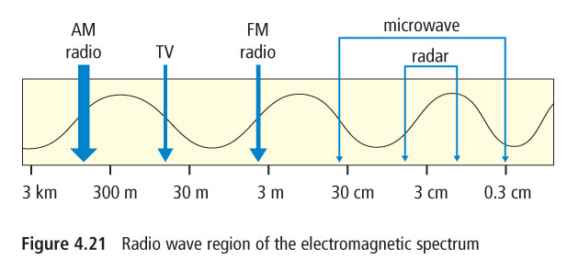



* In magnetic resonance imaging (MRI), __________ _________ are used to see parts of the brain
* Microwave ovens use a specific wavelength and frequency that is strongly absorbed by _____________ molecules
* Only foods that contain water can be heated by water molecules (see simulation)
* Microwaves are used in _________________________________________________________________

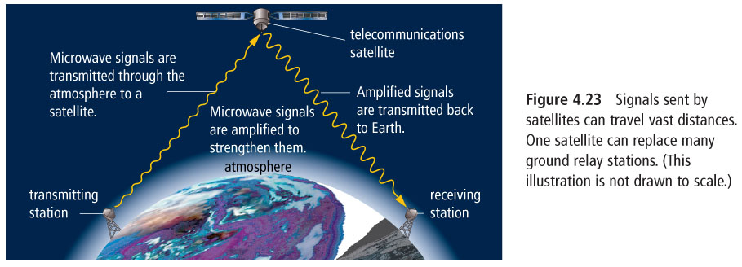

**Radar**

* ________________ wavelength microwaves are used in radar
* Radar is an acronym: _____________________________________
* Radar is used for tracking movement of ______________________________________________

______________________________________________________________________________

**Infrared waves**

* Infrared waves are a type of electromagnetic radiation used in _____________________and ______________________________
* Infrared radiation is also known as ____________________
* ________________ emit infrared radiation including you!

**Wavelengths shorter than visible light**

* Wavelengths that are shorter than visible light carry _____________ energy than light waves

**Ultraviolet Waves**

* Ultraviolet rays striking your skin allows your body to make ______________________
* Overexposure to ultraviolet waves (UV) can cause sunburns and ______________________ and damage to the surface of the eye
* UV can kill _______________________ in food and sterilize medical equipment

**X rays**

* X rays have a very short _____________________and high __________________________
* X rays are used to photograph ________________ and _____________________
* Special precautions must be used when using x rays such as wearing protective padding



**Gamma Rays**

* Gamma rays are the ______________ energy and frequency
* Gamma rays are produced in ______________________________________
* Gamma rays can be used to kill cancer cells during radiation therapy