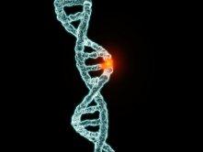
NOTES 4.2: Mutation

What is a mutation?
Mutations are actually quite ________________ (they happen all the time).
Mutagens
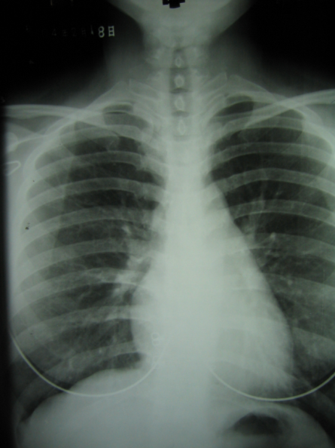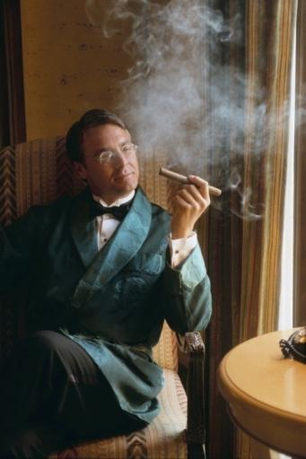
________________

___________
______________
Mutagens are factors that cause _____________________ to happen. The more mutagens you are exposed to, the greater the odds of generating mutations that may be _________________ to you.
How gene mutations work- Gene mutations are changes in the order of the A,G,C and T bases that make up a gene
Original DNA Sequence: AAT TAC CCT TTT AAA ACT TAC CAT
Addition: AAT TAC ACC TTT TAA AAC TTT ACC AT
Deletion: AAT TAC CTT TTA AAA CTA CCA T
Substitution: AAT TAC TCT TTT GAA ACT TAC AAT

The Effects of Mutation
Positive Mutation
A mutation that BENEFITS the individual who has it.
Examples:
Negative Mutation
A mutation that is HARMFUL to the individual who has it.
Examples:
Neutral Mutation
A mutation that does not affect the individual. Most mutations are of this type.
Examples:
Correcting Mutations
- Is used to correct mutations that cause _____________________
- Gene therapy is risky, complicated and experimental
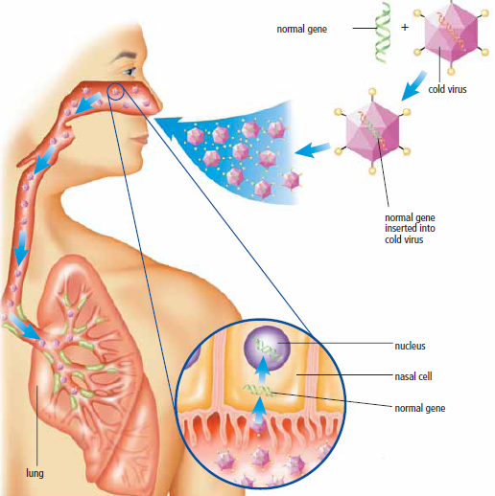
  - An inactive virus such as a cold virus in engineered to carry a “______________” gene
  - The virus must somehow be targeted to the cells with the mutated gene
  - The normal gene must then ________________ the defective gene
  - The normal gene must then be “switched on” to produce the correct ______________ of healthy protein

DO THIS!
- Pg 145 #1-17
- Complete 4.1 Questions if not completed

