**NOTES 4.1: Properties of Waves**

* A wave is a disturbance or movement that transfers __________________ through matter or space without causing any ____________________.

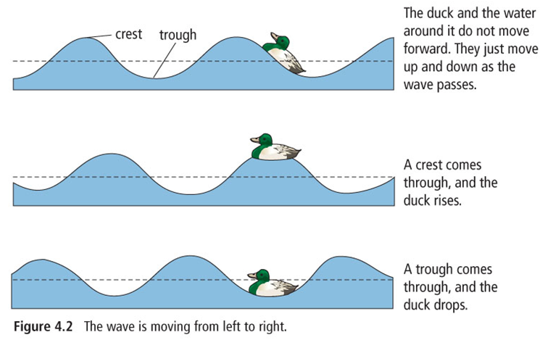

* ___________________ is the capacity to apply a force over a distance.
* A ________________is a push or a pull on an object.
  + Examples of waves include:_____________waves, ___________ waves, and microwaves.

**Parts of a wave**

* A _______________ is the highest point on a wave.
* A ____________________ is the lowest point on a wave.
* The ______________________________ is the distance, in metres, for one complete cycle of the wave. Crest to crest or trough to trough.
* The ________________________ is the height of a wave crest or depth of a trough, as measured from its rest position.
* **The larger the amplitude, the greater the energy transported…**
  + **Light waves 🡪 bright light has a large amplitude (more energy)**

**🡪 dim light has a lower amplitude (less energy)**

Label each of the following parts of a wave

F =_________________________

G=_________________________

H=_________________________

J=__________________________



The matter that waves travel through is called a ____________________

* Two types of waves that travel through a medium are:
  + _________________________ wave – matter in the medium moves perpendicular to direction of the wave



* + _______________________ wave – matter in the medium moves parallel to direction of the wave.



**Frequency**

* Frequency is the number of repetitive motions, or __________________________ , that occur in a given time.
* Frequency is usually measured in ____________________
* When the frequency of a wave increases the wavelength decreases.
  + Wavelength and Frequency behave as opposite’s 🡪 they have an __________________



Frequency can be calculated using the following equation:

__________________________________________________________

Use the above equation to find the frequency for each of the following: (complete on separate sheet of paper)

* a) A hummingbird flaps its wings 120 times in 3 seconds.
* b) A DVD spins 350 times in 1 minute seconds.

HW: Pg 143 # 1-9