NOTES 2.3: The Periodic Table
and Bohr Diagrams

Bohr Model Diagrams

Bohr Models illustrate energy shells and the electron arrangement of a particular atom.
In this model, electrons will fill up each inner shell before flowing into the next shell on the outside.
The capacity of each shell from inside to out is as follows: 2, 8, 8, 18, 18.
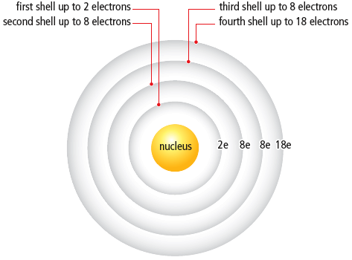

Drawing Bohr ATOMS

- Pick an Element. Write Symbol in nucleus!
- Write the number of PROTONS.
- Write the number of NEUTRONS (atomic mass – atomic number).
There are 2 different ways to draw a Bohr Atom:
- Draw electrons as dots filling up the shells from the nucleus out (remember: 2, 8, 8, 18, 18):
(The total number of electrons is equal to the number of protons in an uncharged atom.)
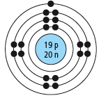
- Write the number of electrons as symbols and shells as semi-circles from the nucleus out:
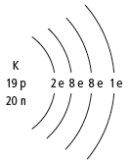

_{Element symbol}
_{#protons}
_{#neutrons}

TRY IT:
- sodium

- fluorine

Electron configurations of the first 18 elements in the Periodic Table

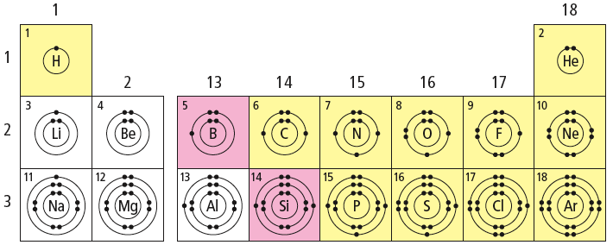

Patterns in the Periodic Table

Elements in each ________________ have the same number of __________________ electrons
(electrons in the ______________ ________________).

Elements in each ________________ have the same number of shells. ________________ number indicates the number of shells that will be occupied by electrons.

DEFINE Valence Electrons: _______________________________________________________________

DEFINE Valence Shell: __________________________________________________________________

Ions

An______ is an atom that has _______or_______ electrons resulting in an electric charge. The number of protons does not change.
    - In an ion the # electrons ____ # protons
Most elements gain or lose electrons in order to be ____________ like Noble gases and have the same e- arrangement as the nearest noble gas.
  - Metals __________electrons to empty their valence shell and form __________ions (Ca²⁺ --> lost 2 e-)
  - Non-metals (except noble gases) _________electrons to fill their valence shell and form ________________ ions (O²⁻ –-> gained 2 e-)
Noble gases are stable and _______________ because their ____________ shells are completely full. They do not form _________.

Charge on an Ion
Cl- charge is _____ vs Be²⁺ charge is ______
The charge on an ion = _______ of charges on its protons and electrons
  - Ex. Mg²⁺ has 12 protons (12+) and 10 electrons (10-)
Total Charge = (12+) + (10-) = 2+
  - O²⁻ has ______ protons and _______ electrons
Total Charge = ( 8+ ) + ( -) = 2-
What pattern in ion charges do you notice on the periodic table?
Elements of the ________________ form ions ______________________________________________
(except transition metals) which form____________________________________________________
Drawing Bohr IONS
- Follow the same steps for drawing a bohr atom except:
  - Write the element symbol with its __________
  - Determine # electrons # electrons $_____$# protons
Ex. K ⁺ the charge is 1+ this means: Potassium atom lost ______ e- to form a +ve ion
i.e 19 e- in the neutral potassium atom subtract 1 e- = __________ in the positively charged ion
Drawing a semi-circle Bohr Ion:

- Write the number of electrons as symbols (2e, 8e, 8e, 18e, 18e) filling up the shells from the nucleus out
- Draw shells as semi-circles from the nucleus out and put the charge of the ion on the element symbol
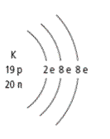
_{Charge}
₊
_{#protons}
_{#neutrons}

TRY IT:
- Potassium Ion

- Sodium Ion

Do this Now! Complete Note Examples and Bohr Diagram Practice sheet;
Unit Test: Chapter 1.2-2.3 ________________________

